

**LAB 2 Report**

**Dropbox**

**By:**

**Varun Shah**

Table of Contents

1. Dropbox 3

1.1. Introduction 3

1.2. System Design 3

1.3. Results 5

1.4. Performance Test 26

1.5. Performance Analysis 46

1.6. Unit Test 46

2. Answers 72

# Dropbox

Dropbox Web Application replica of Dropbox to demonstrate Rest Web Services with Apache Kafka Distributed System

## Introduction

Goal:

Designing Dropbox Web API to demonstrate REST web services with Distributed System Apache Kafka using react.js as front-end and 2 node servers as back-end.

Purpose:

Purpose of this system is to demonstrate stateless REST web service by integrating it with Apache Kafka Distributed System by building Dropbox API with following operations:

* Basic Users functionalities
  + Sign up new user (first, name, last name, Email and password)
  + Sign in existing user (Encrypt Passwords))
  + Sign out.
  + Upload files
  + List a file
  + Create a directory
  + Star a folder/directory
  + Share a folder/directory by email/name/link
* Users account should provide basic details such as:
  + About: User overview, Work and education, contact info and life events
  + Interests like music, shows and sports
* Provide Groups (share) functionalities:
  + Create group
  + Add member in a group
  + Show members in group
  + Assign access permission to a directory
  + Delete member from a group
  + Delete group
* Provide file list and activity report functionality

## System Design

Calculator API is created using following:

* React.js
* Node.js
* Express.js
* Bootstrap
* MySQL

Front-end is developed using React.js and Bootstrap for better look and feel. Components are divided in following way:

React Component App

MainPage.js

Successful login

SignUp

Login

User

Group

Activity

Profile

File

Home

Group/ :groupid

After logging in successfully user can access all the child components of User. When user logs in successfully session gets creation with user’s username and client server state will be managed by session. When session expires, user get redirected to login screen.

Distributed System Architecture:

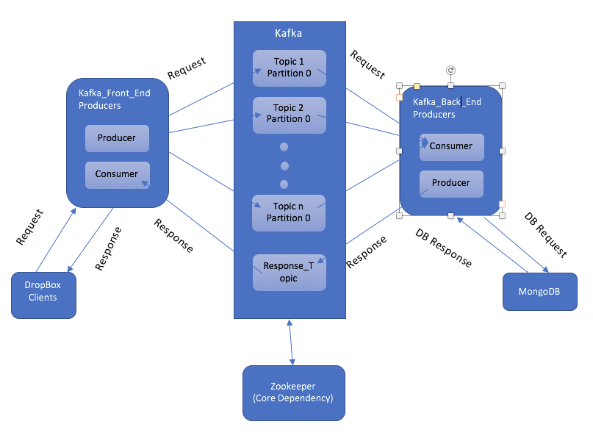

Above diagram depicts architecture followed in developing Dropbox. Apache Kafka us used as distributed streaming platform. It allows to publish and subscribe to streams of records just like a message queue or enterprise messaging system. Kafka lets streams of records to be stored in a fault-tolerant way. Kafka requires Zookeeper server to perform. In dropbox system, kafka contains different topic for each API call from kafka_front_end to kafka_back_end. Then after performing operation on MongoDB Database producer on the kafka_back_end send response in Response_Topic to the kafka_front_end. Kafka_front_end Consumer receives the response and sends it to the respective client (React). This way the whole dropbox system performs

## Results

* Signup
  + Client

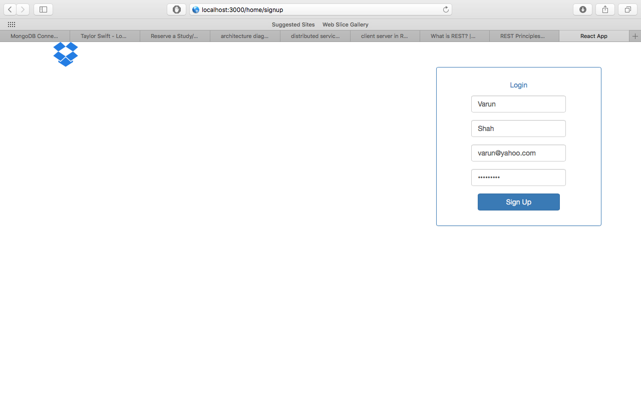

* + Kafka_Client

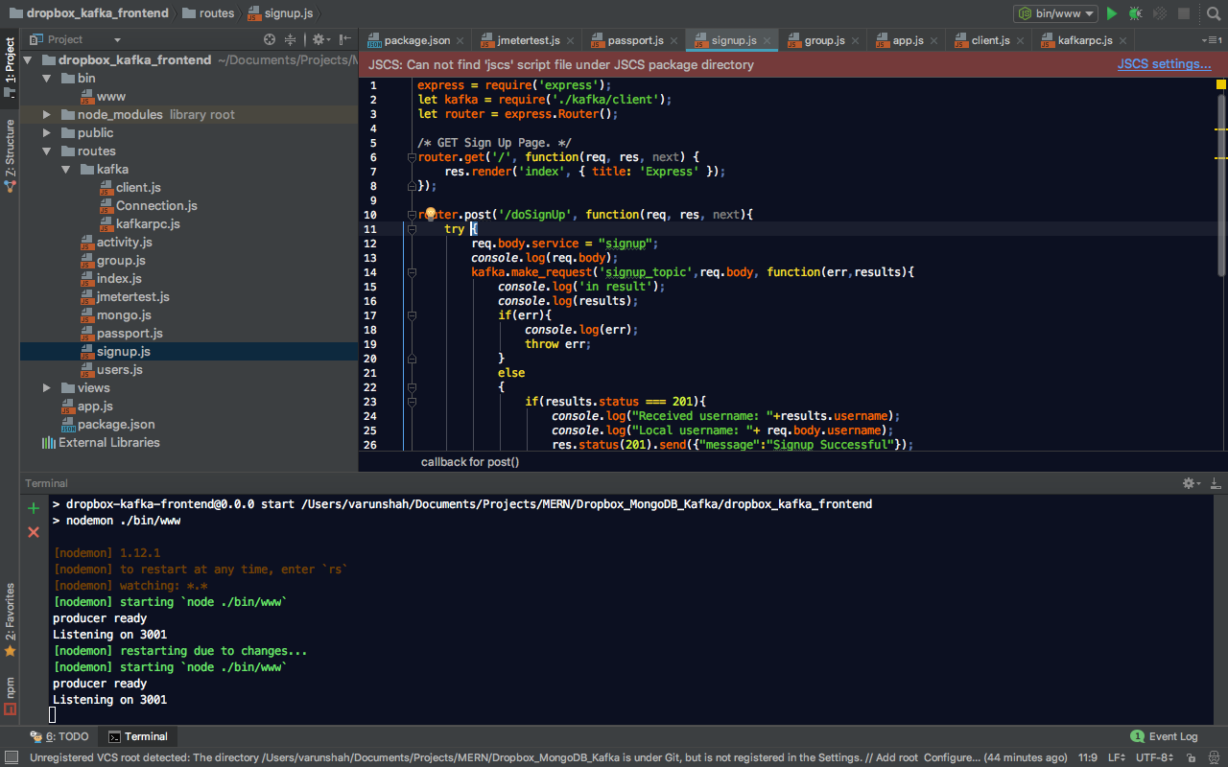

* + Kafka_Server

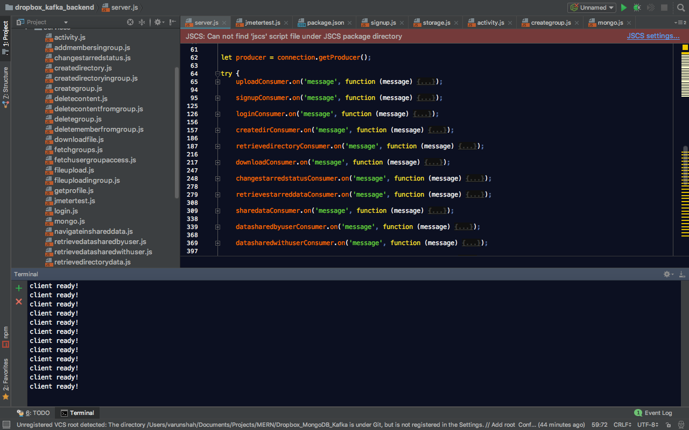

* Login
  + Client

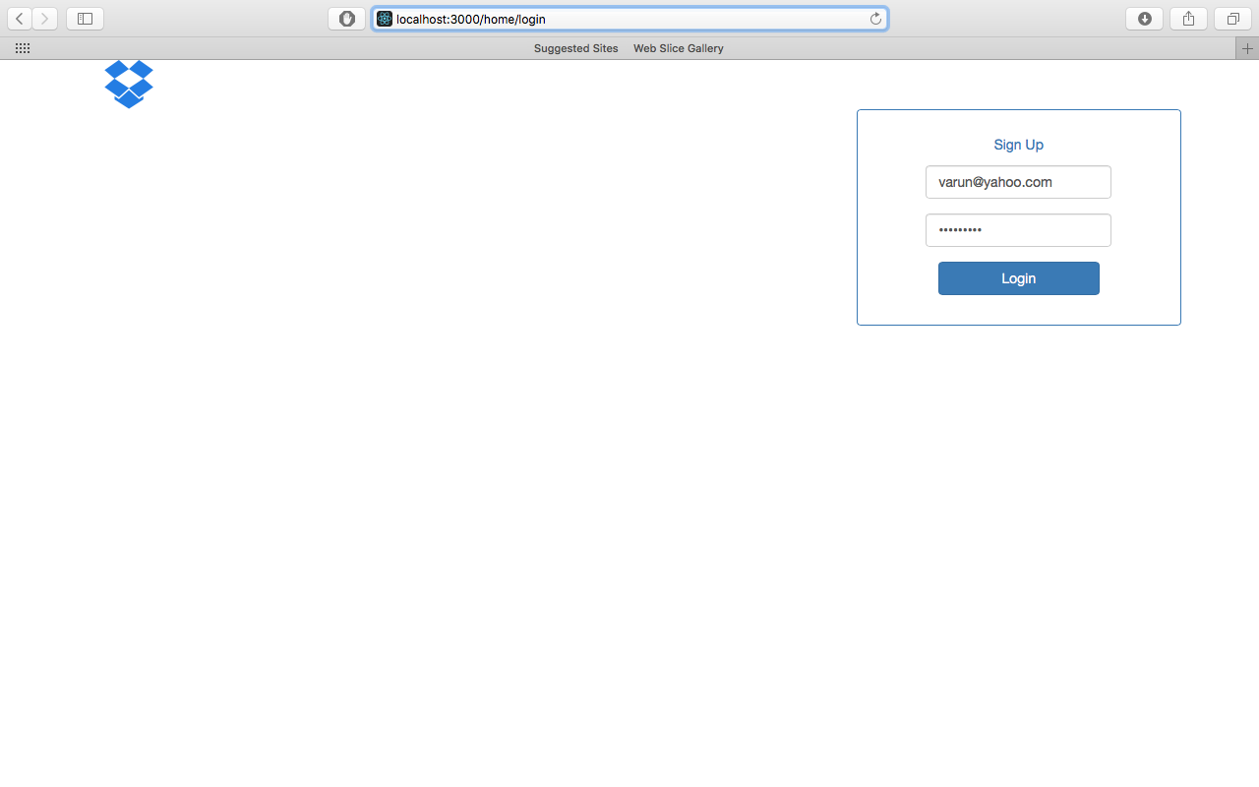

* + Kafka_Client

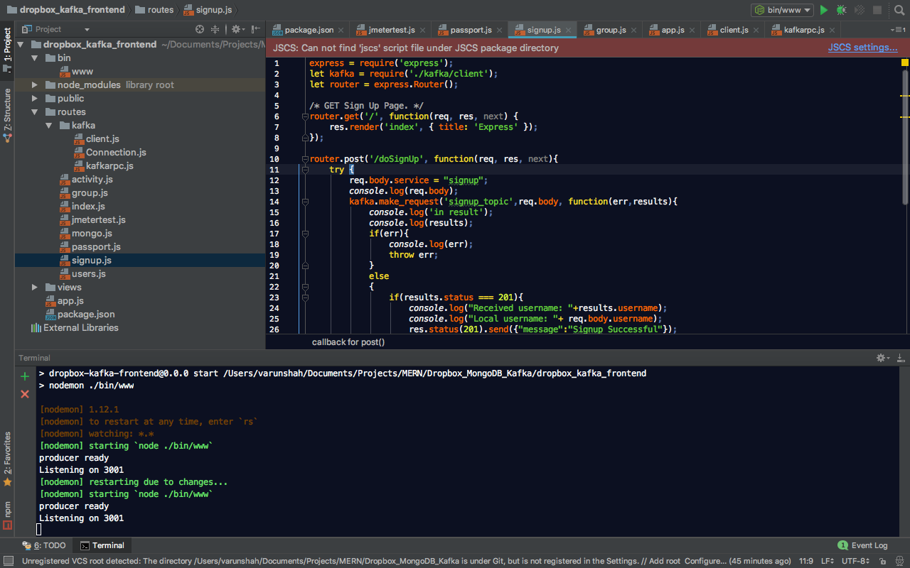

* + Kafka_Server

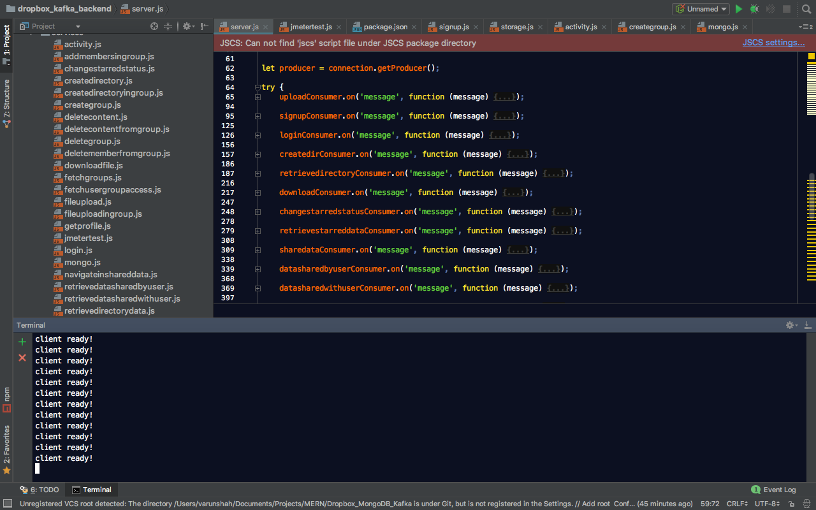

* After login User Home Screen with Starred data, data shared by user and data shared with user
  + Client

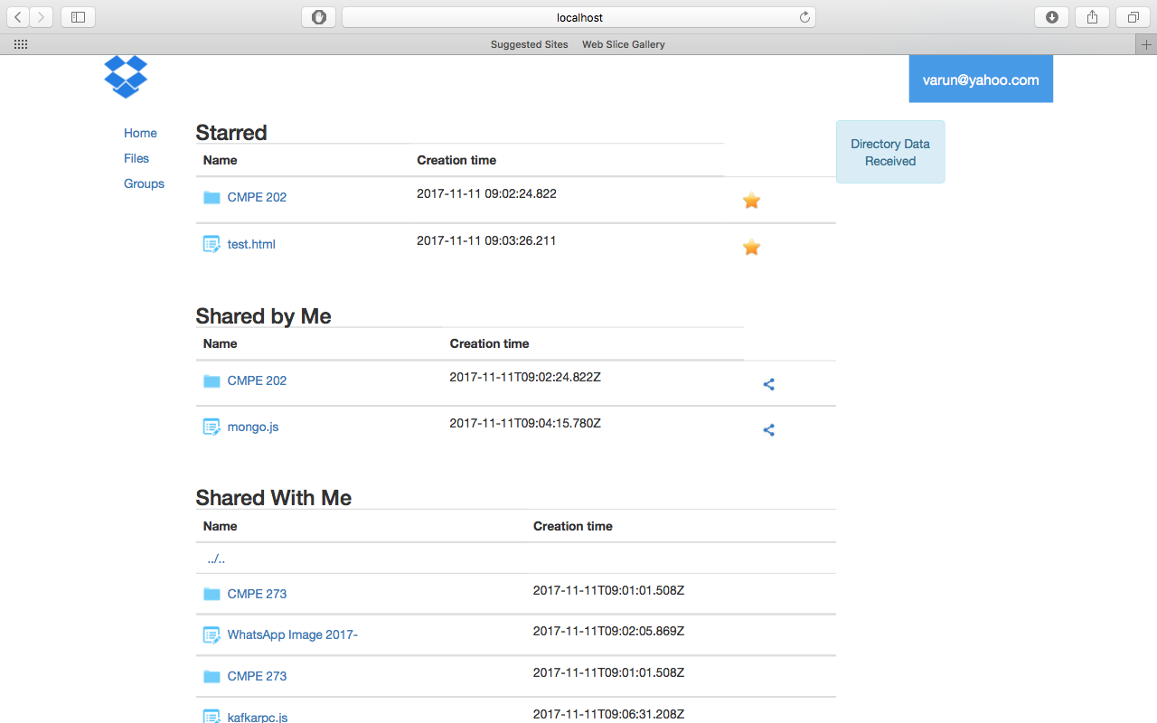

* + Kafka_Client

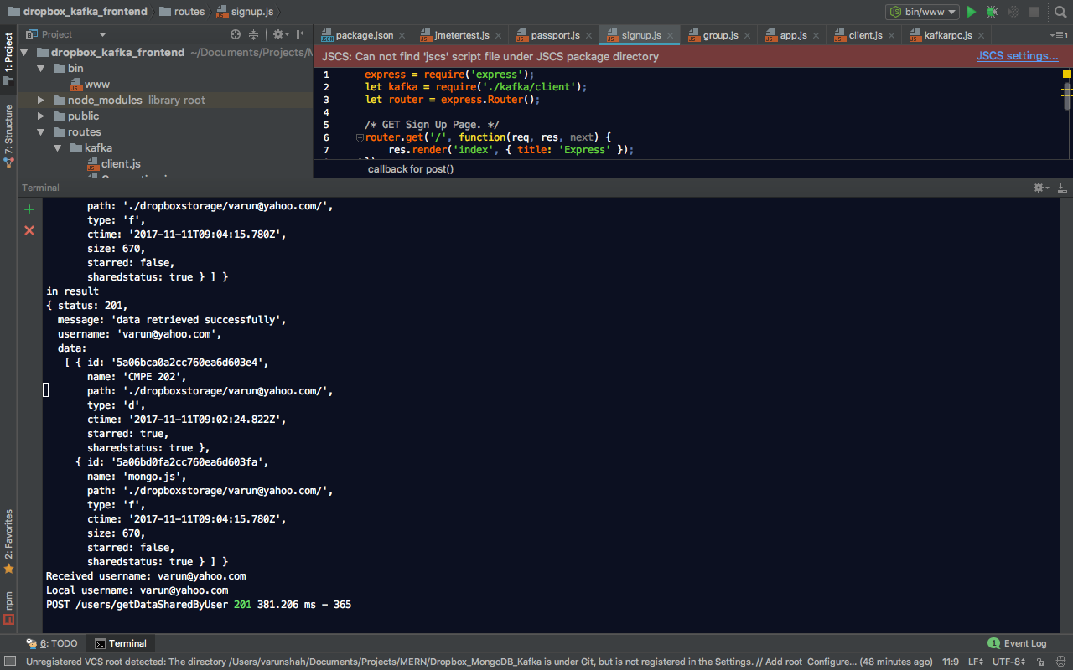

* + Kafka_Server

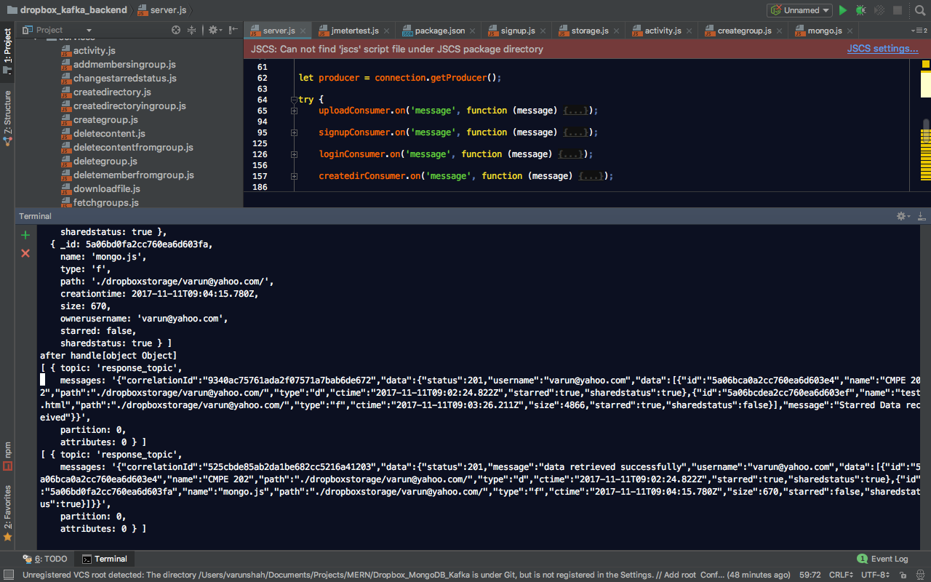

* User’s uploaded Filesystem
  + Client

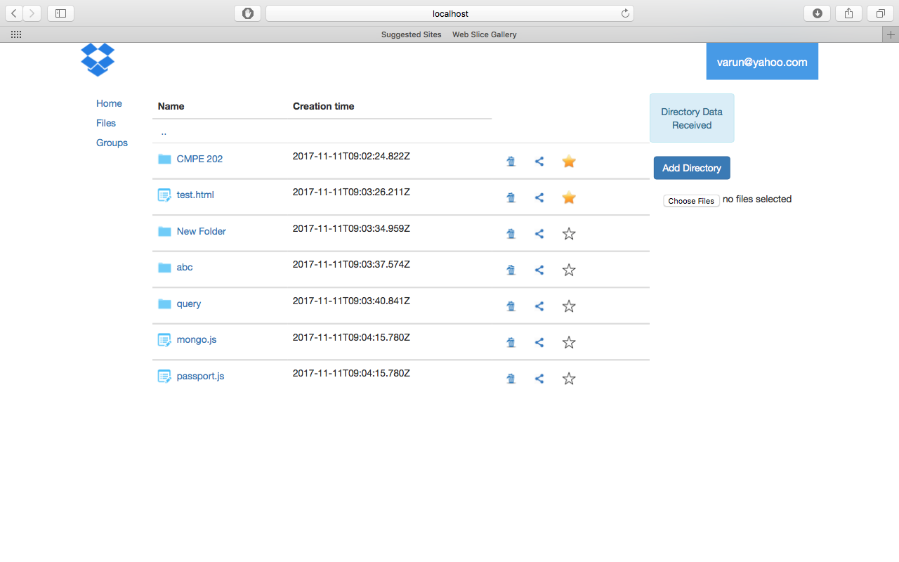

* + Kafka_Client

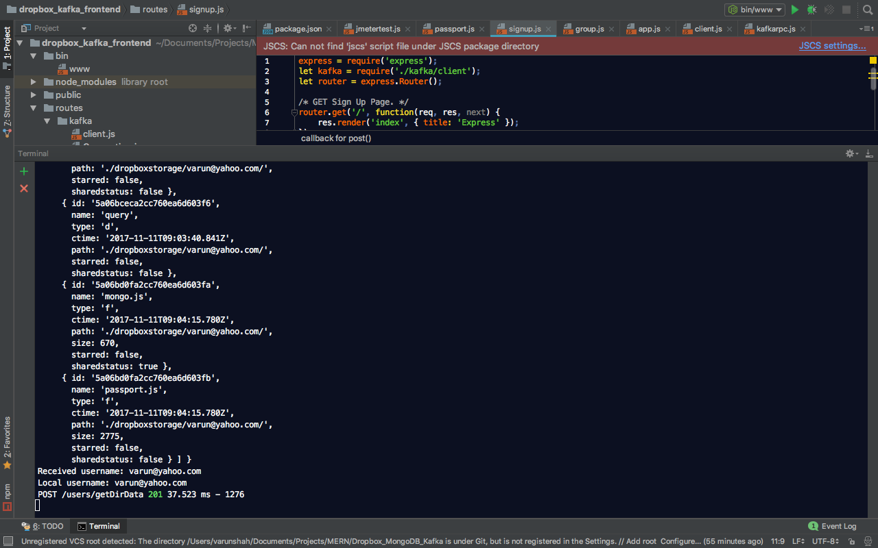

* + Kafka_Server

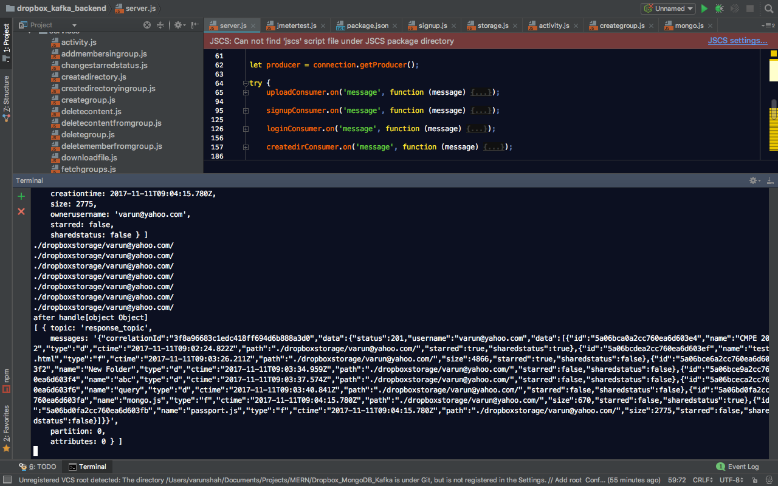

* Navigation in file system
  + Client



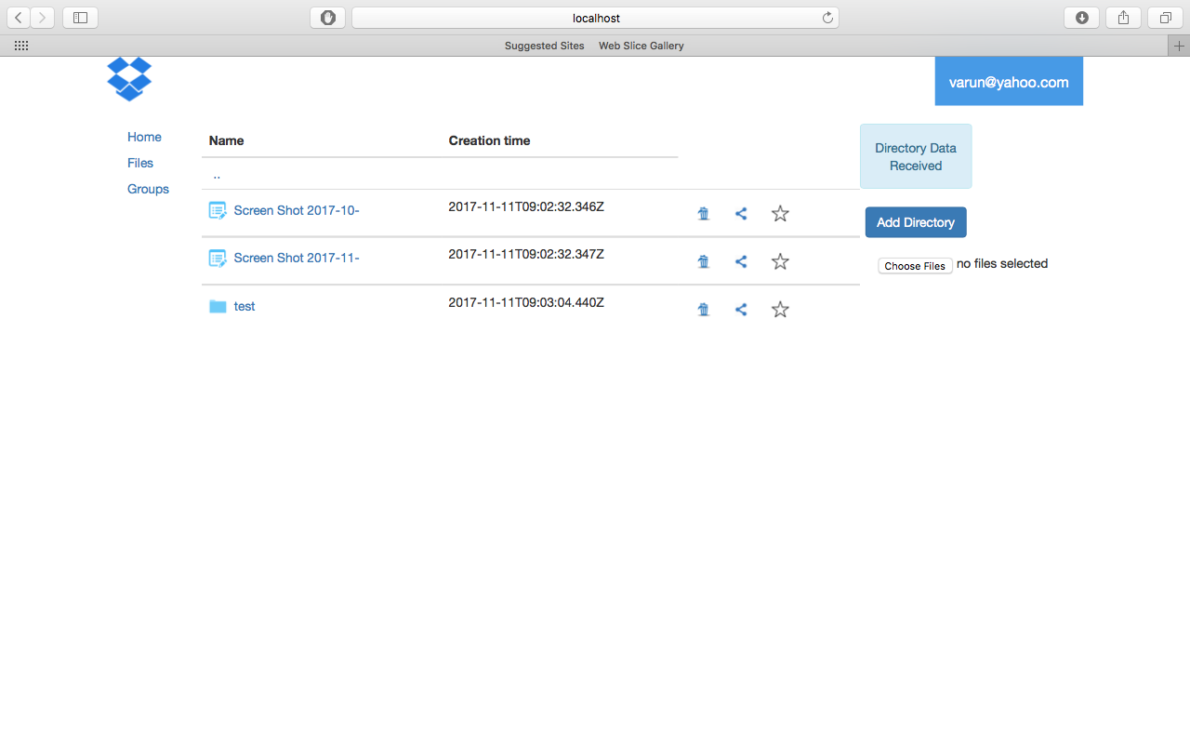

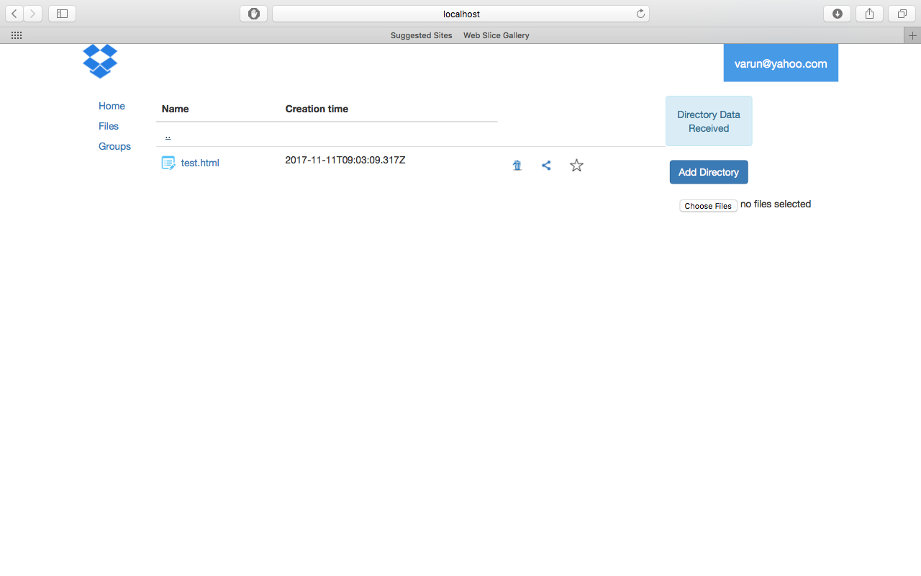

* + Kafka_Client

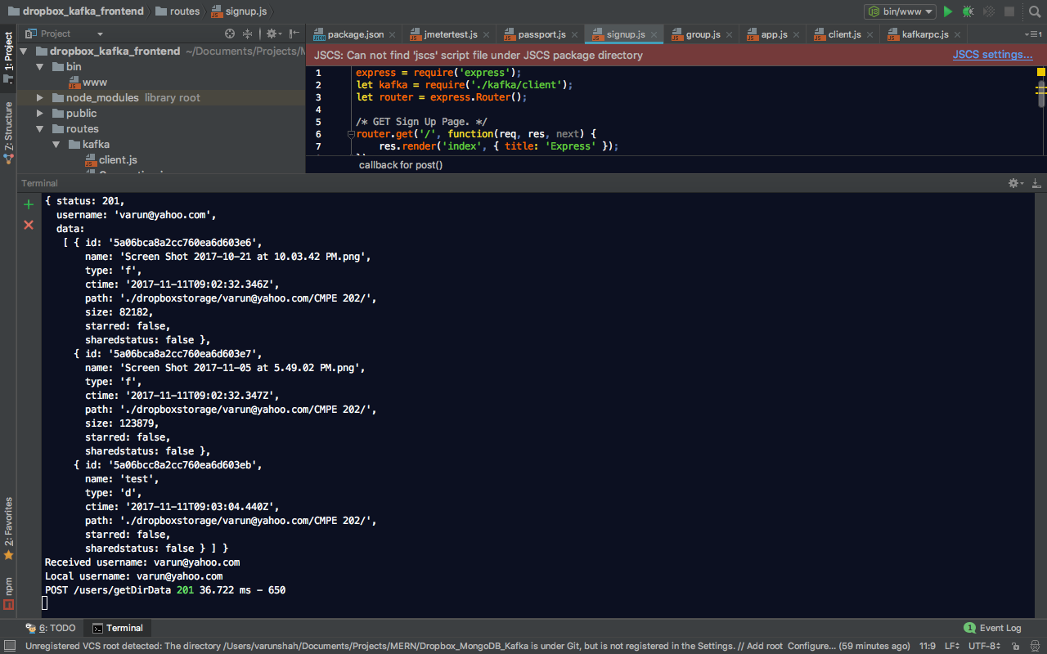

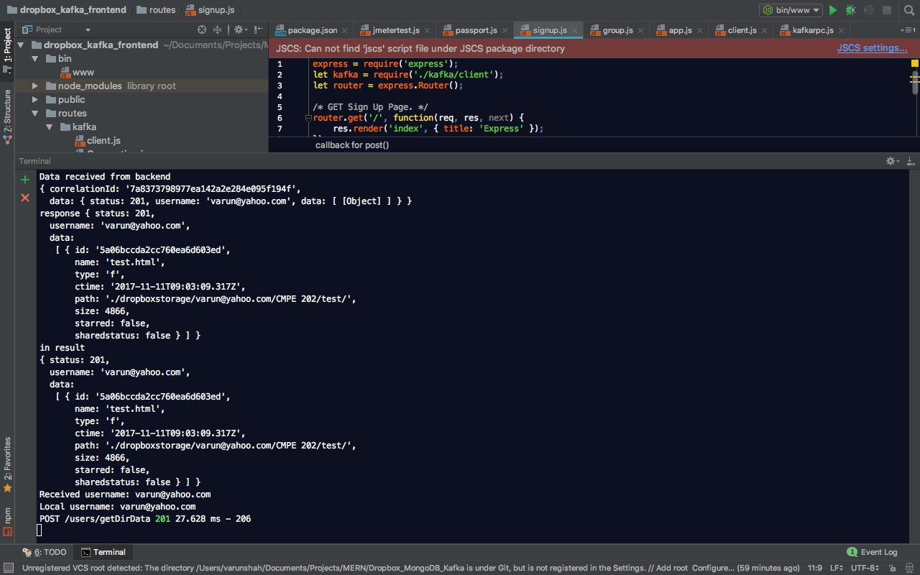

* + Kafka_Server

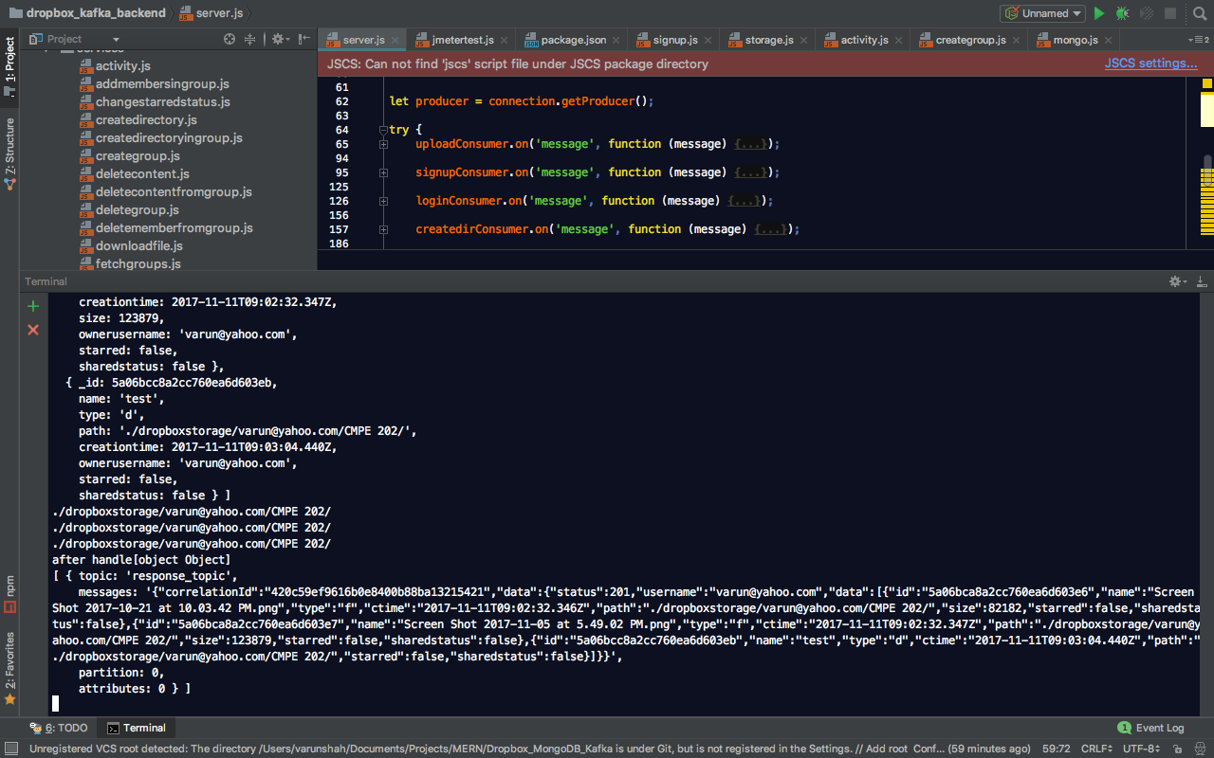

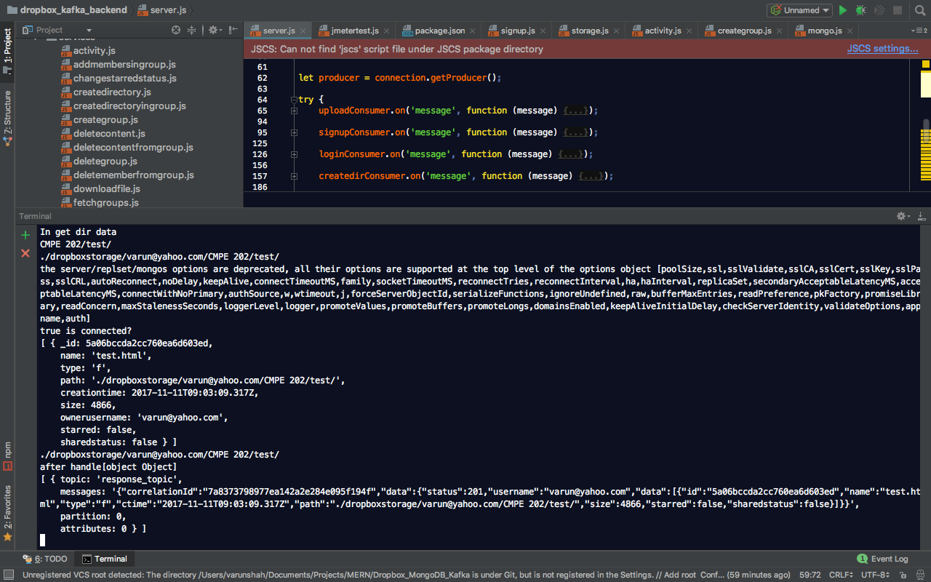

* Activity Screen
  + Client

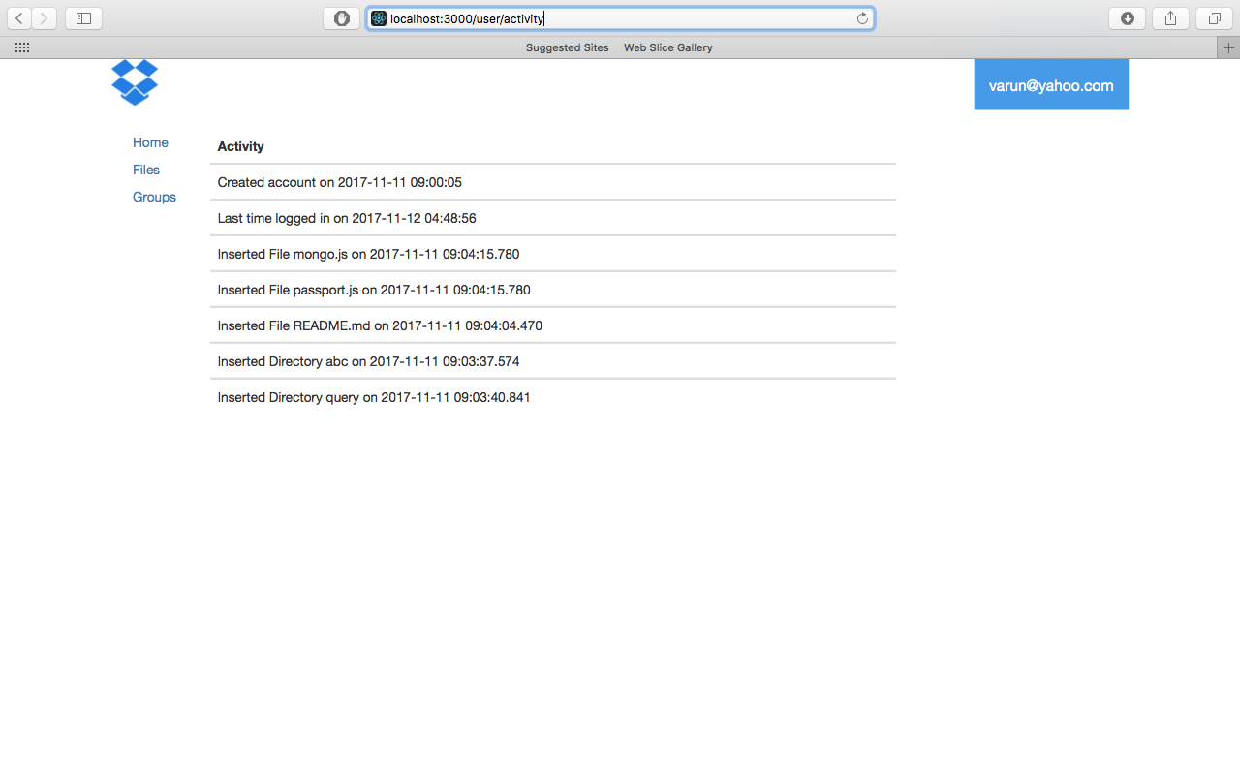

* + Kafka_Client

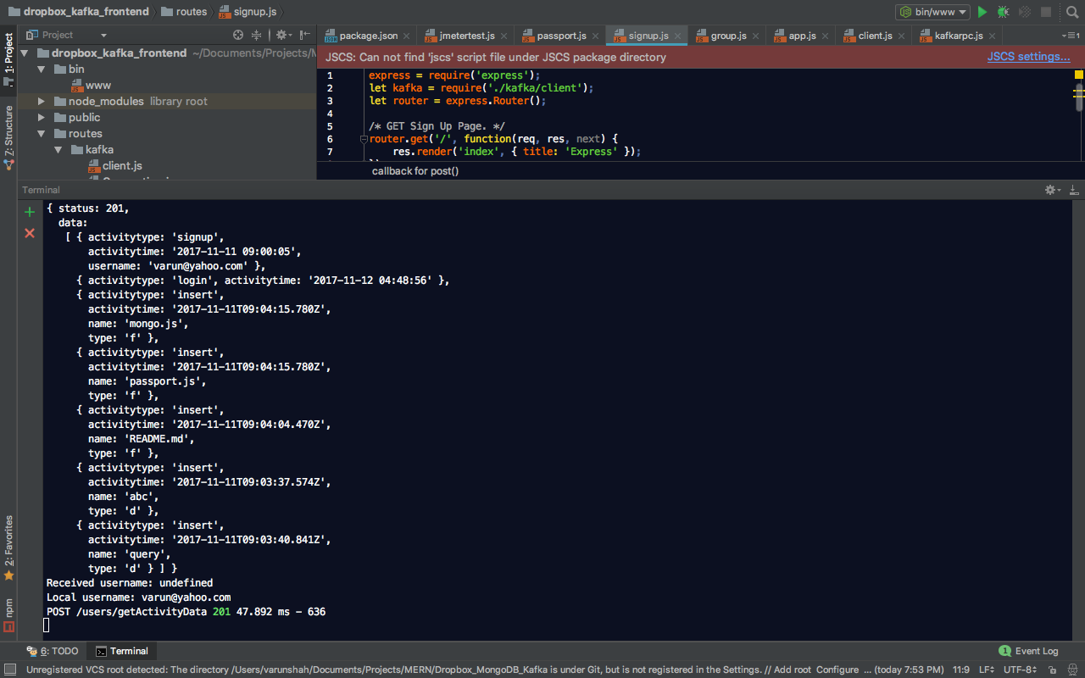

* + Kafka_Server

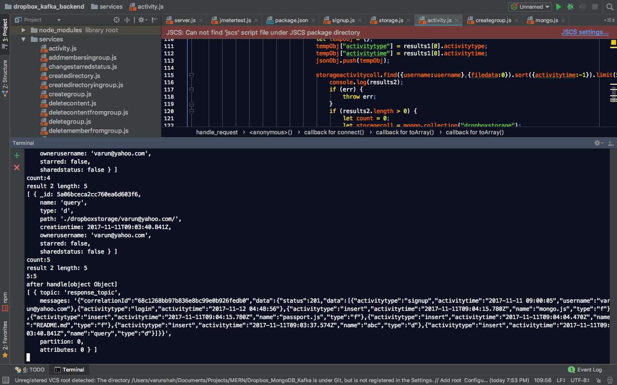

* Profile
  + Client

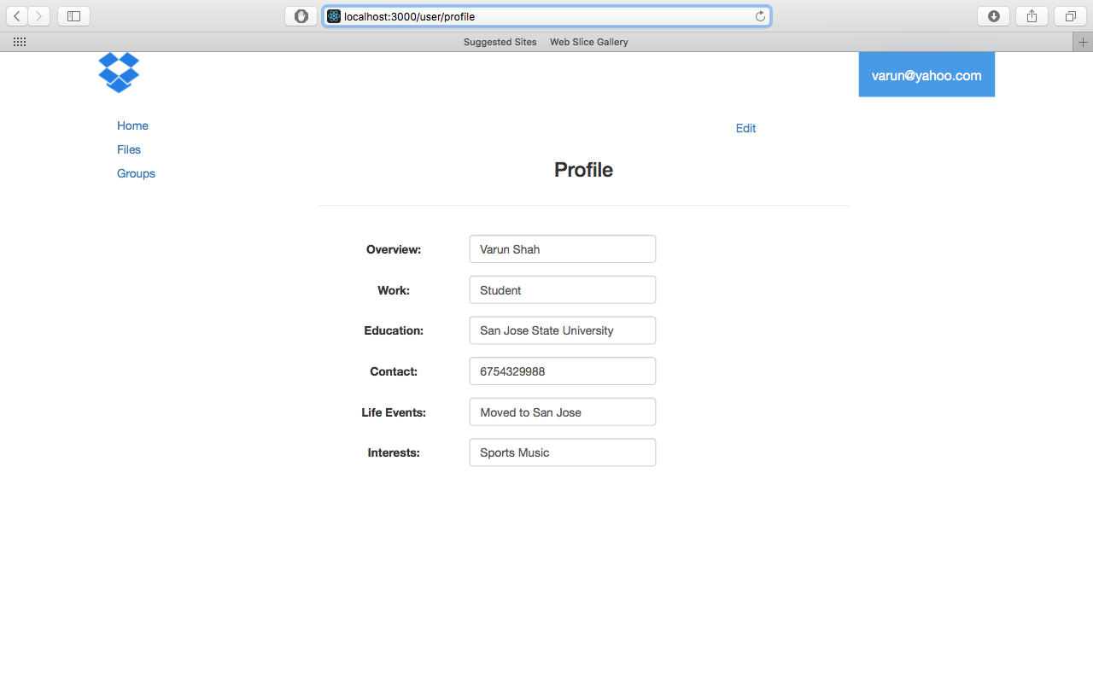

* + Kafka_Client

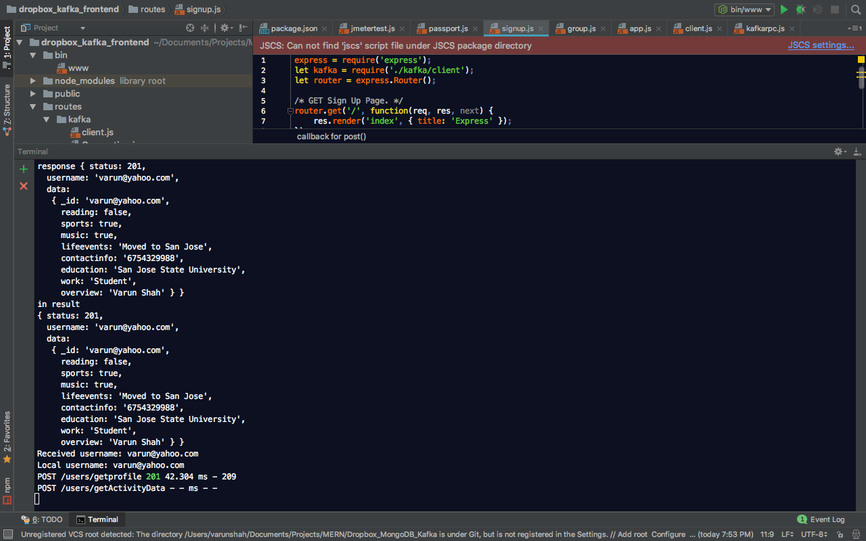

* + Kafka_Server

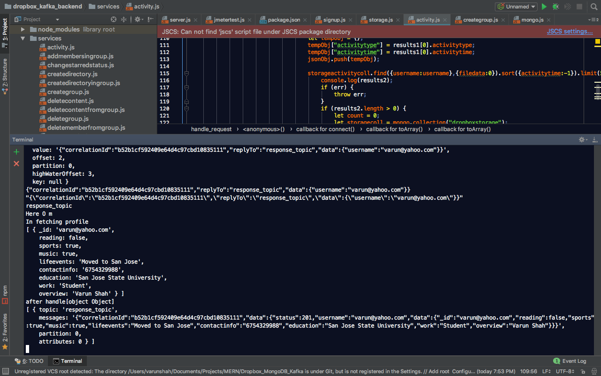

* Group

Retrieves all the groups in which user is member with the type of access and the ones where user is the group owner

* + Client

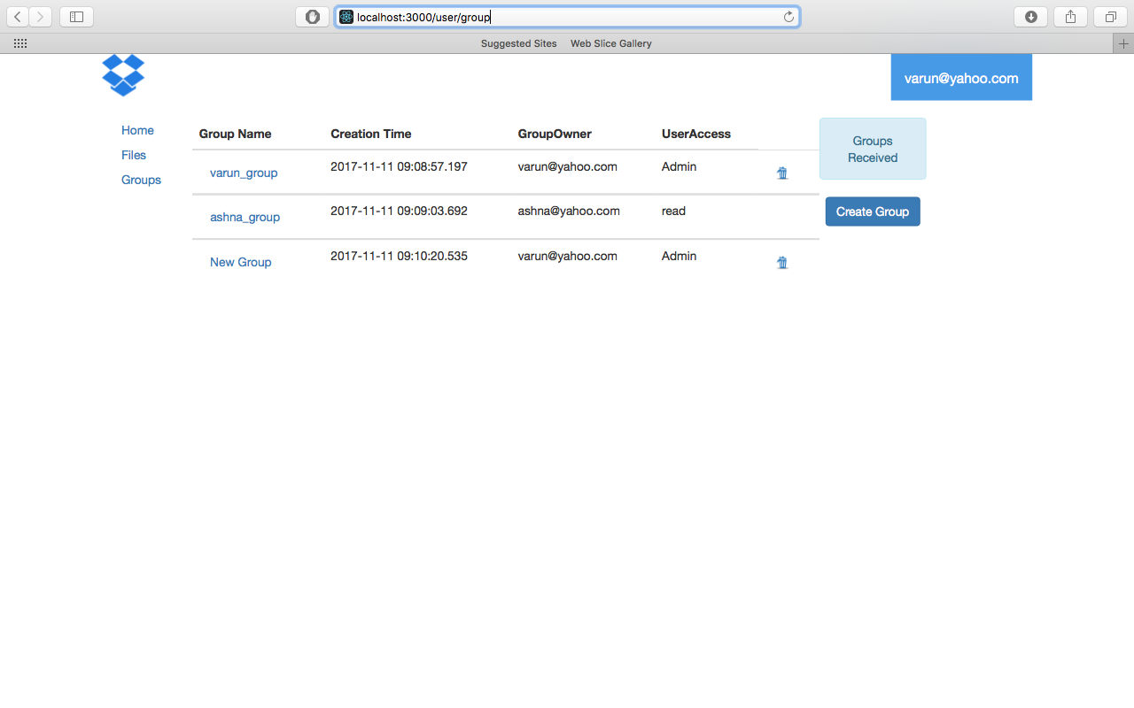

* + Kafka_Client

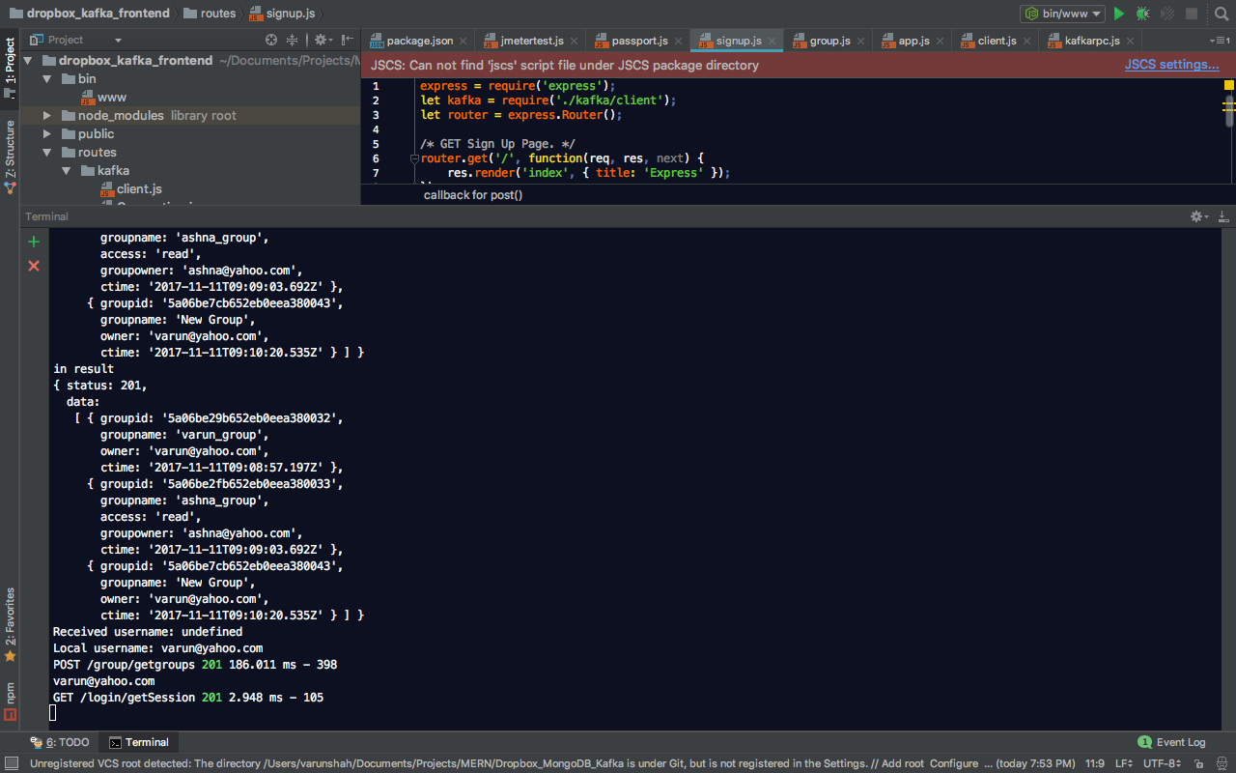

* + Kafka_Server

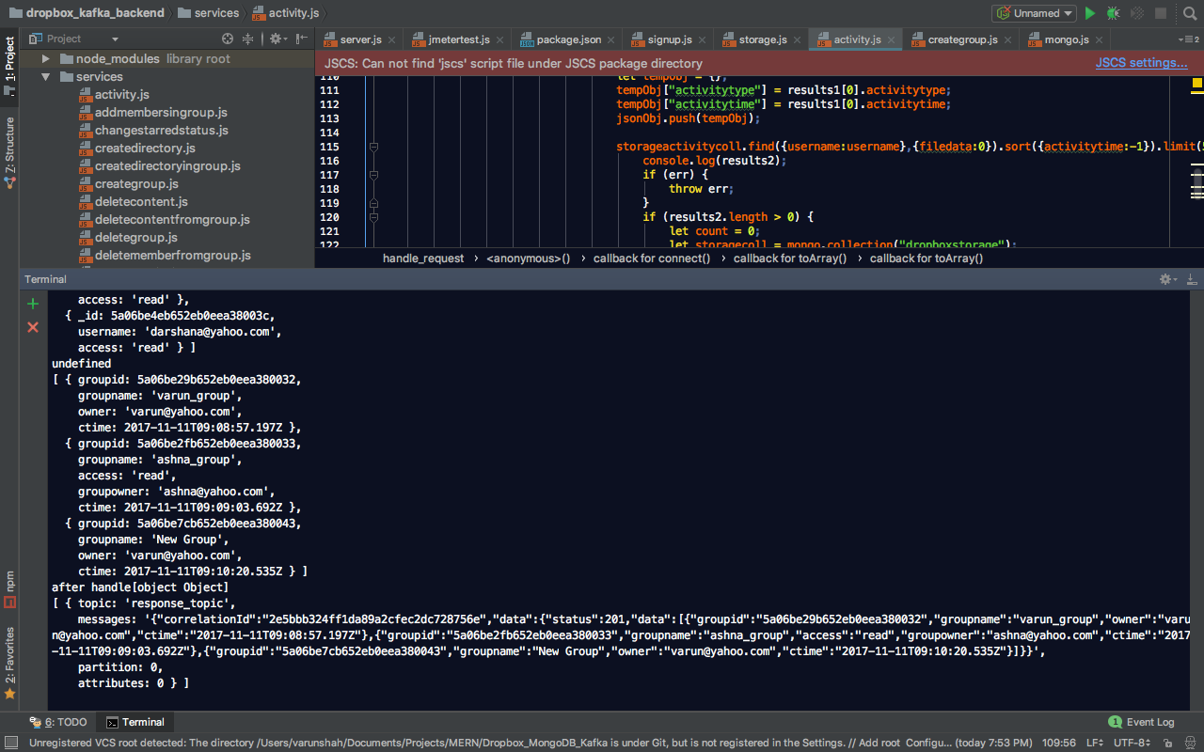

* Data in Group where user is Owner

Owner has all the rights to add/remove users and data

* + Client

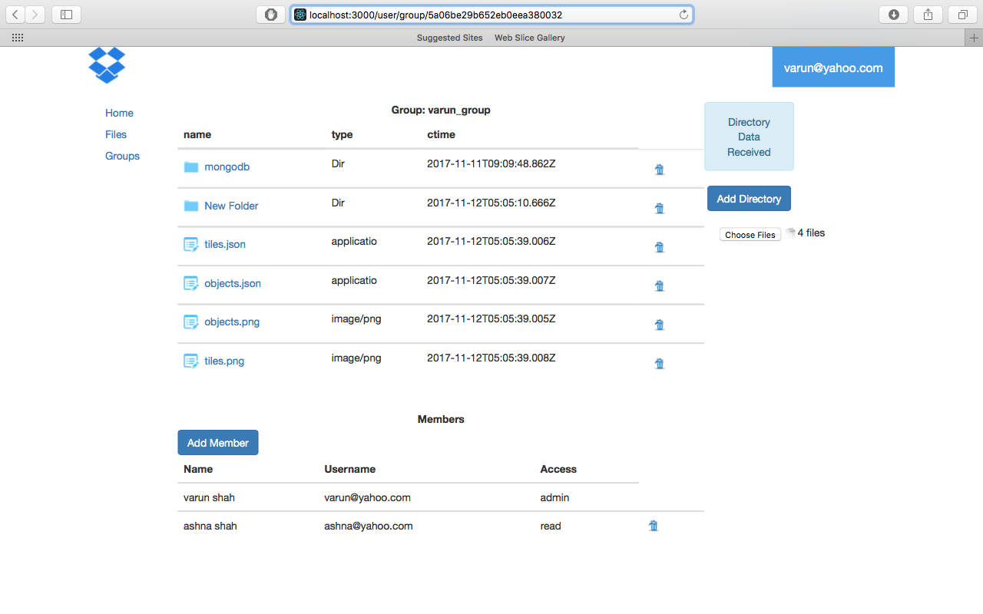

* + Kafka_Client

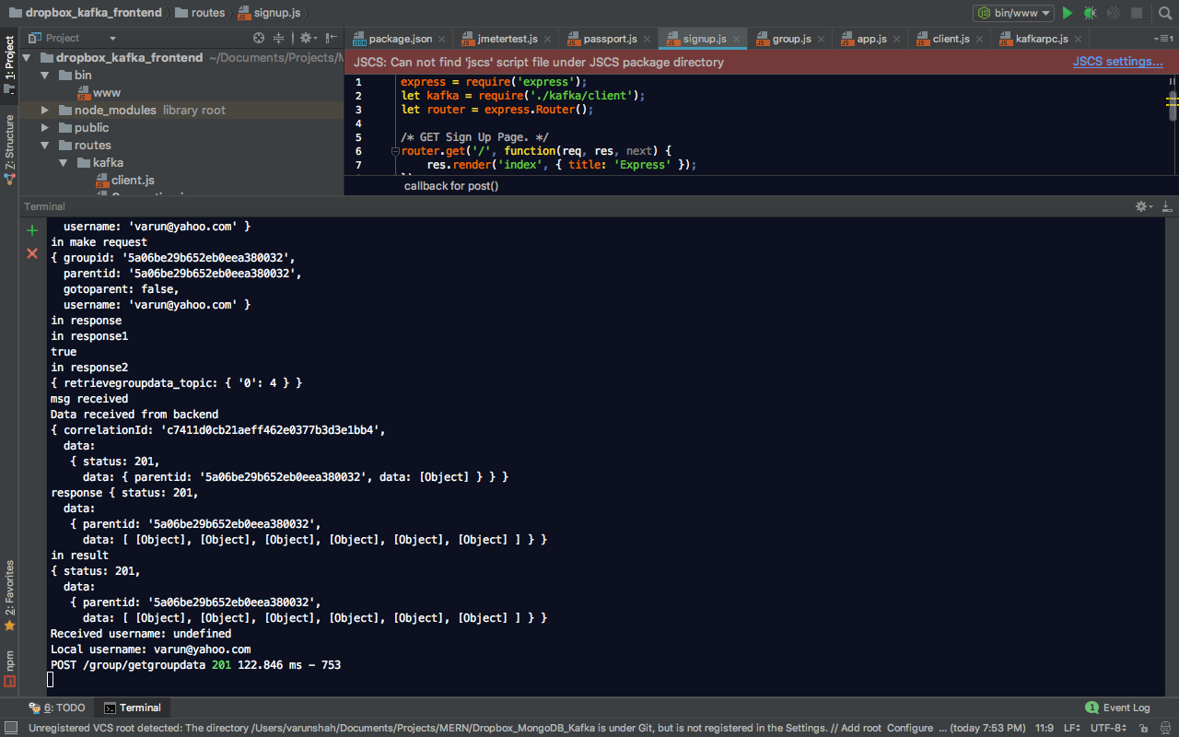

* + Kafka_Server

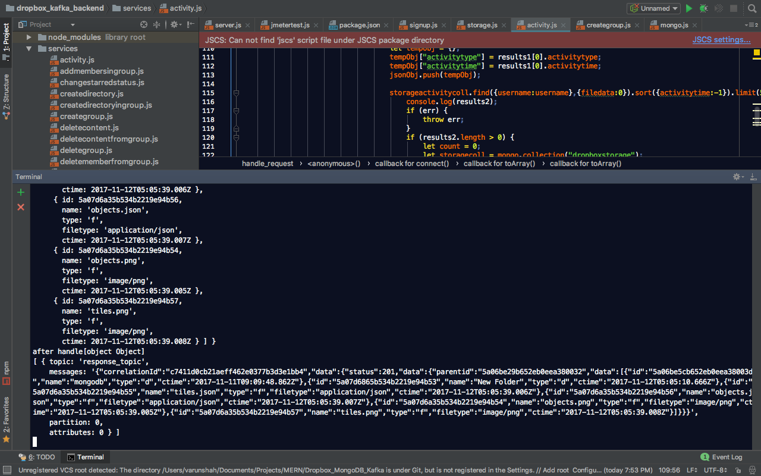

* View in Group where user is Member

Member can download data. Member cannot add members or delete data. Member can upload data only if member has the write access

* + Client

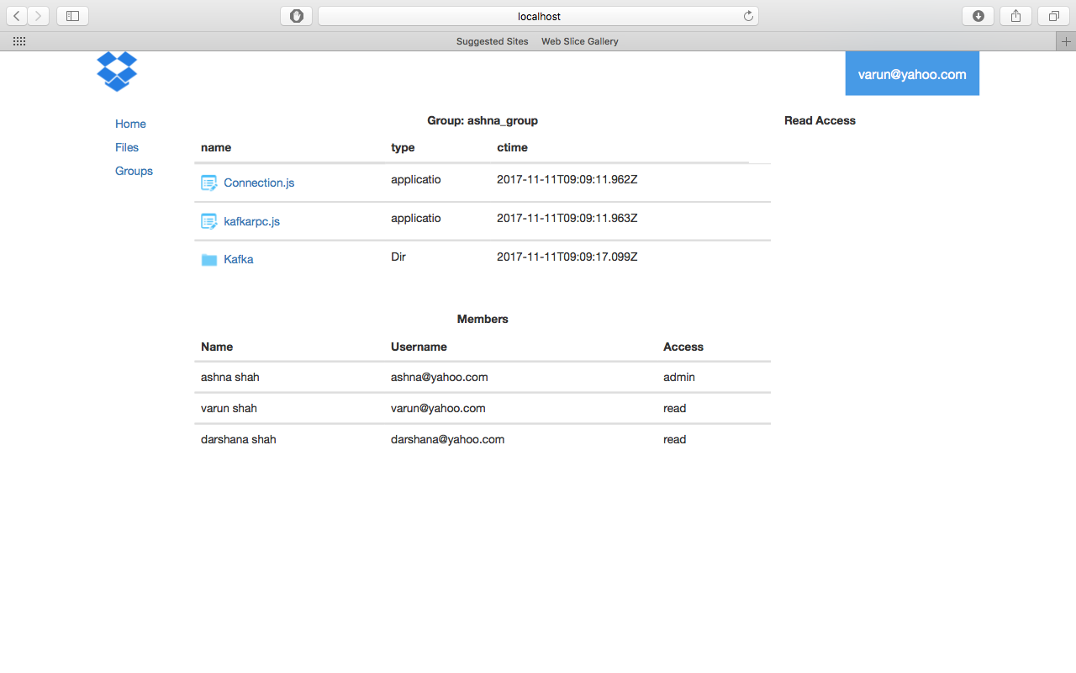

* + Kafka_Client

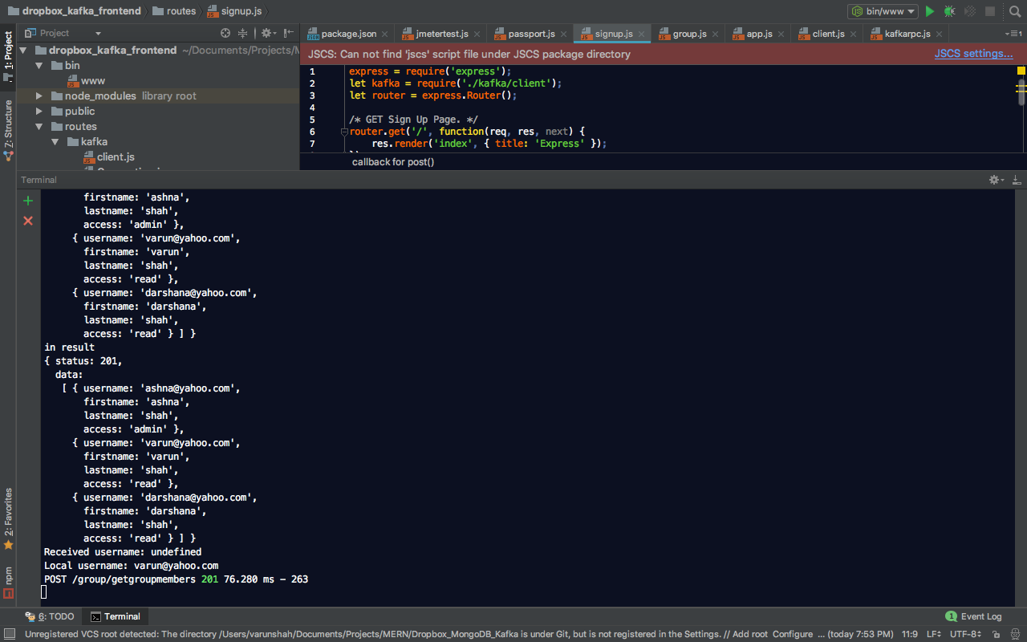

* + Kafka_Server

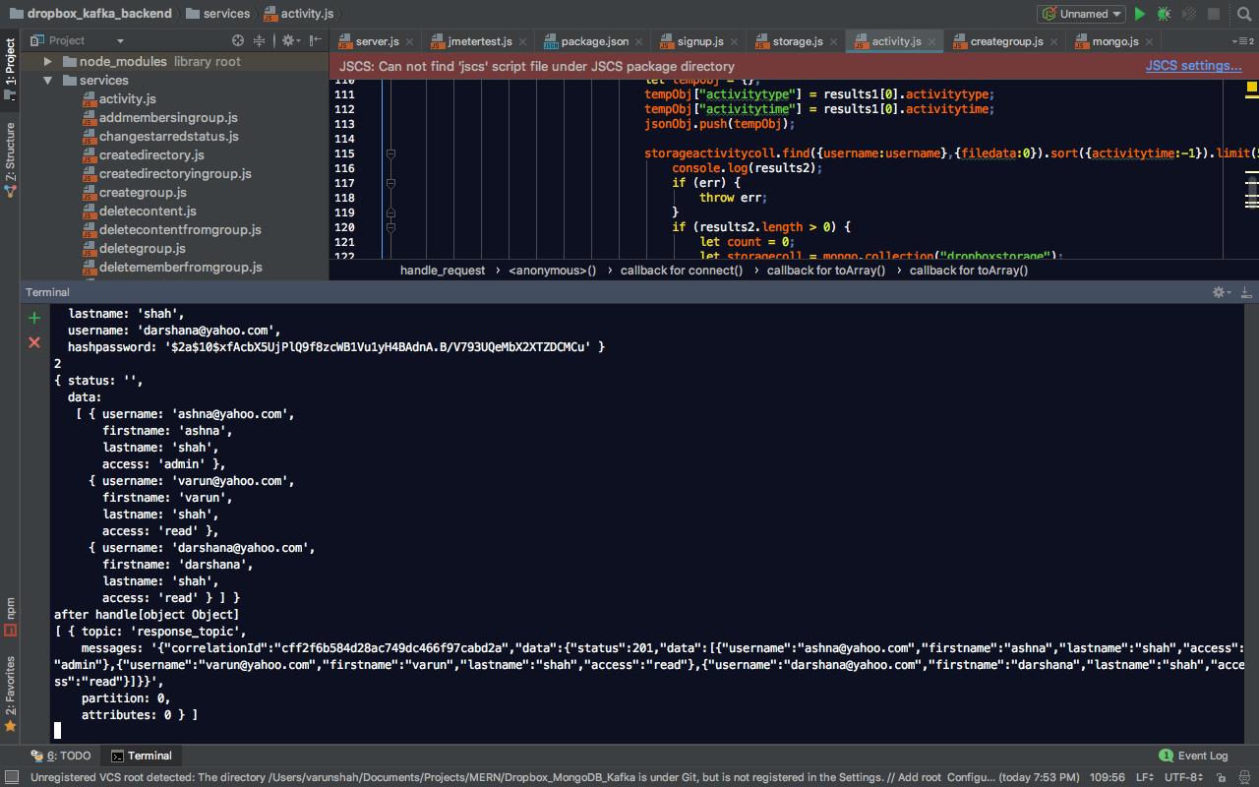

## Performance Test

* Without connection pooling
  + 100 concurrent users

Graph Result

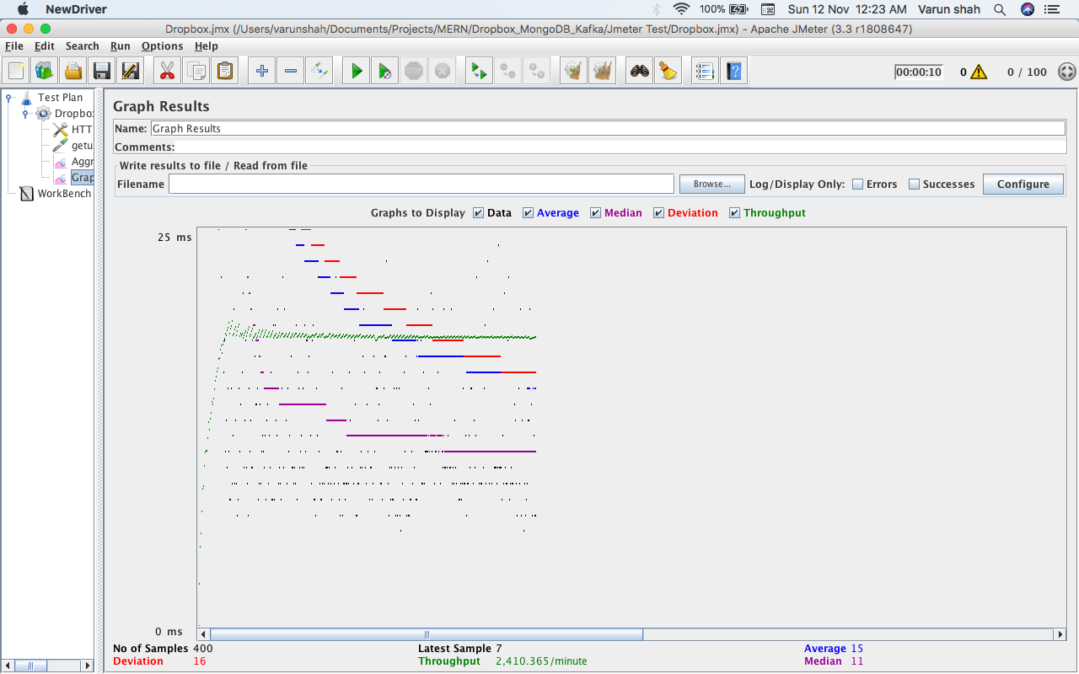

Aggregate Graph

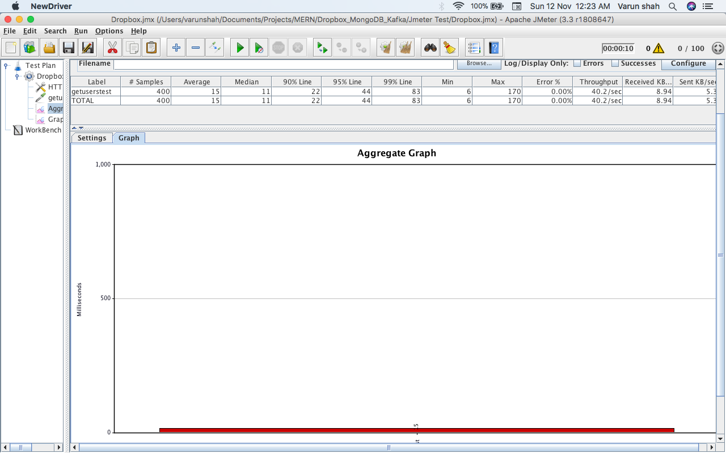

* + 200 concurrent users

Graph Result

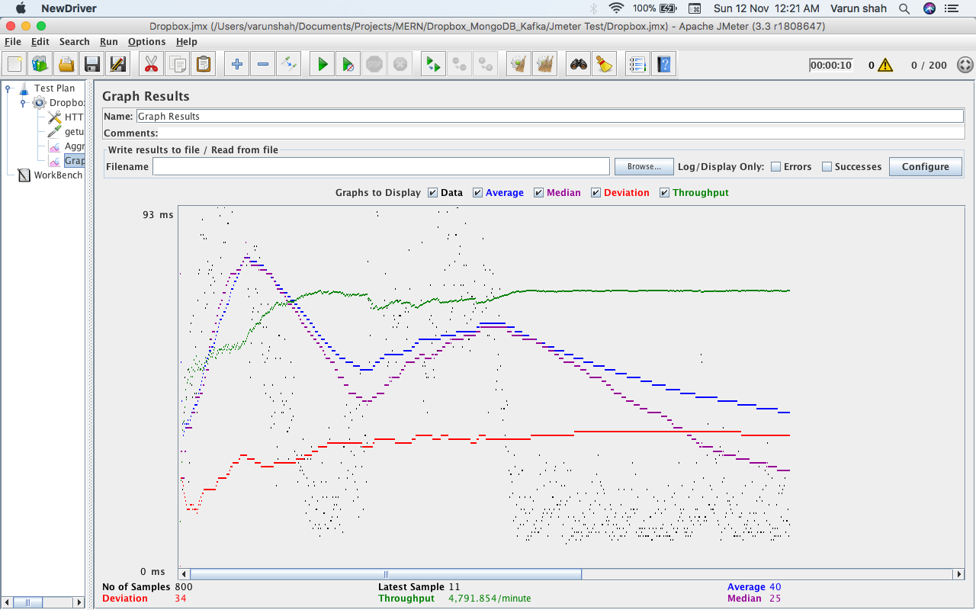

Aggregate Graph

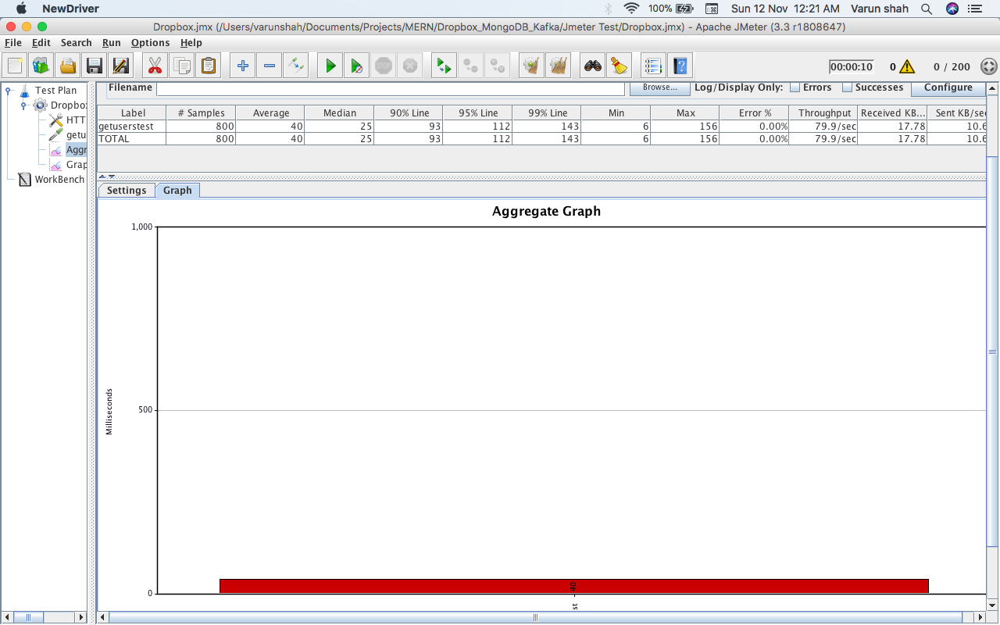

* + 300 concurrent users

Graph Result

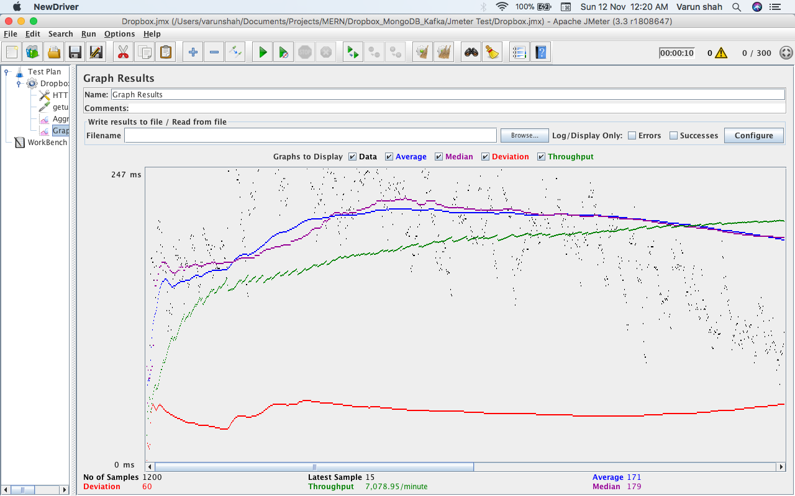

Aggregate Graph

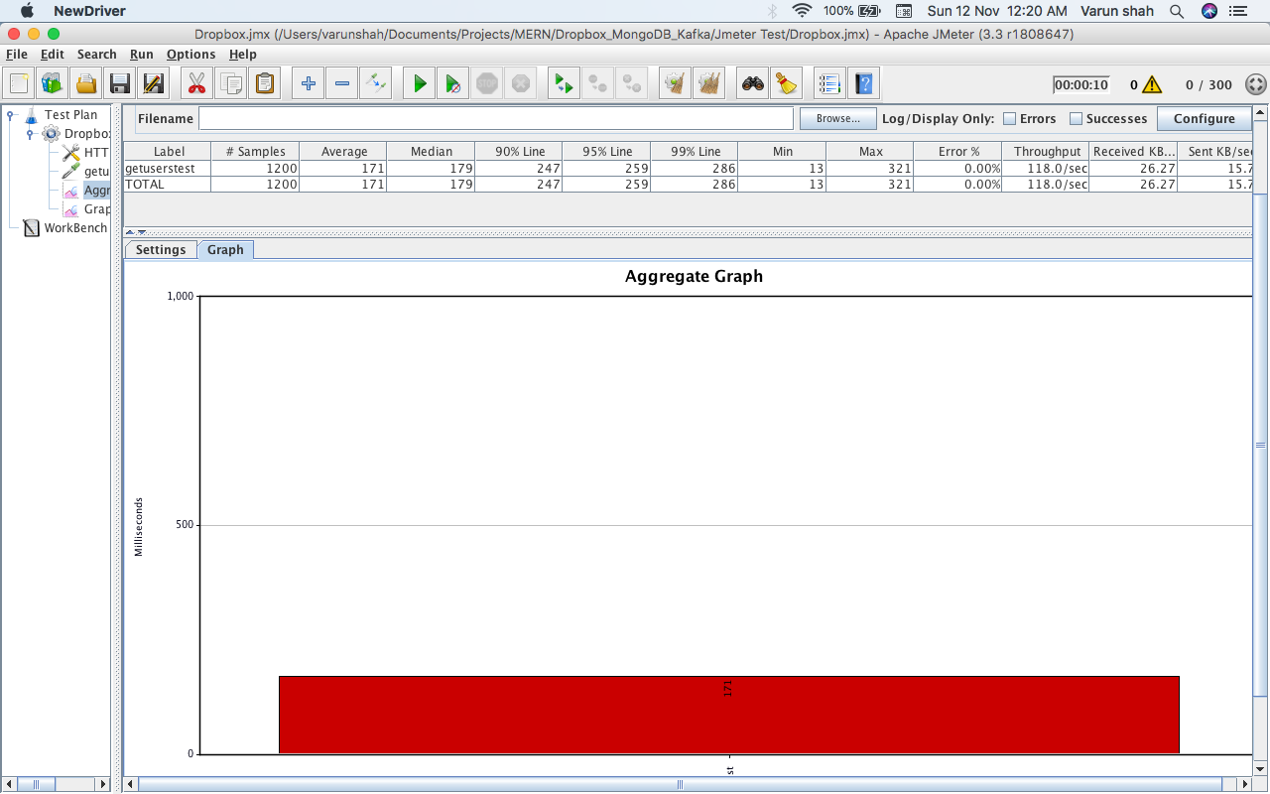

* + 400 concurrent users

Graph Result

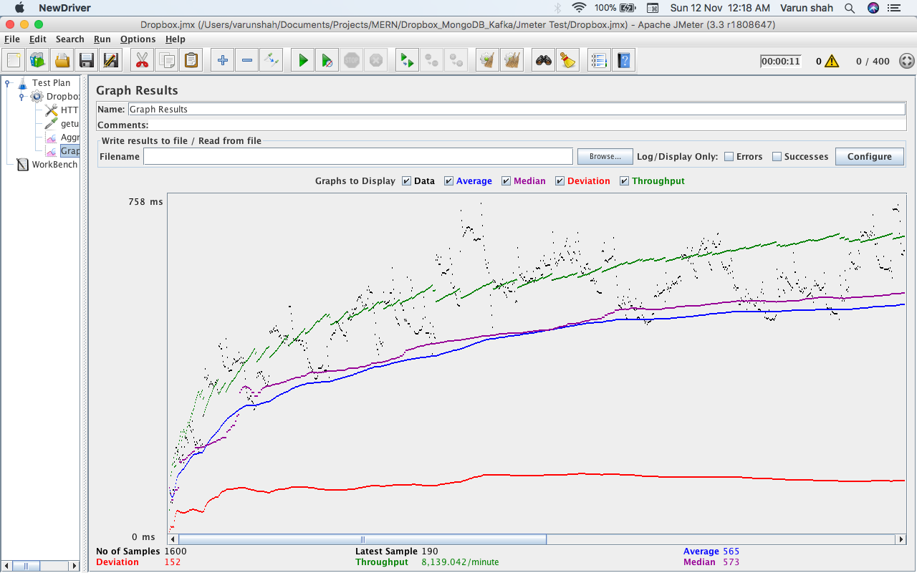

Aggregate Graph

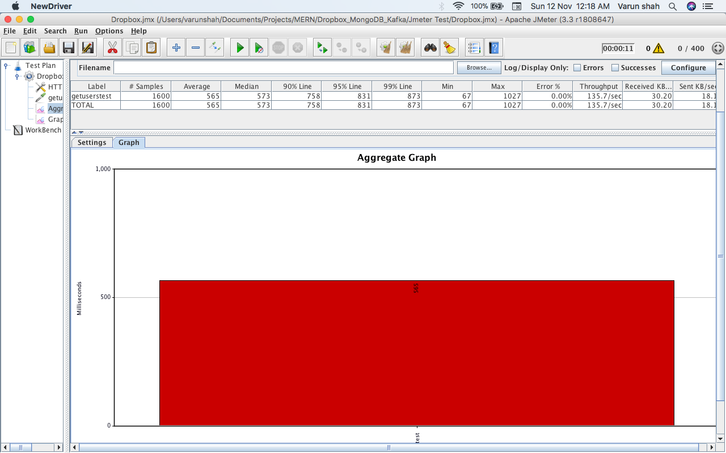

* + 500 concurrent users

Graph Result

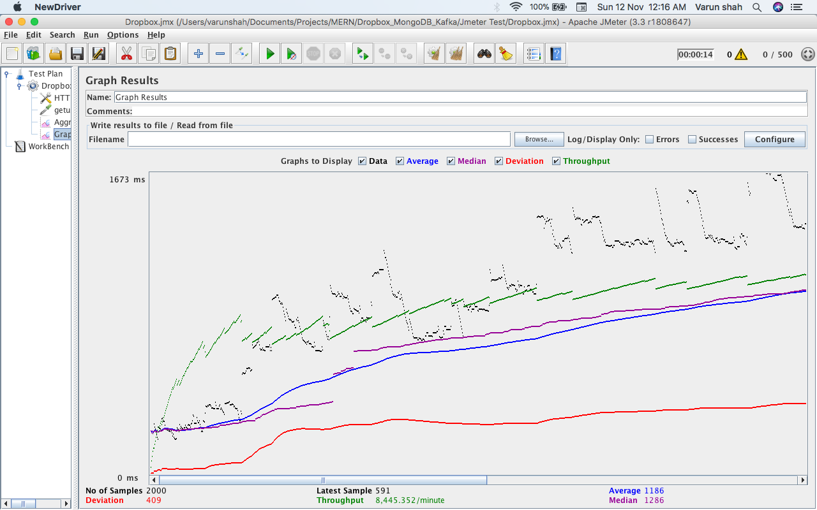

Aggregate Graph

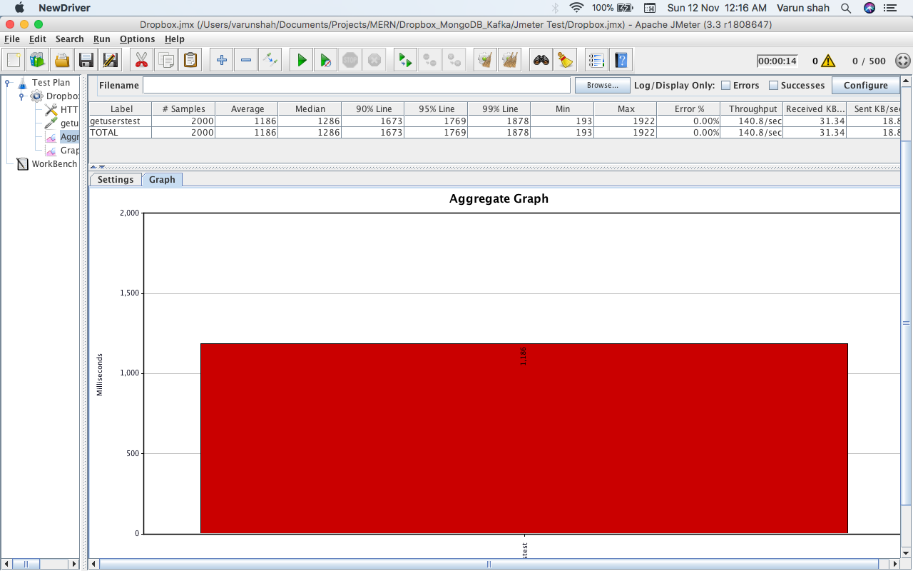

* MongoDB provided connection pooling
  + 100 concurrent users

Graph Result:

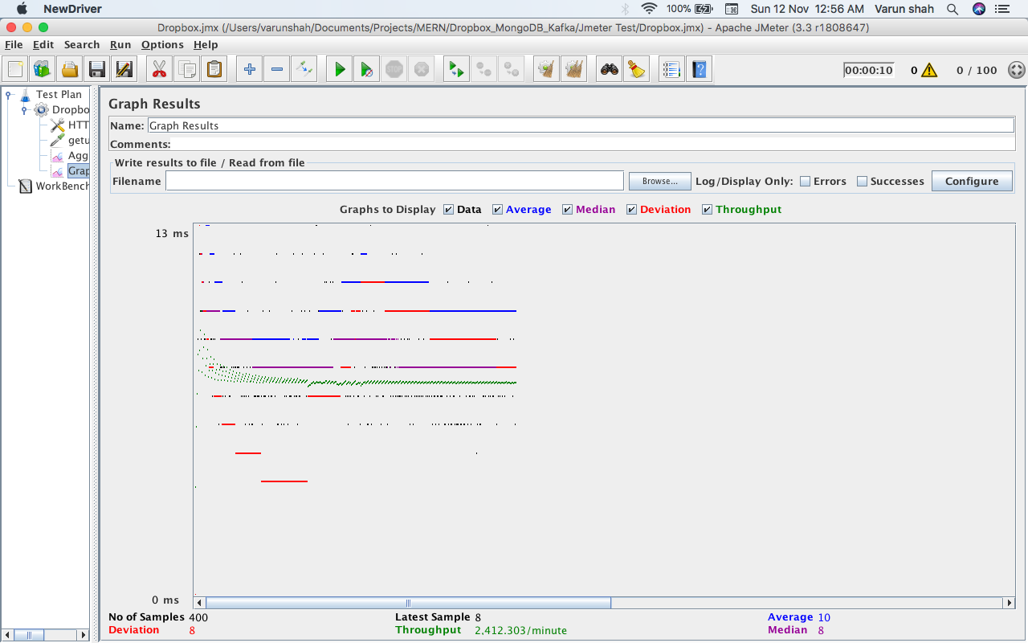

Aggregate Graph:

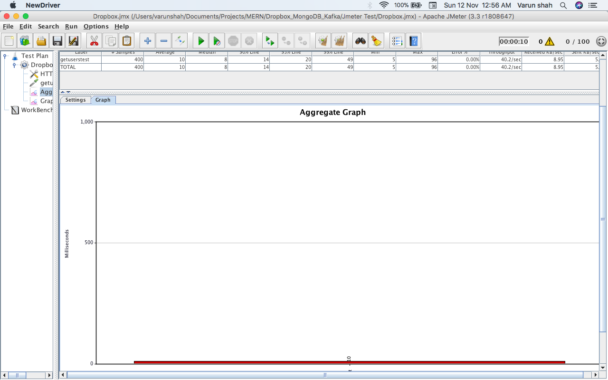

* + 200 concurrent users

Graph Result:

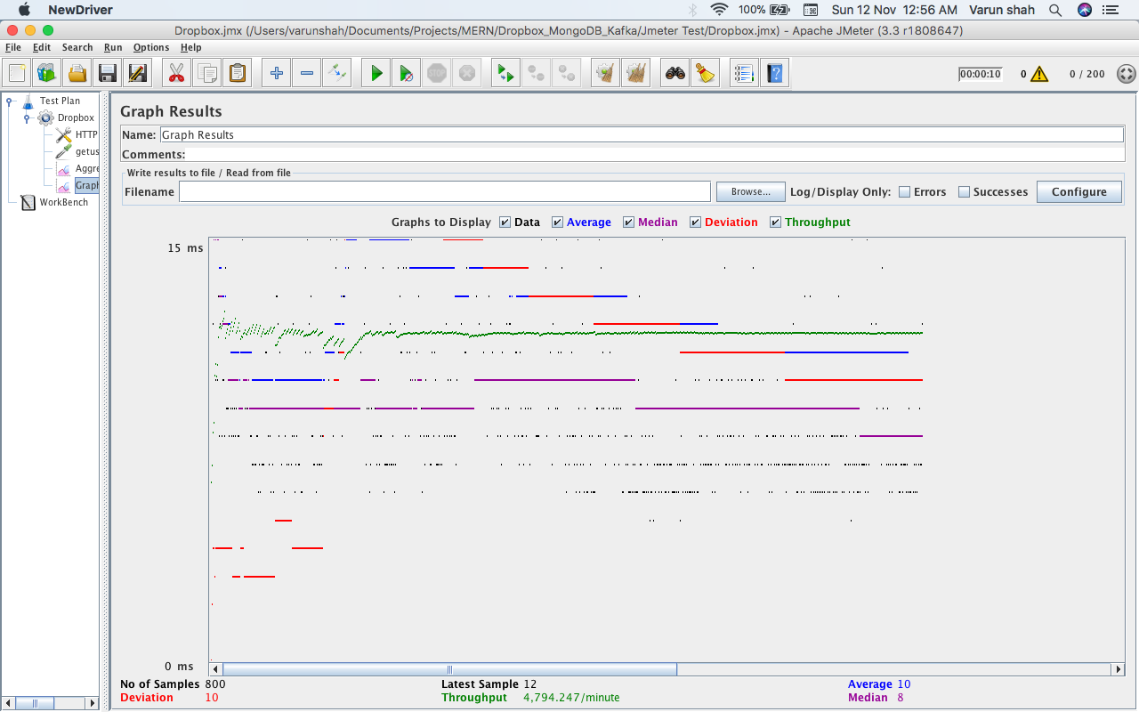

Aggregate Graph:

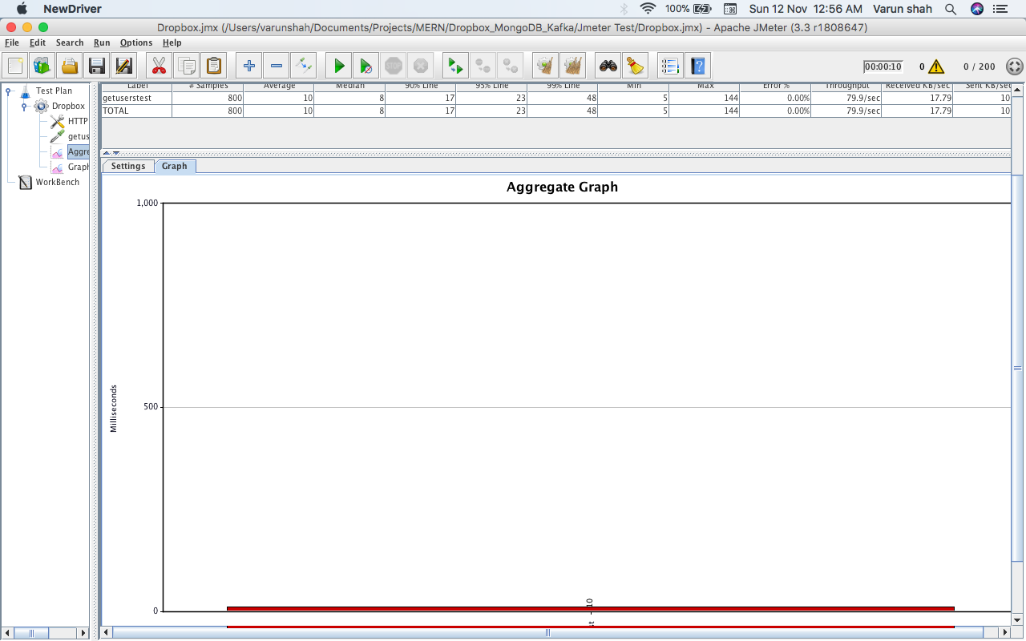

* + 300 concurrent users

Graph Result:

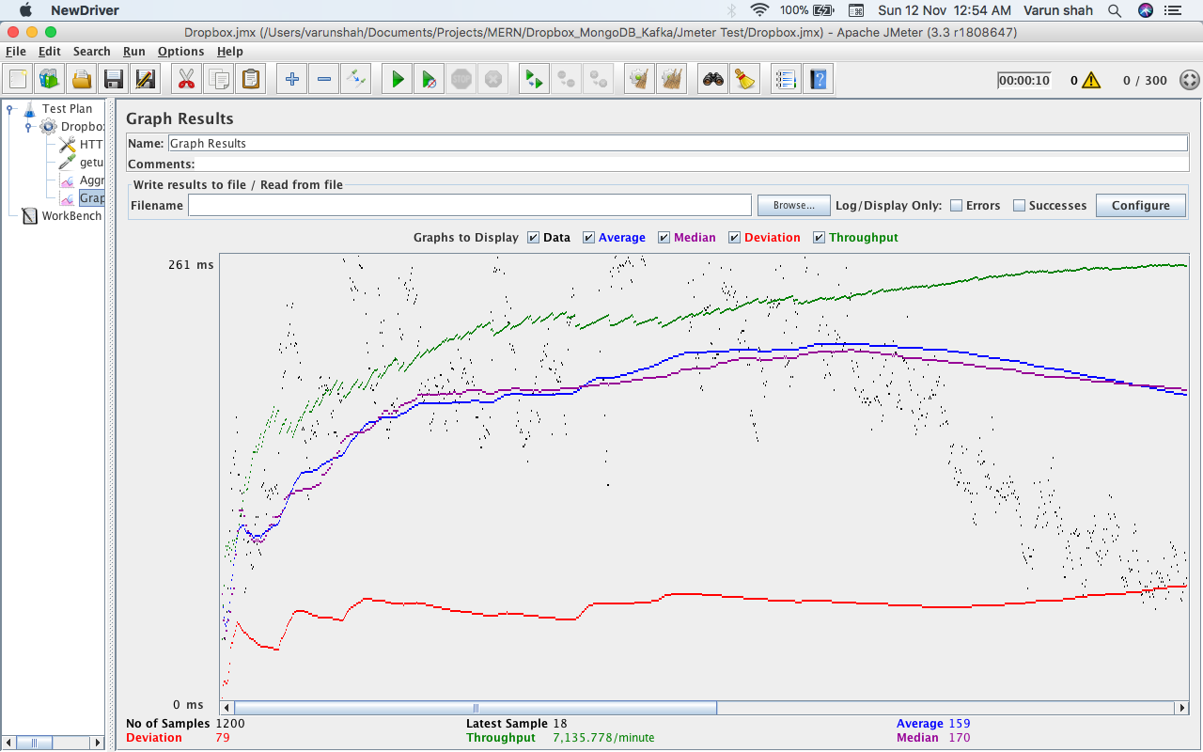

Aggregate Graph:

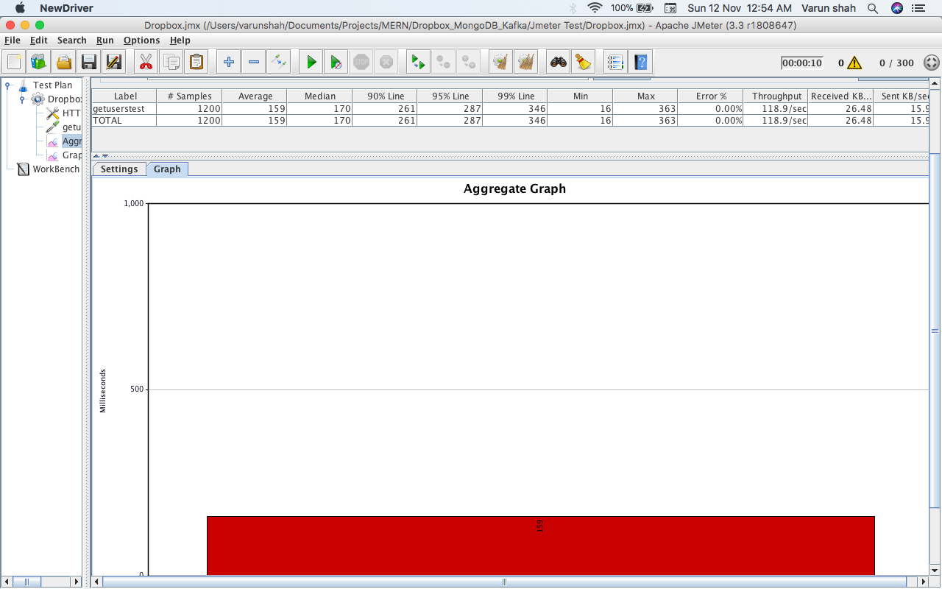

* + 400 concurrent users

Graph Result:

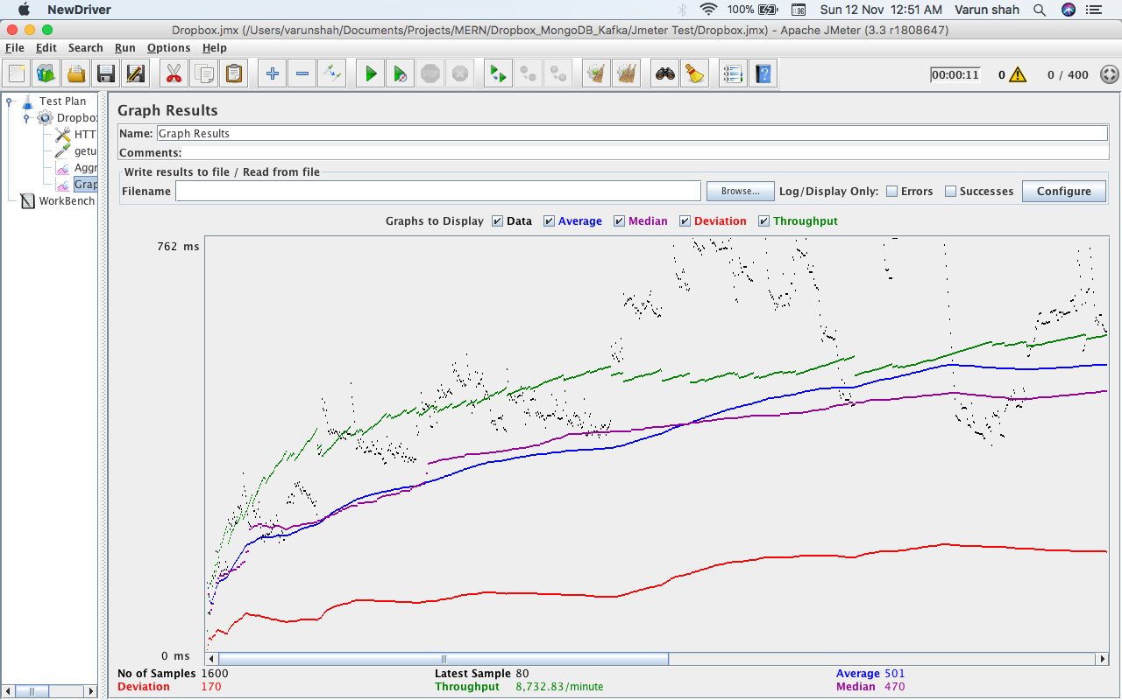

Aggregate Graph:

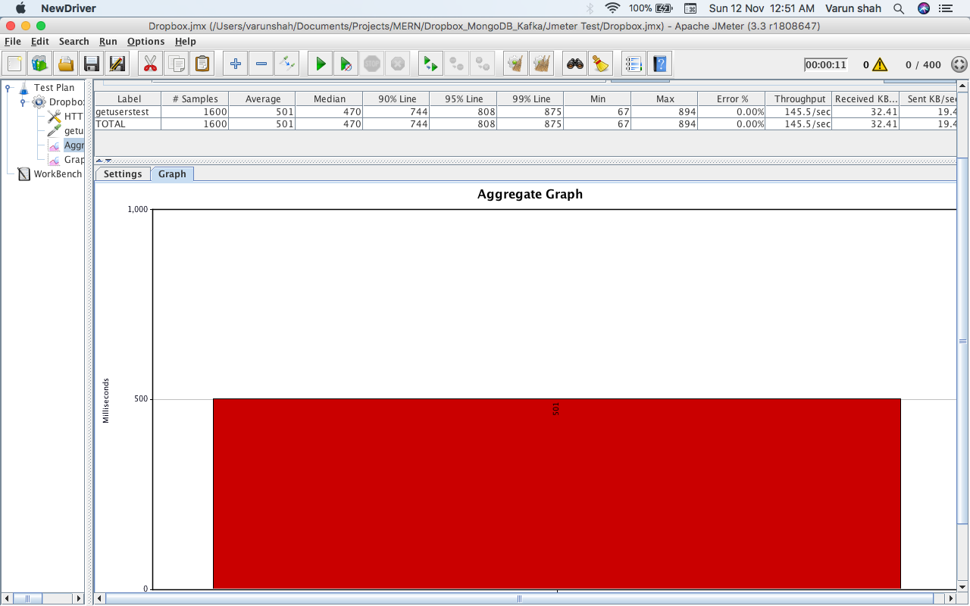

* + 500 concurrent users

Graph Result:

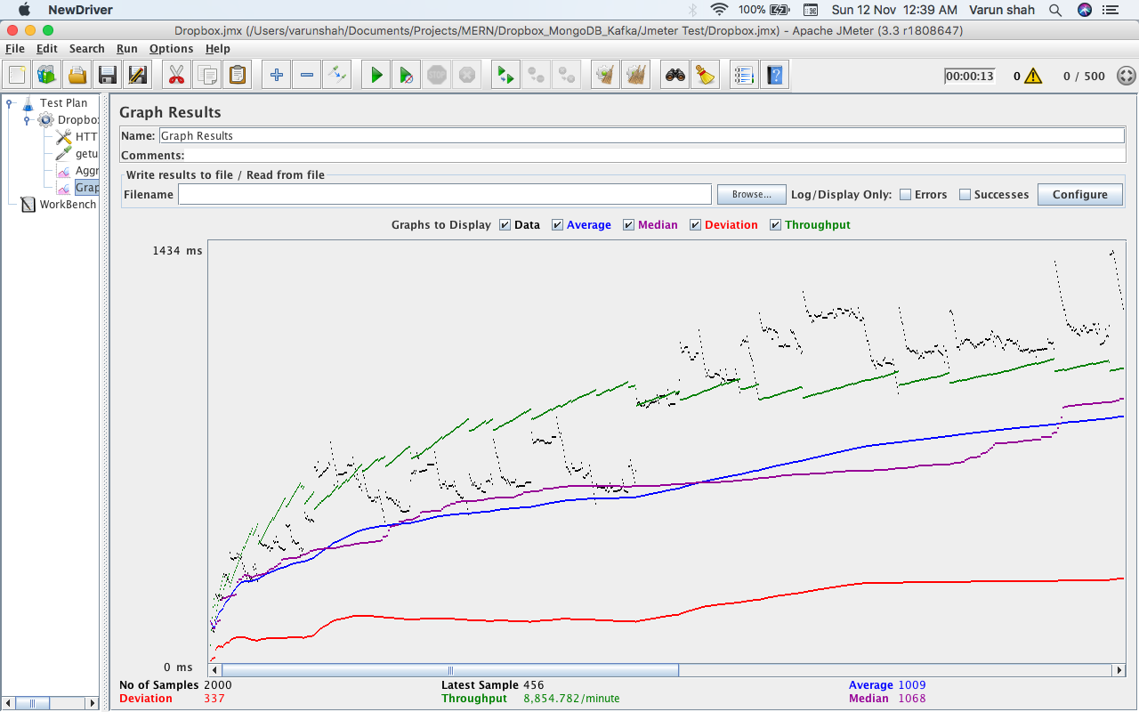

Aggregate Graph:

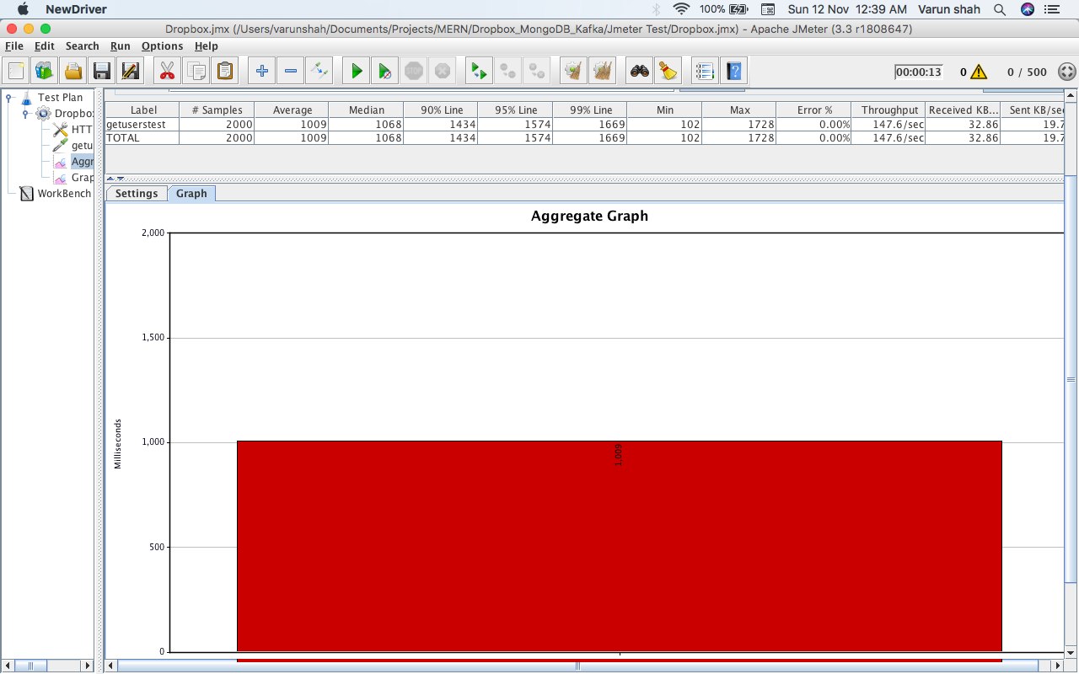

* With own implementation of connection pooling
  + 100 concurrent users

Graph Result:

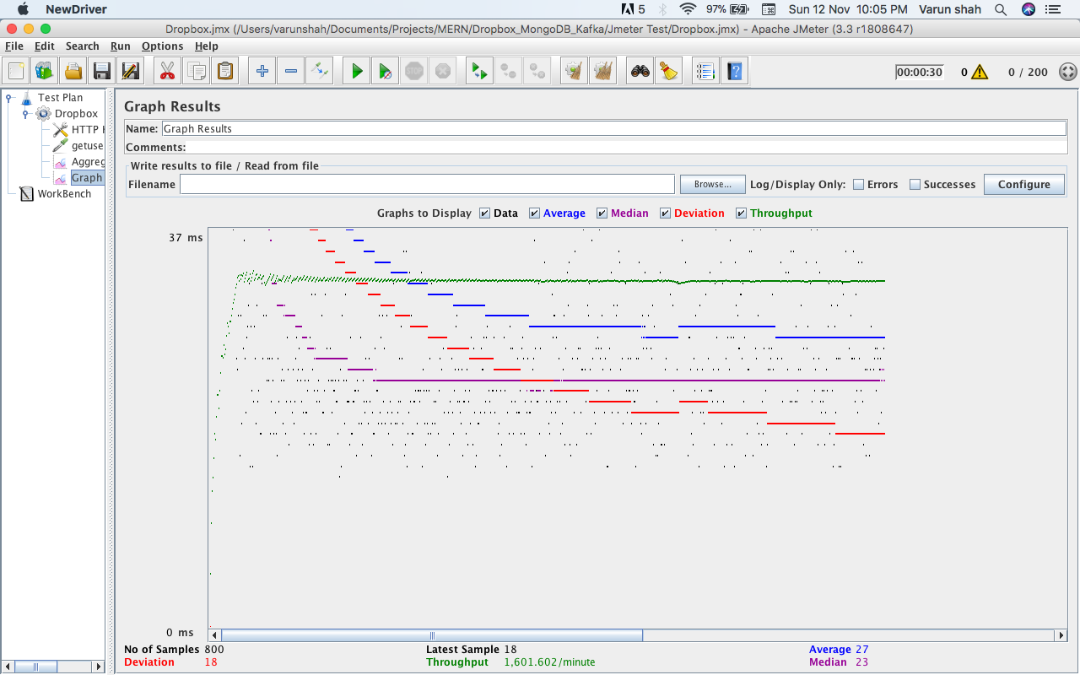

Aggregate Graph:

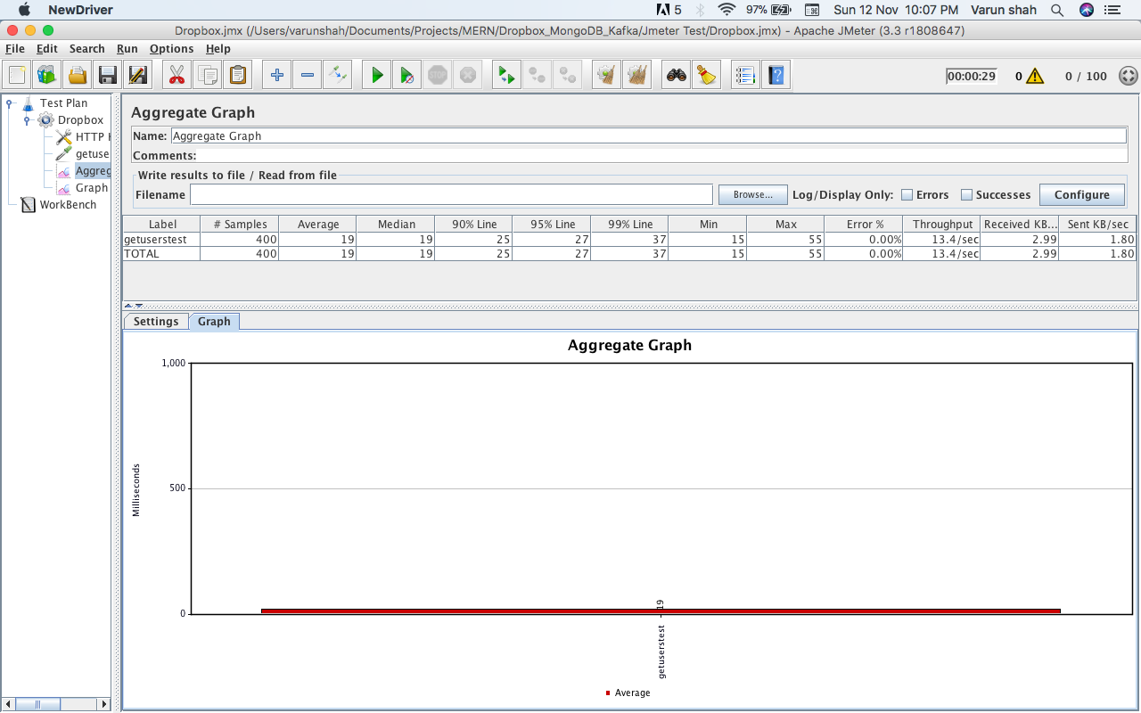

* + 200 concurrent users

Graph Result:



Aggregate Graph:

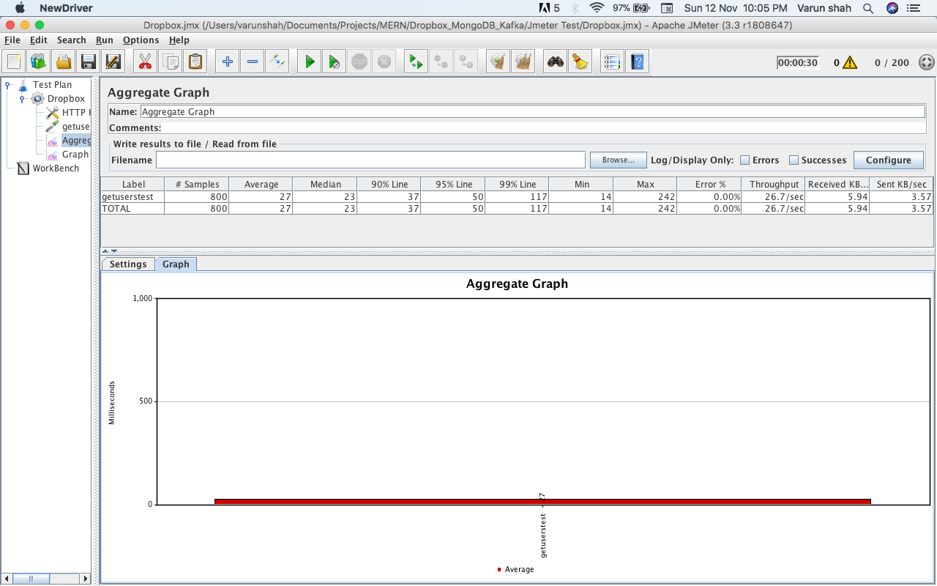

* + 300 concurrent users

Graph Result:

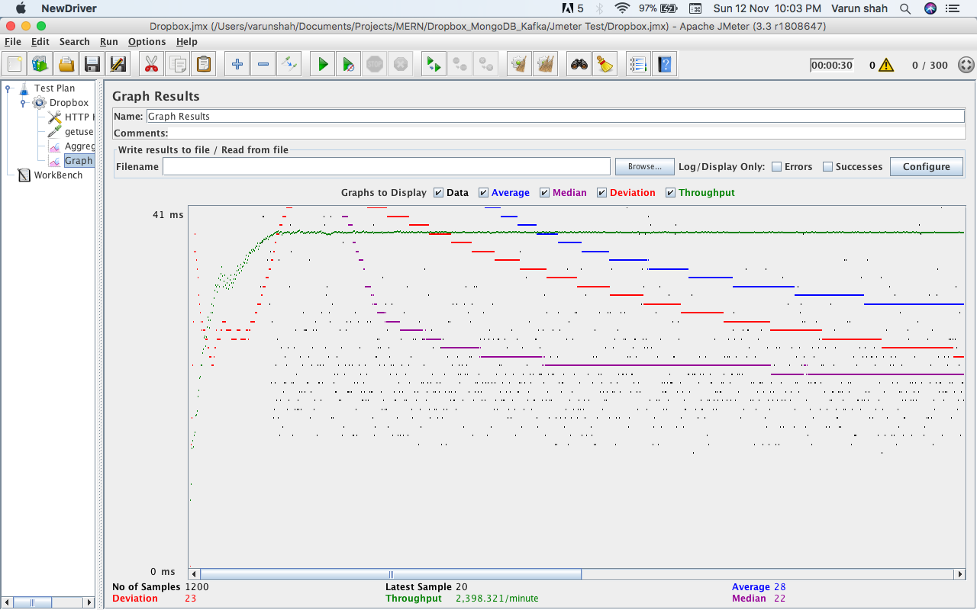

Aggregate Graph:

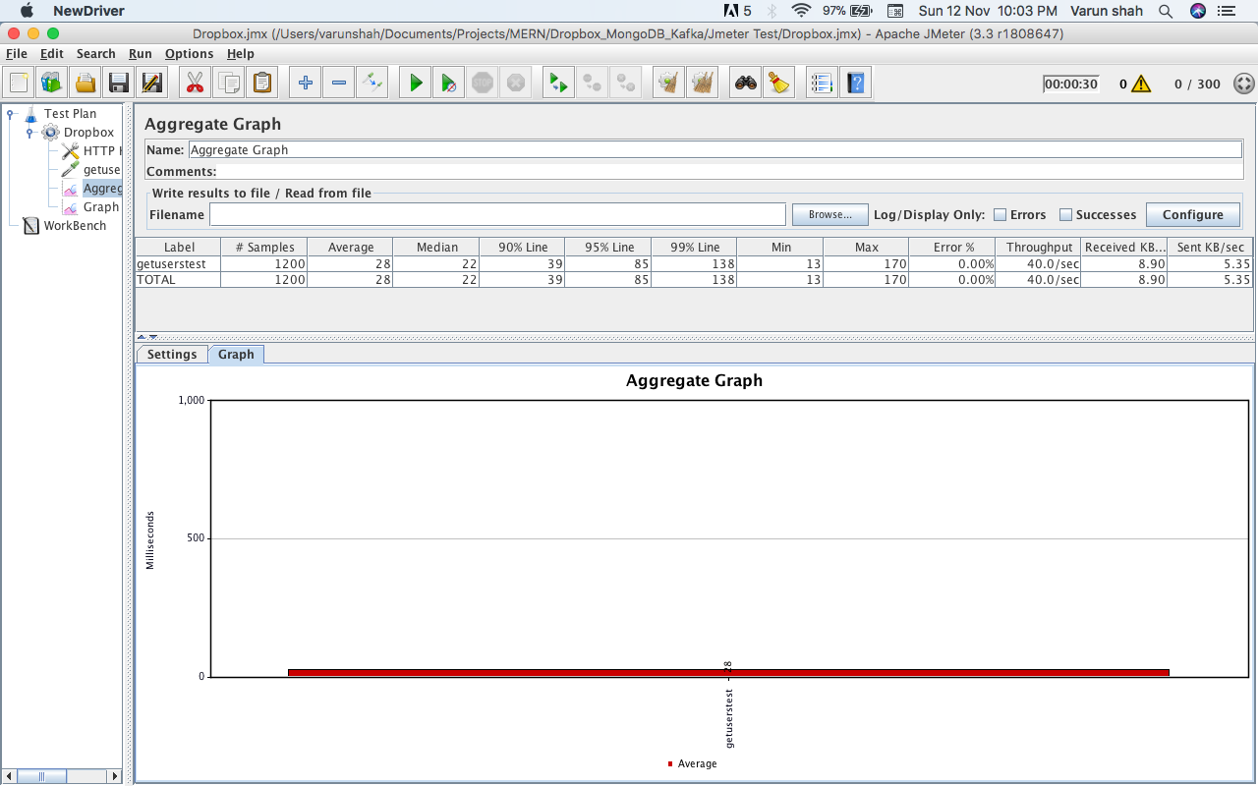

* + 400 concurrent users

Graph Result:

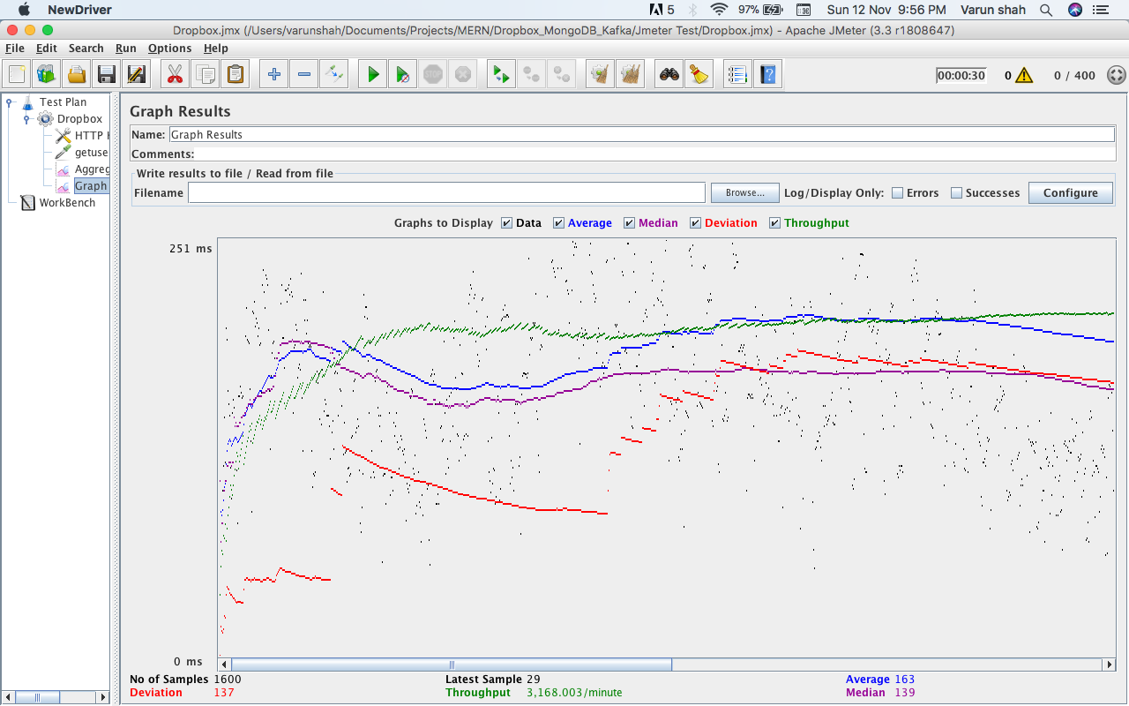

Aggregate Graph:

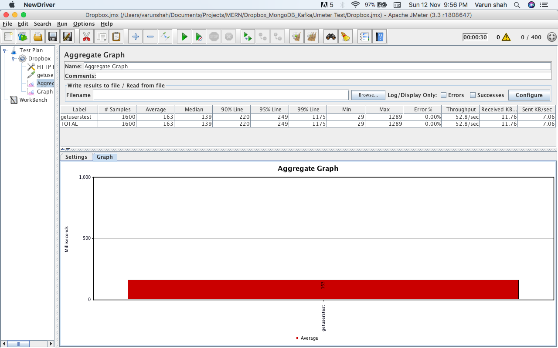

* + 500 concurrent users

Graph Result:

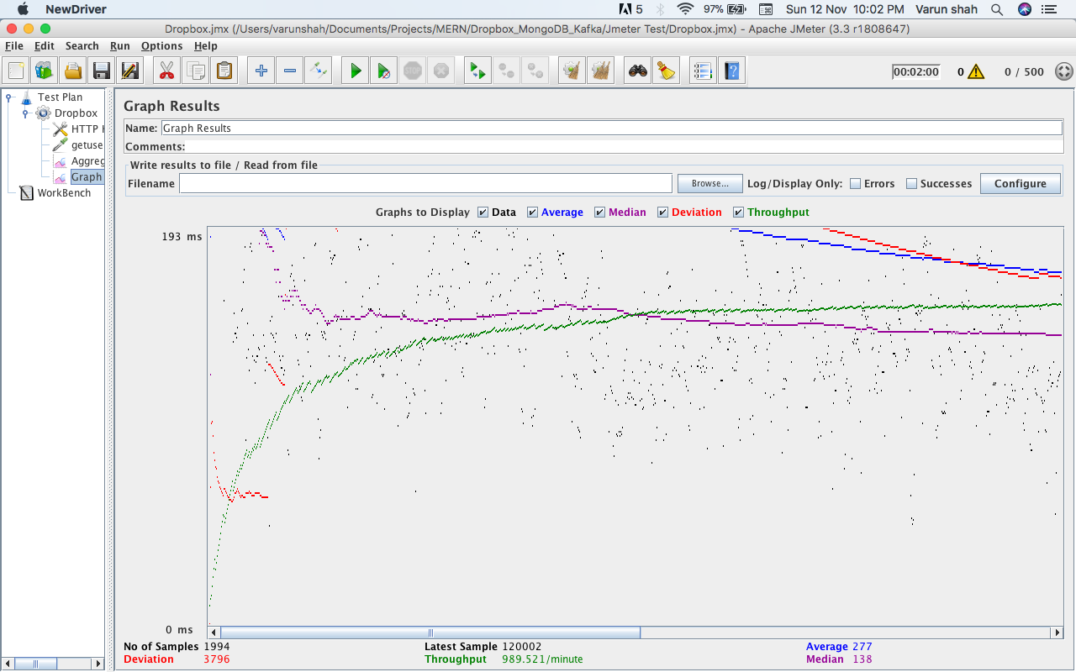

Aggregate Graph:

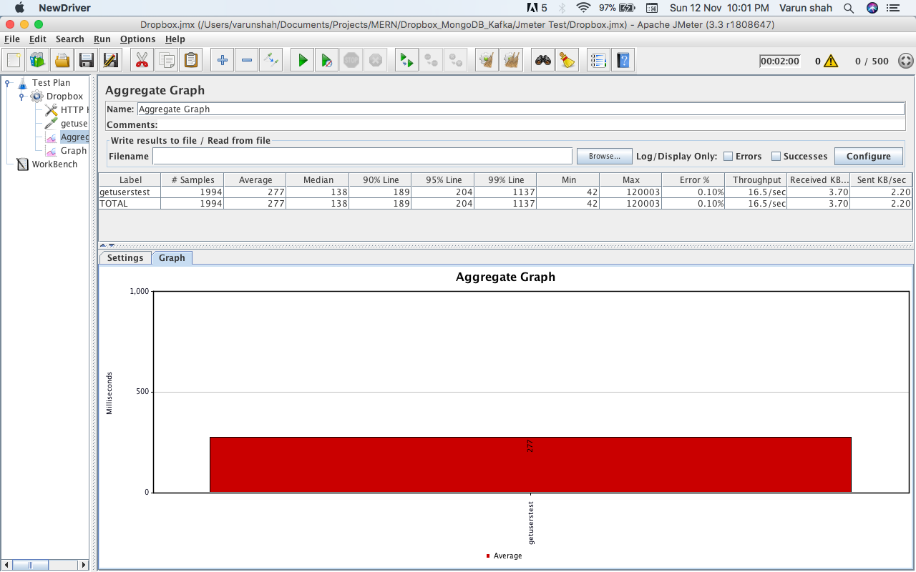

## Performance Analysis

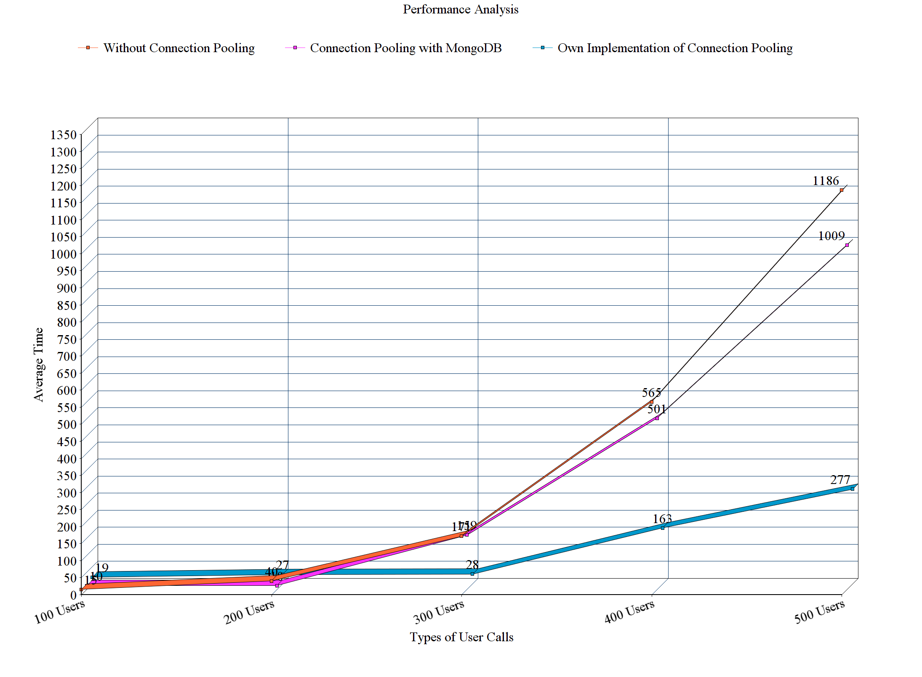

Above figure depicts summary of following Test:

1. Without Connection Pooling
2. With MongoDB Provided Connection Pooling
3. With Own Implementation of Connection Pooling

Own Implementation of connection pooling provides best average time in compare to other two. In MongoDB provided connection pool and own implementation Pool size is kept 10. In Own Connection Pooling Implementation 10 DB objects were created and were assigned to every new request from pool. Once used kept back to the pool and as new request arises database object was given to that request. In conclusion, Own Implemented Connection Pooling provides better performance than without connection pool and DB provided connection pool.

## Unit Test

1. Test to fetch latest activities of the user

* Test Output

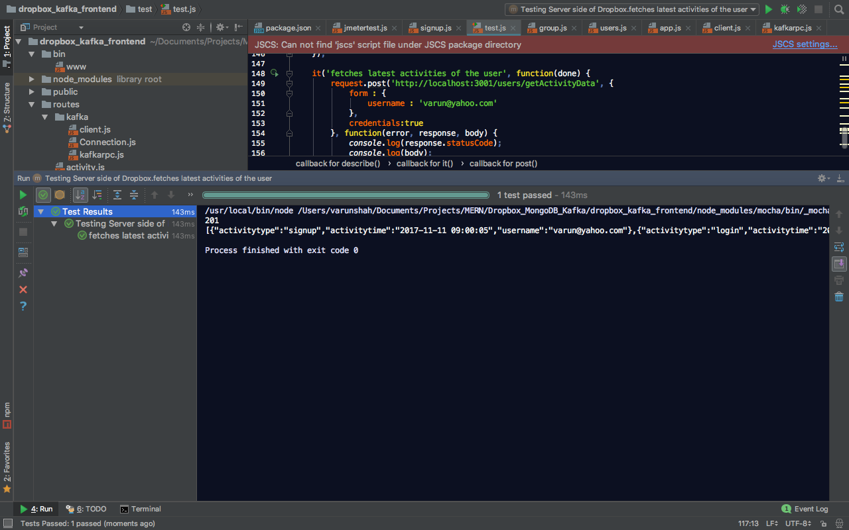

* Kafka_front_end Output

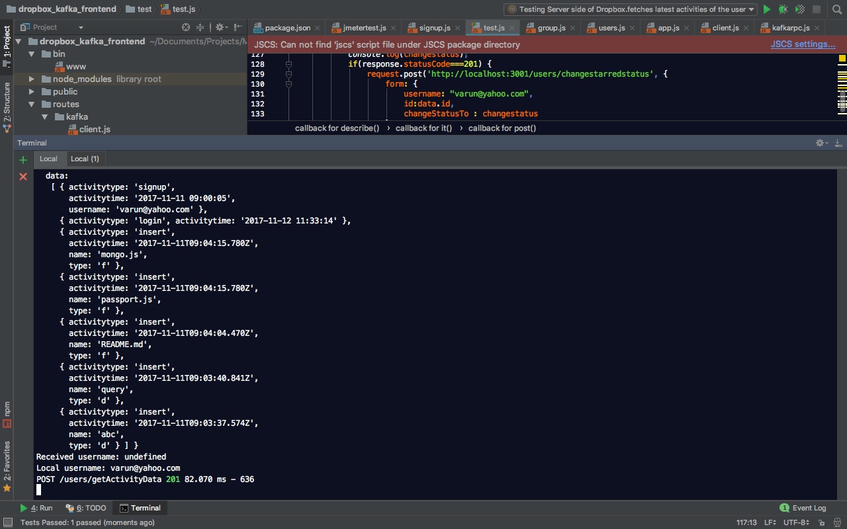

* Kafka_back_end Output

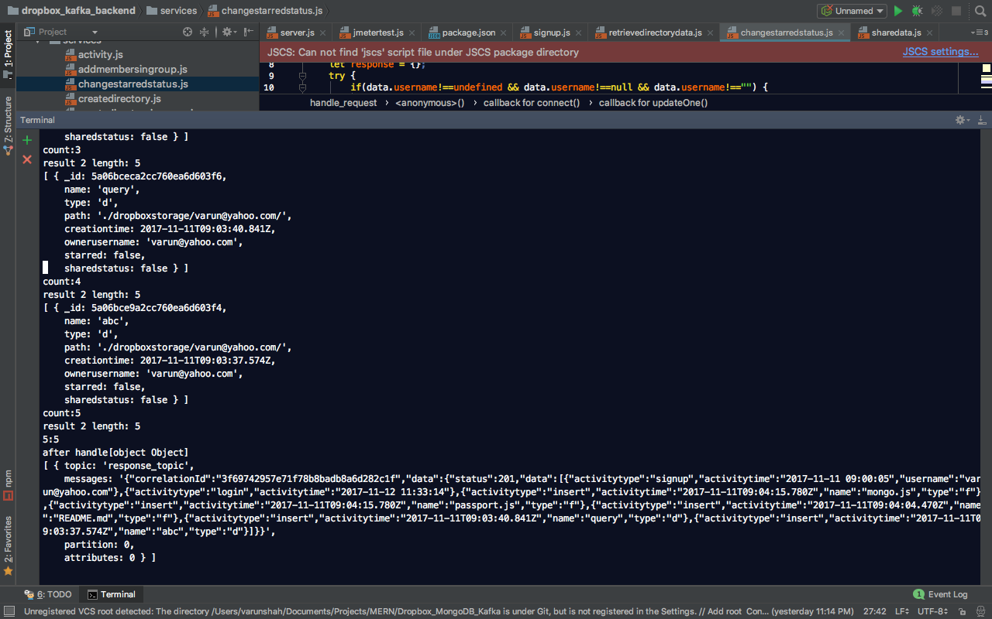

1. Test to fetch the data of the user from user’s root directory and change the starred status of 1st received data

* Test Output

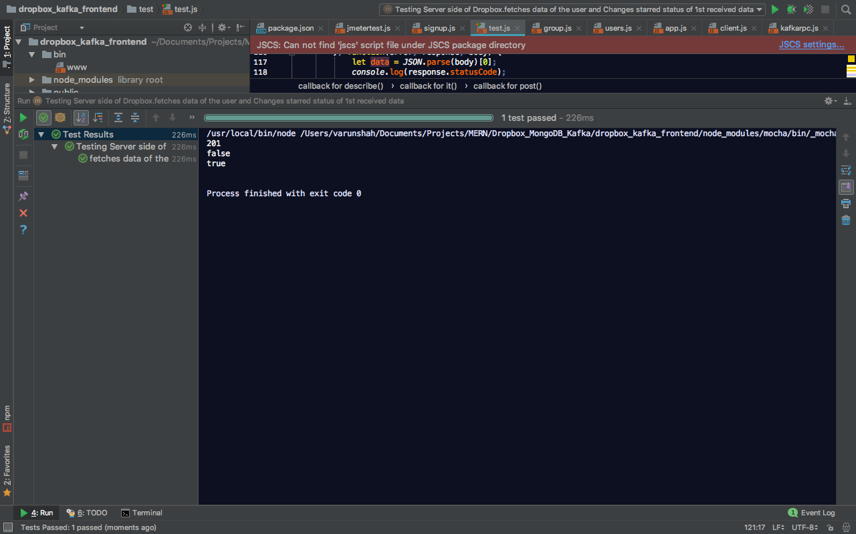

* Kafka_front_end Output

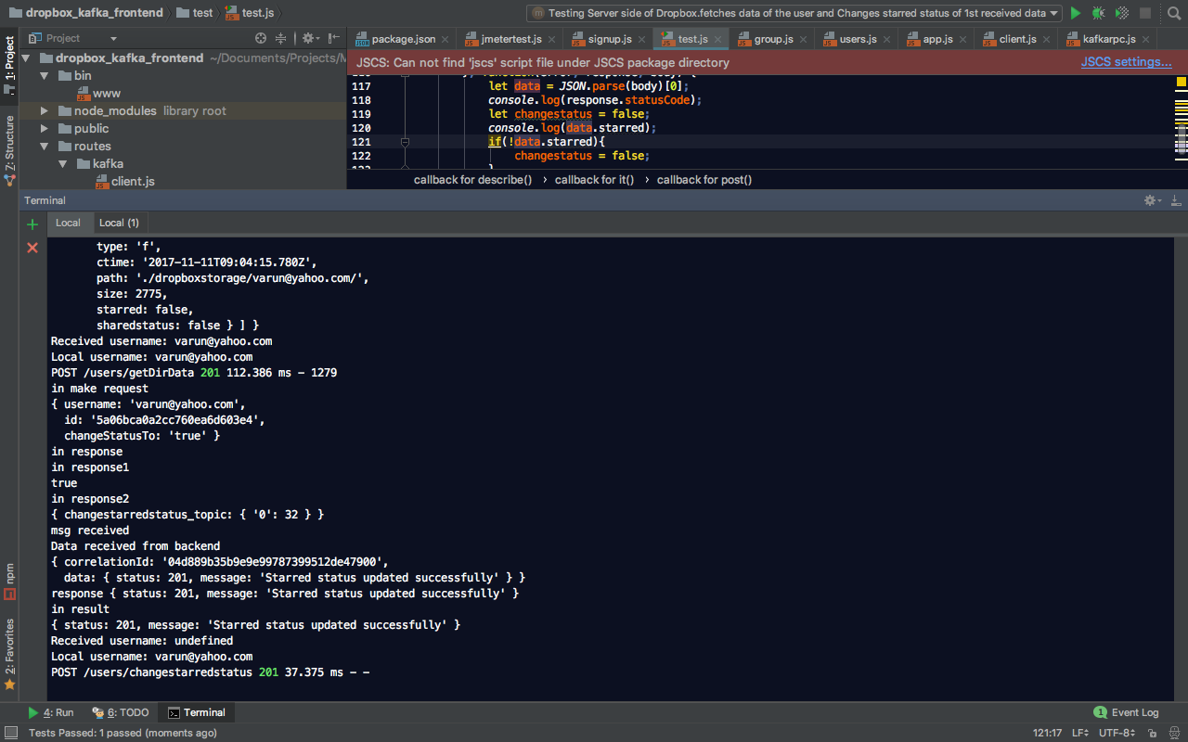

* Kafka_back_end Output

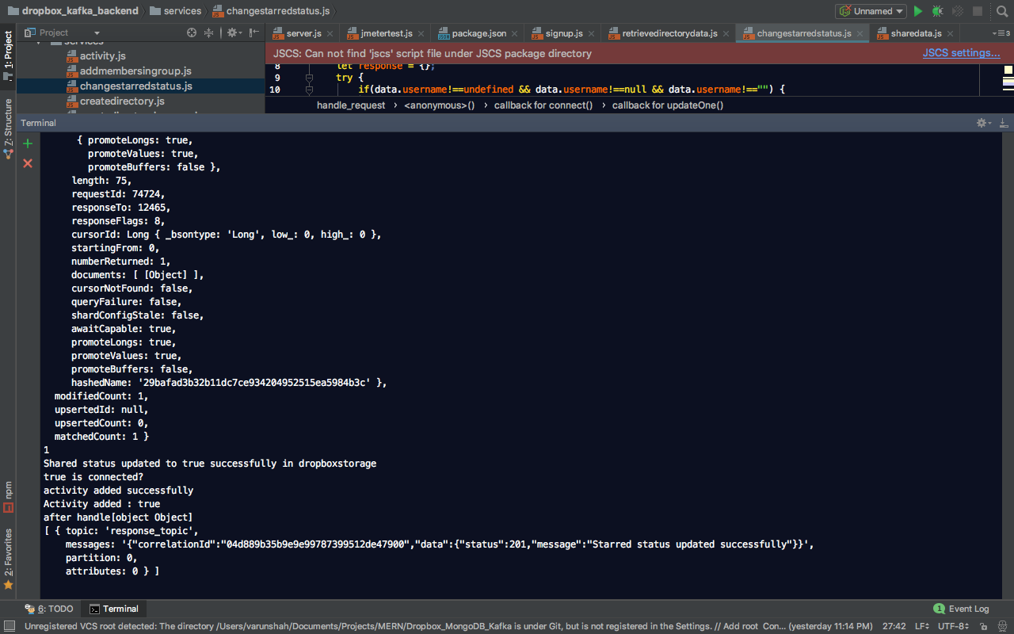

1. Test to fetch Starred Data of User

* Test Output

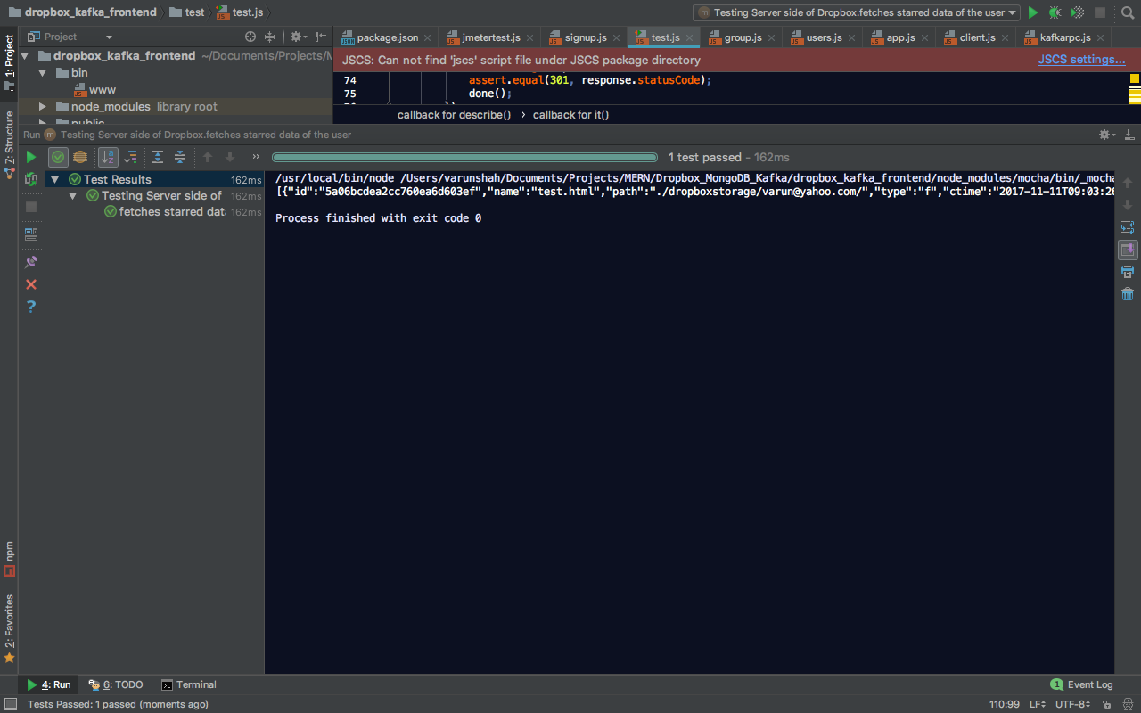

* Kafka_front_end Output

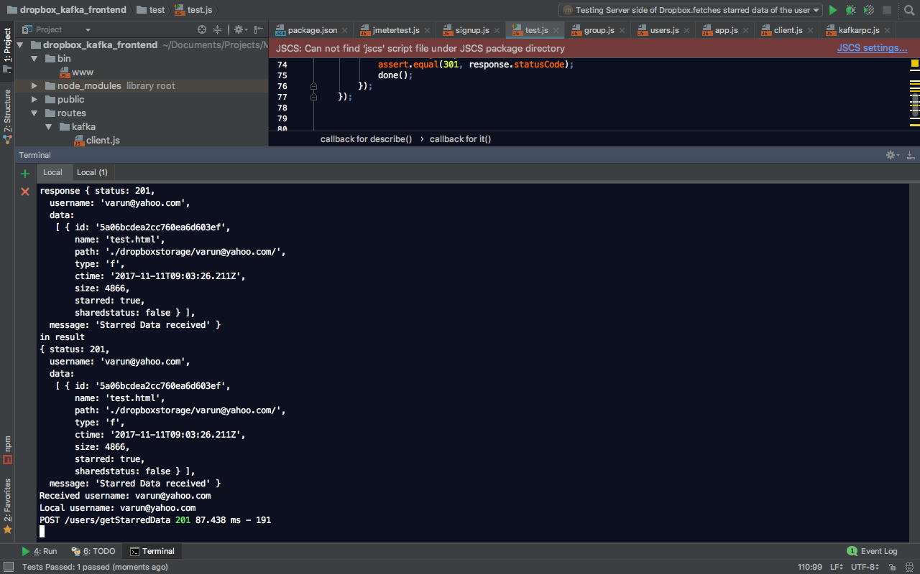

* Kafka_back_end Output

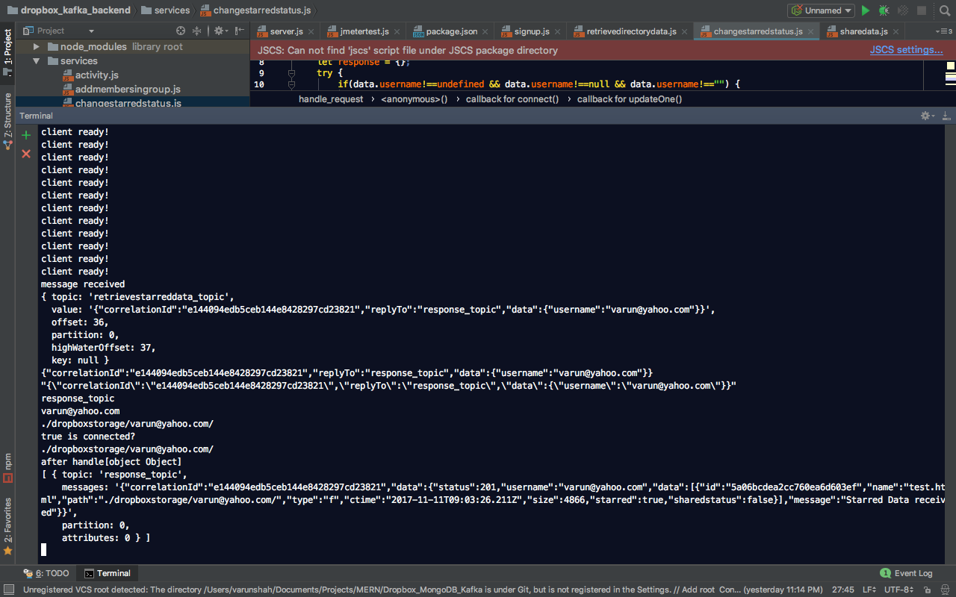

1. Test to verify the URL

* Test Output

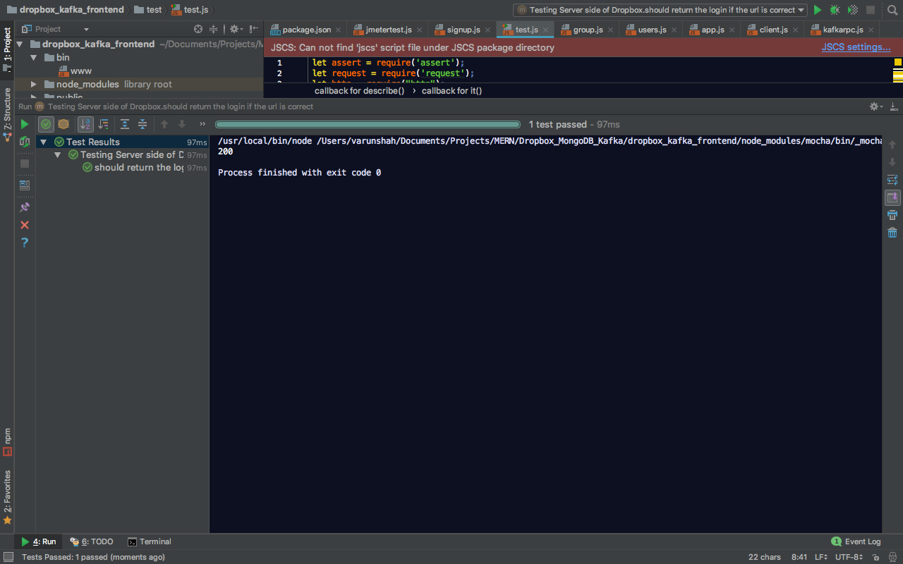

* Kafka_front_end Output

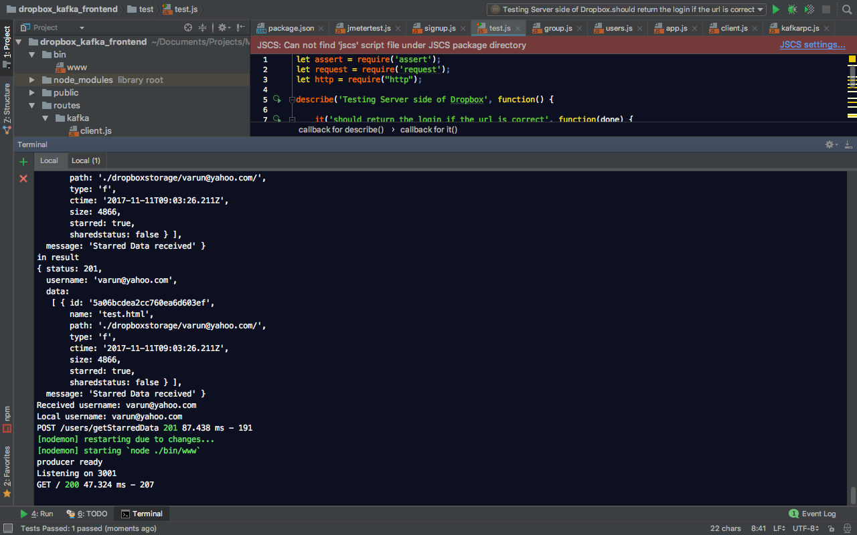

1. Test to Create new group

* Test Output

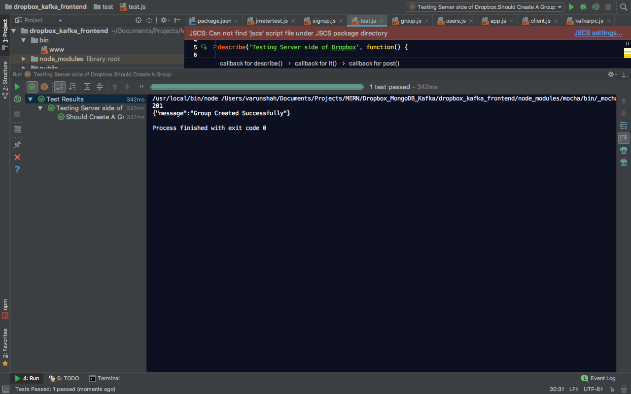

* Kafka_front_end Output

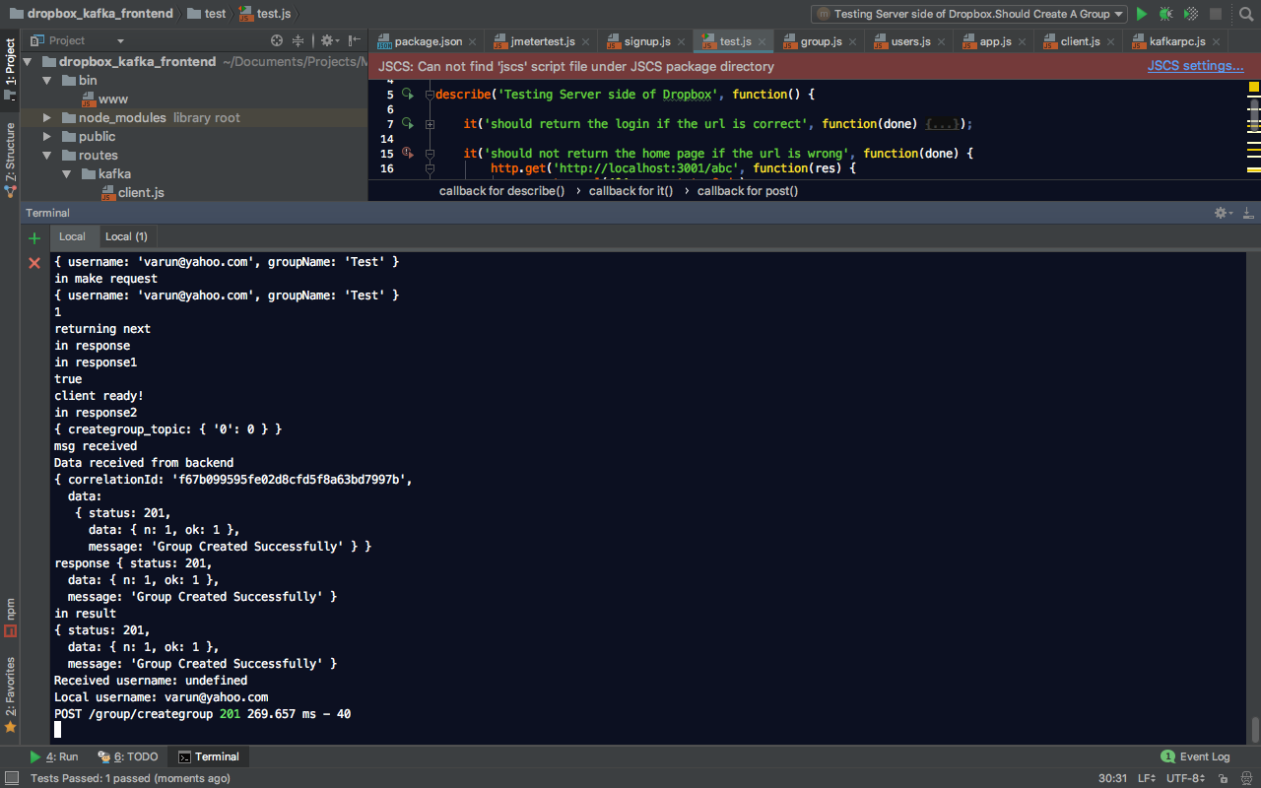

* Kafka_back_end Output

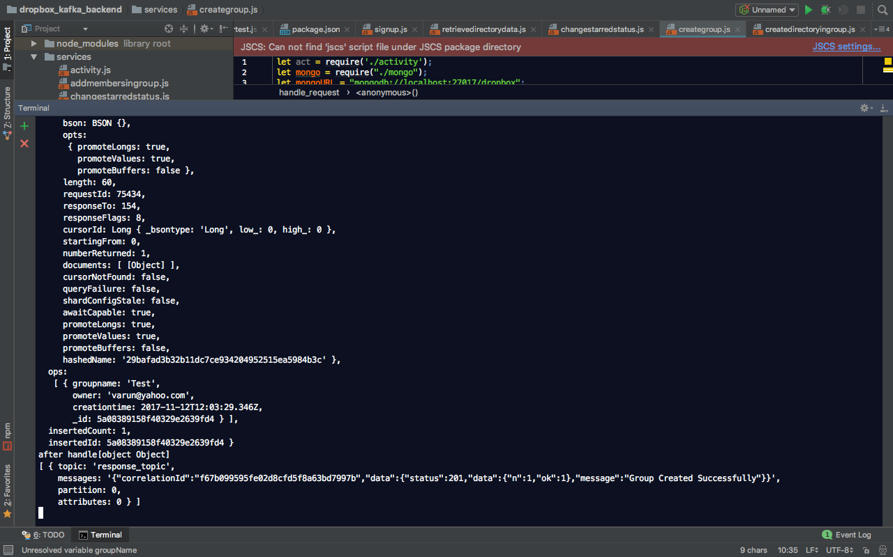

1. Test to fetch data shared with user

* Test Output

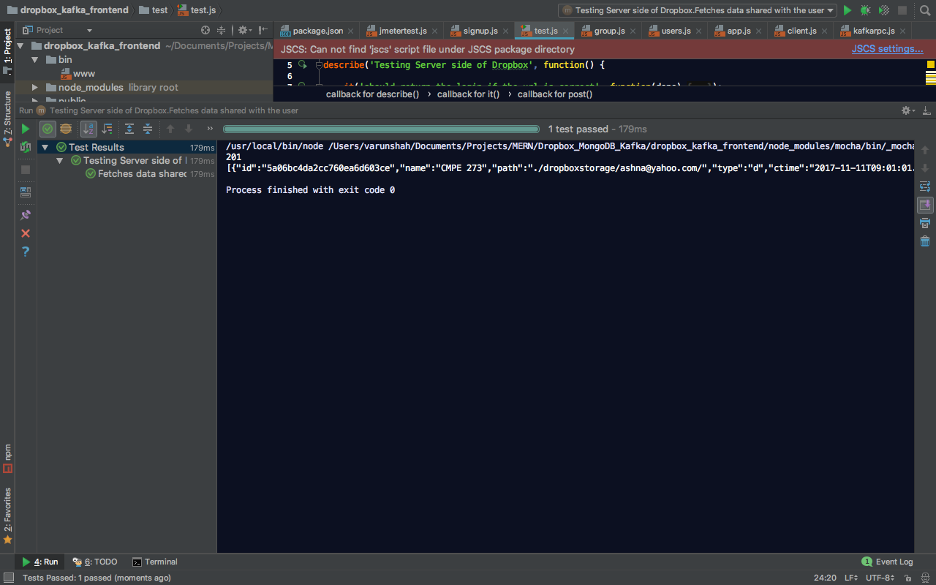

* Kafka_front_end Output

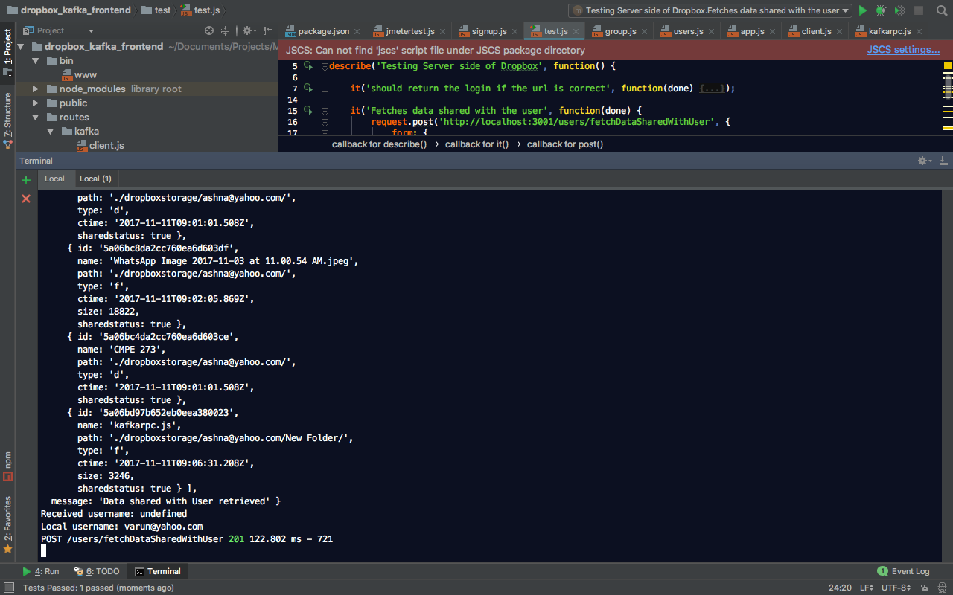

* Kafka_back_end Output

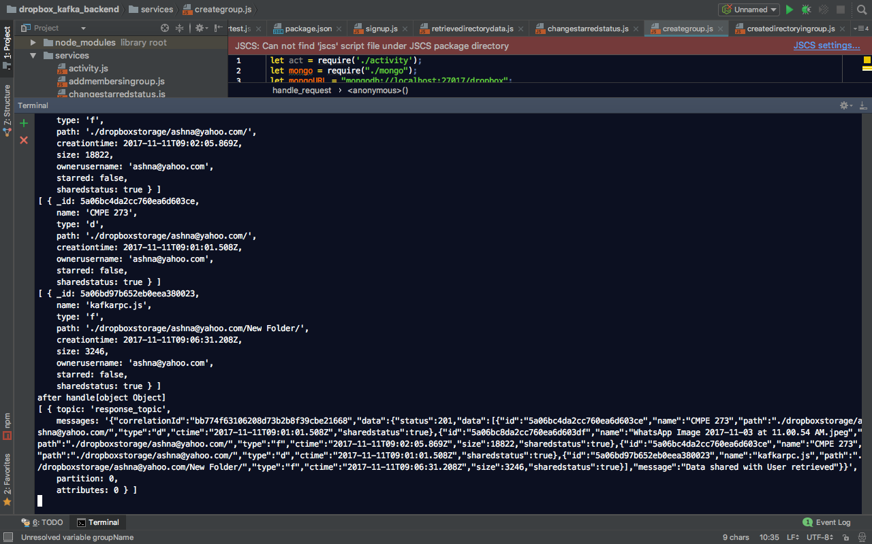

1. Test to stop user from logging in if entered wrong password

* Test Output

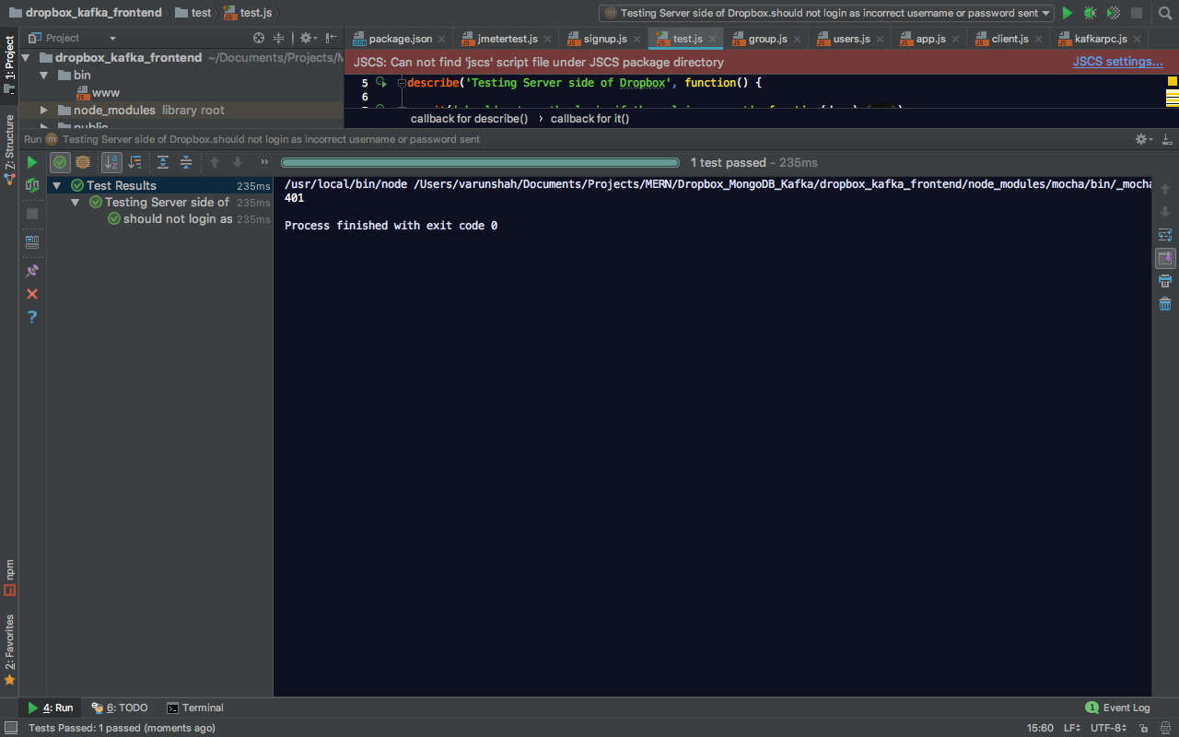

* Kafka_front_end Output

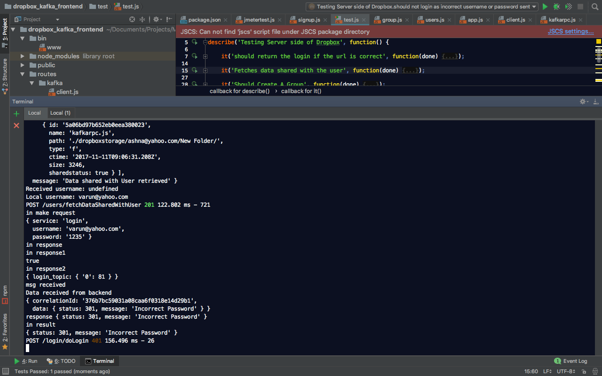

* Kafka_back_end Output

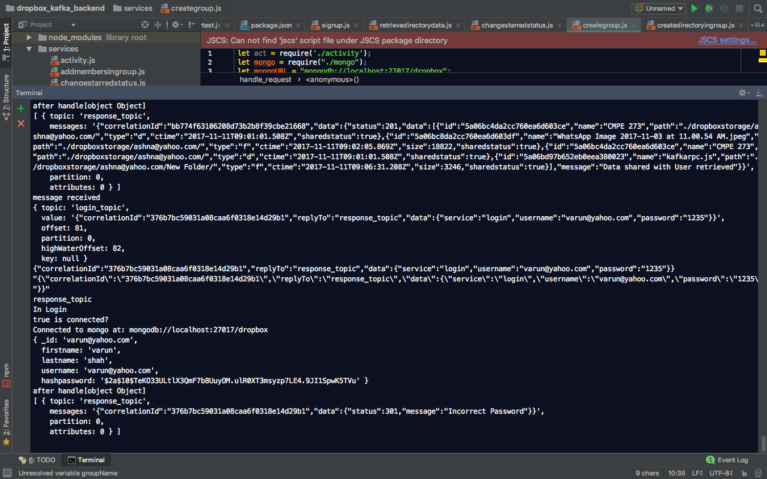

1. Test to fetch groups in which user is either owner or member

* Test Output

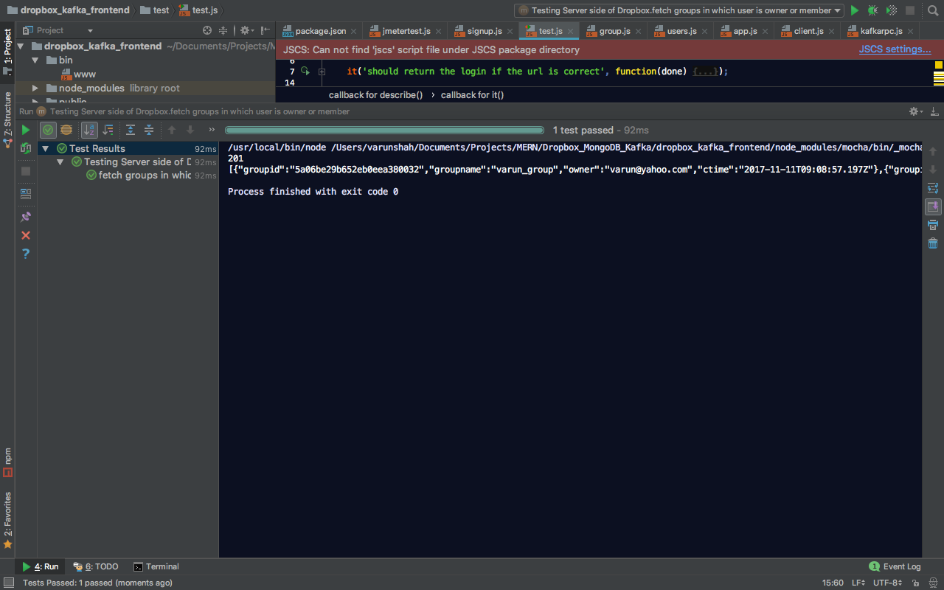

* Kafka_front_end Output

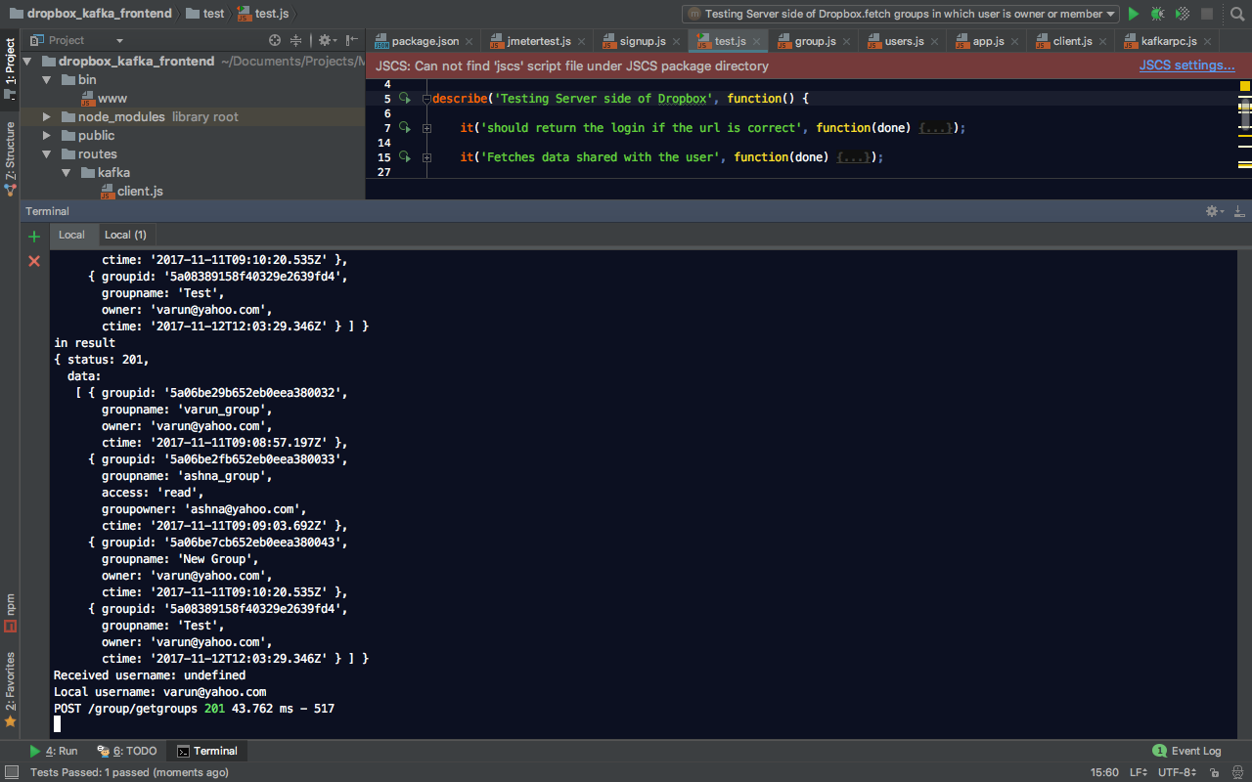

* Kafka_back_end Output

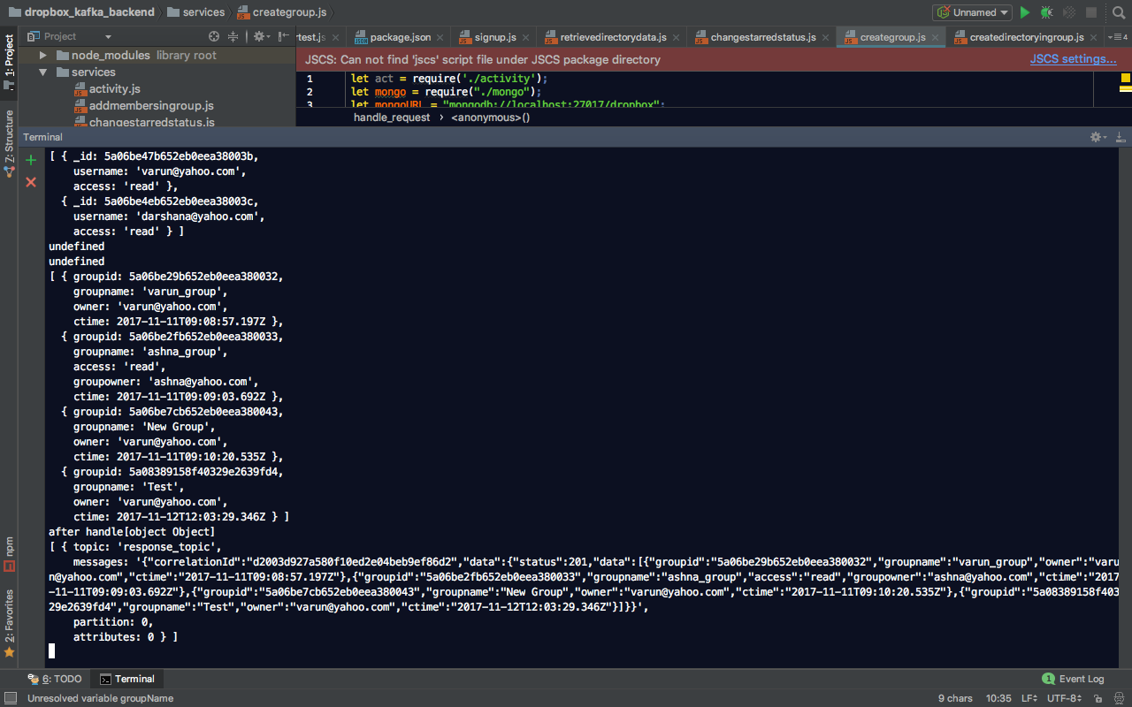

1. Test to prevent user to signup if the username already available in database

* Test Output

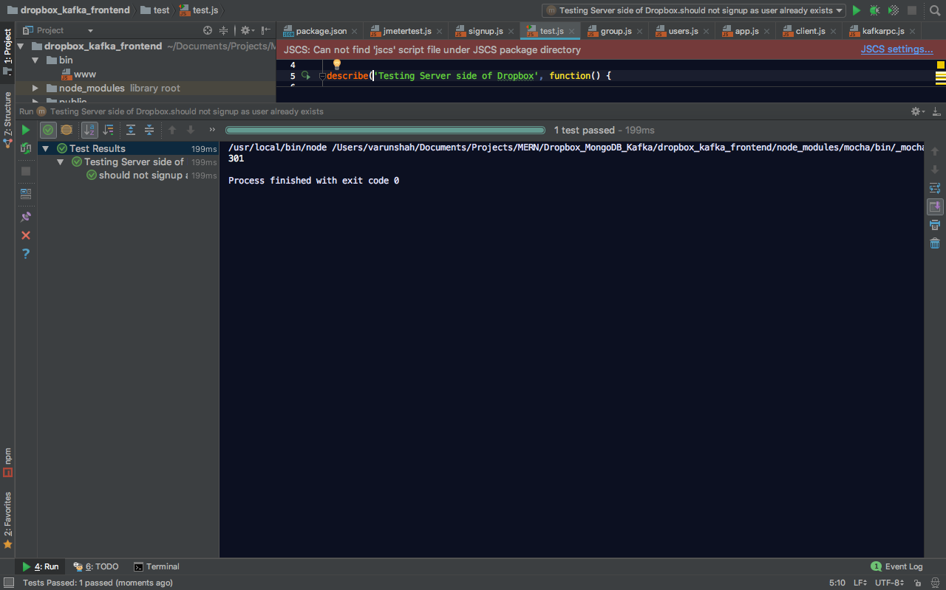

* Kafka_front_end Output

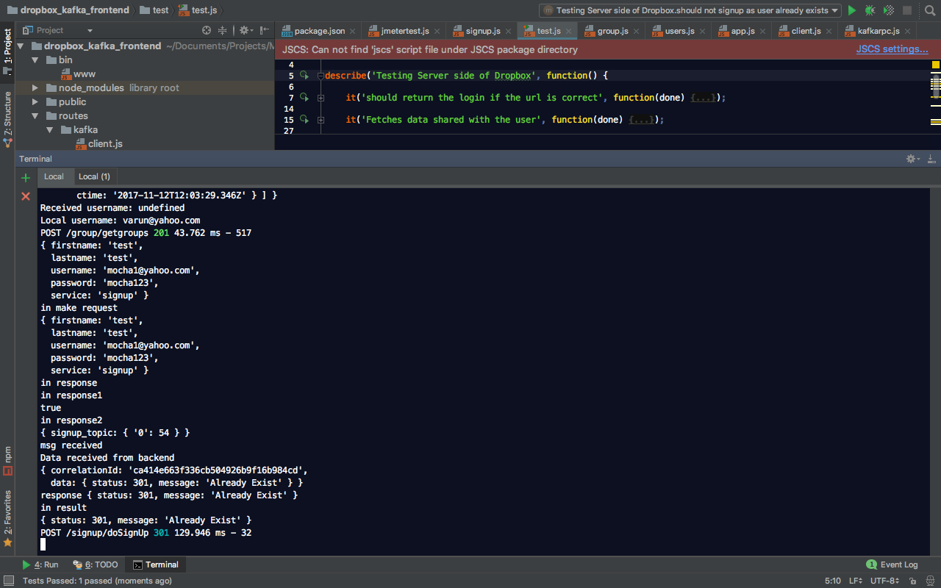

* Kafka_back_end Output

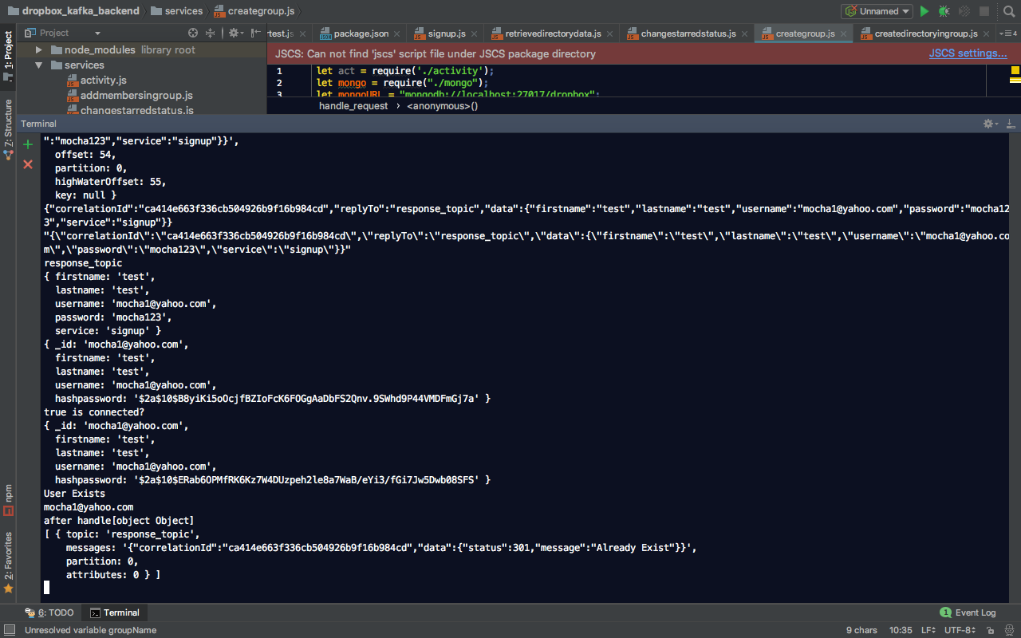

1. Test to retrieve data stored by user in the dropbox storage

* Test Output

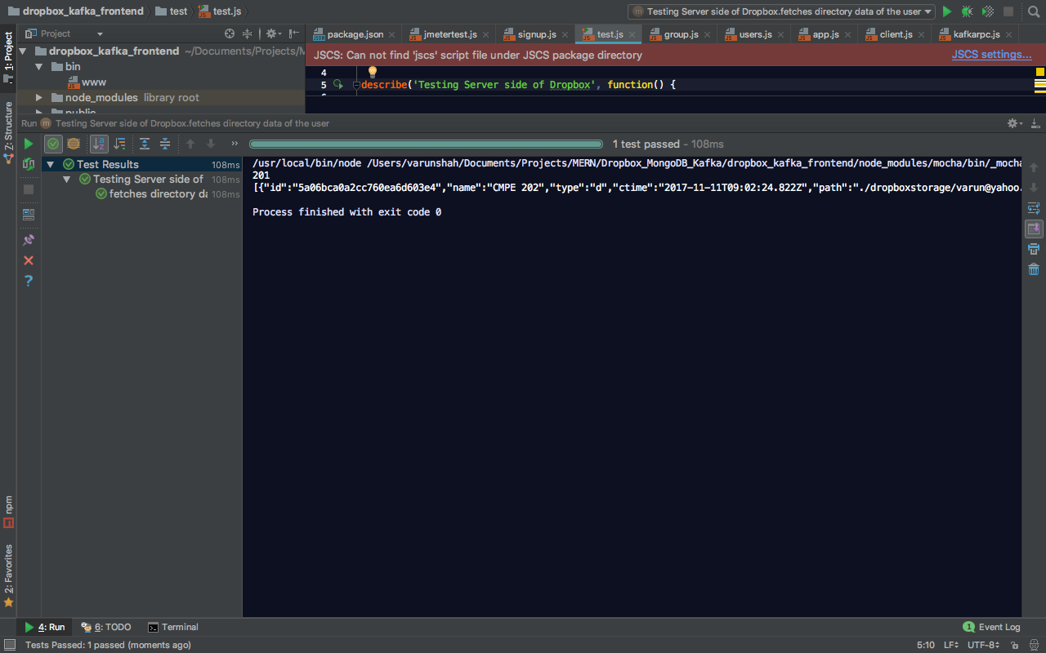

* Kafka_front_end Output

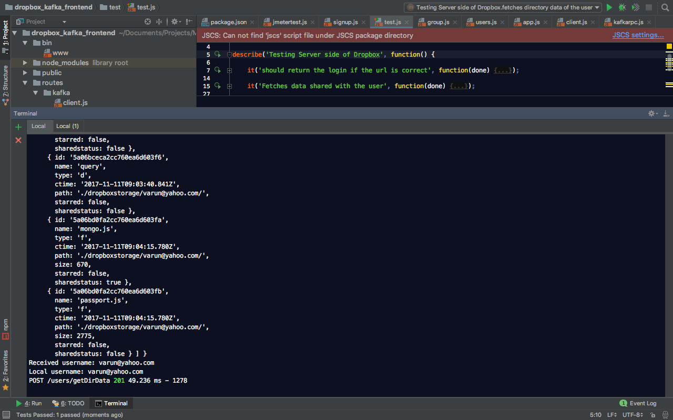

* Kafka_back_end Output

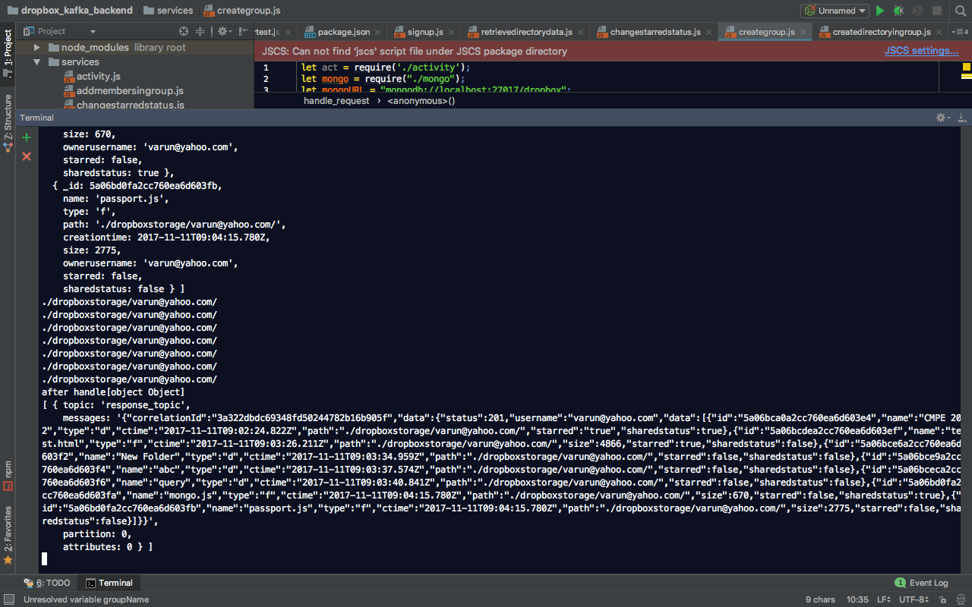

1. Test to verify that user logs in with correct credentials
   * Test Output

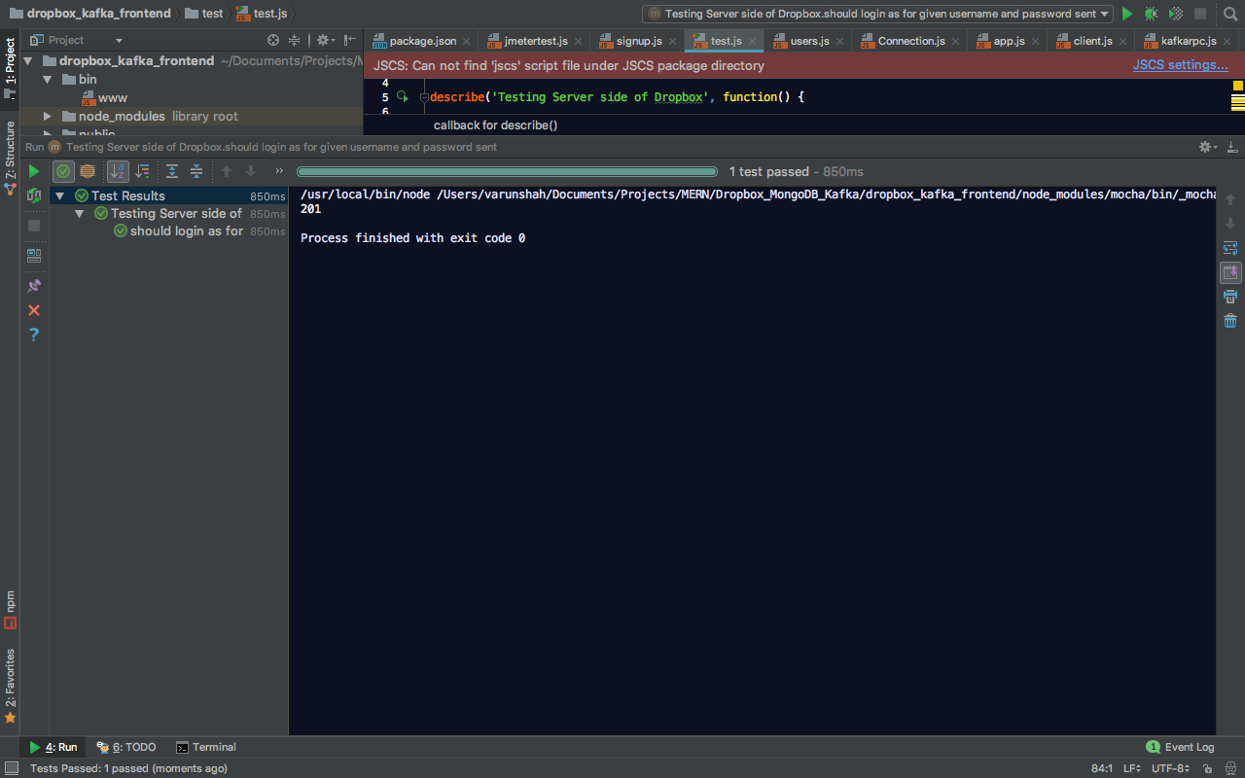

* + Kafka_front_end Output

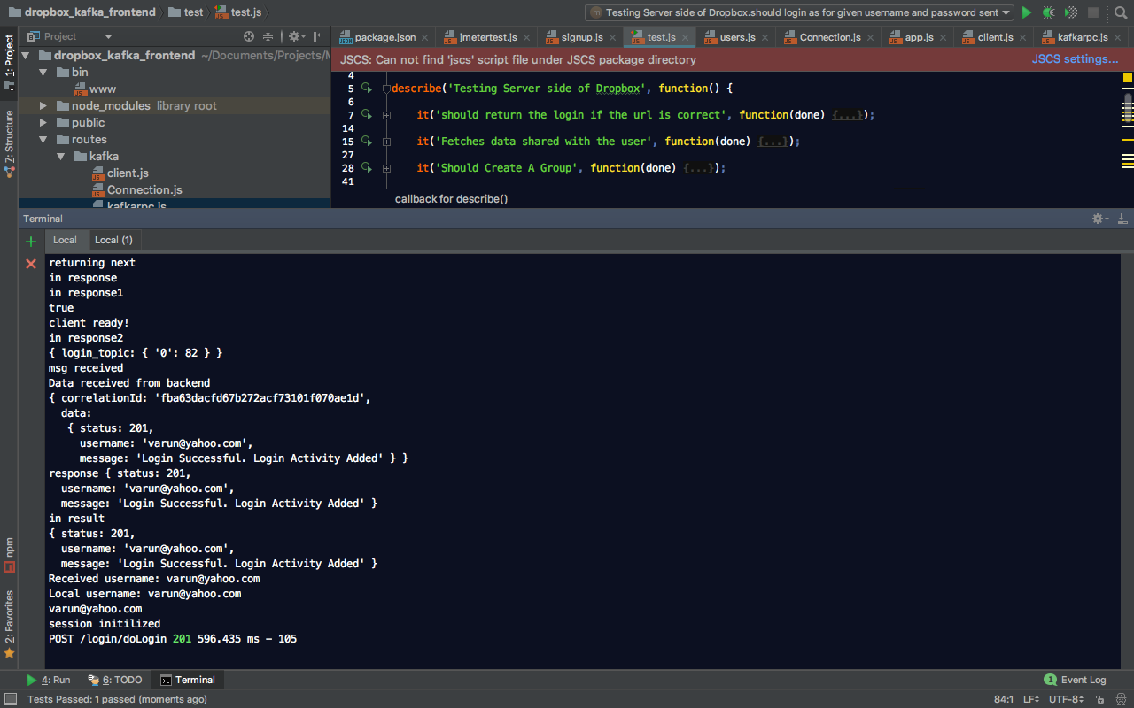

* + Kafka_back_end Output

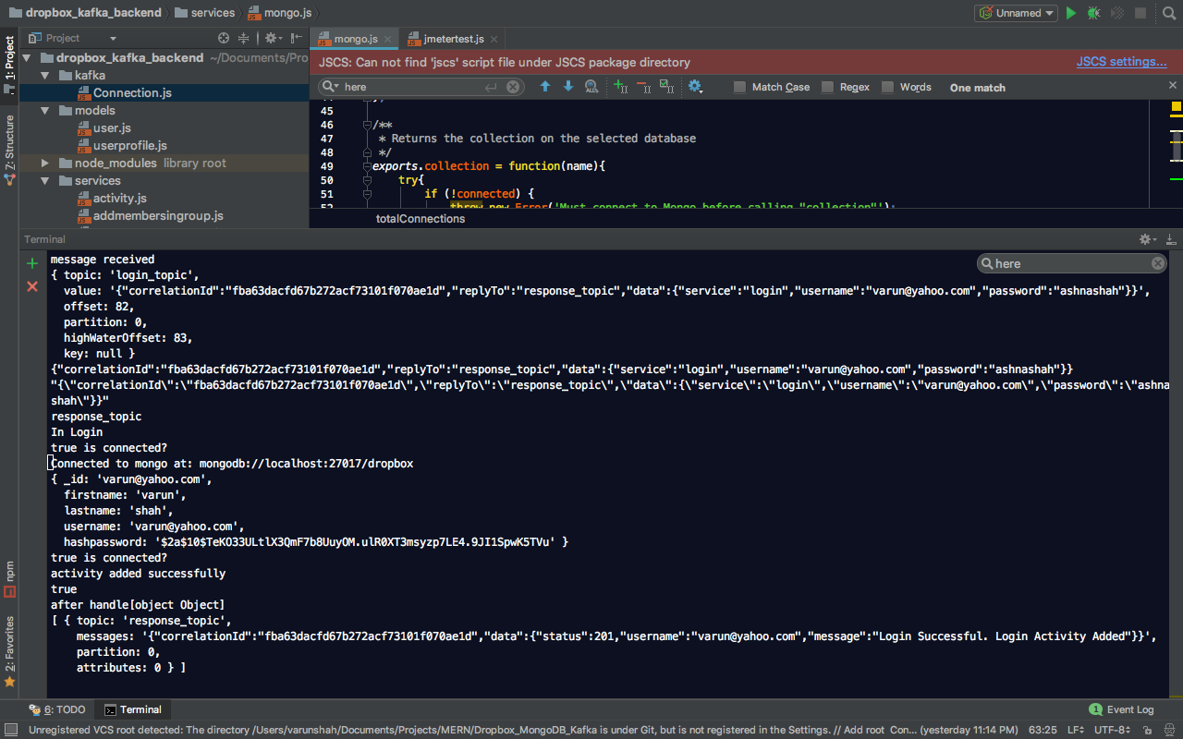

1. Test to verify whether URL is correct. If Incorrect gives error
   * Test Output

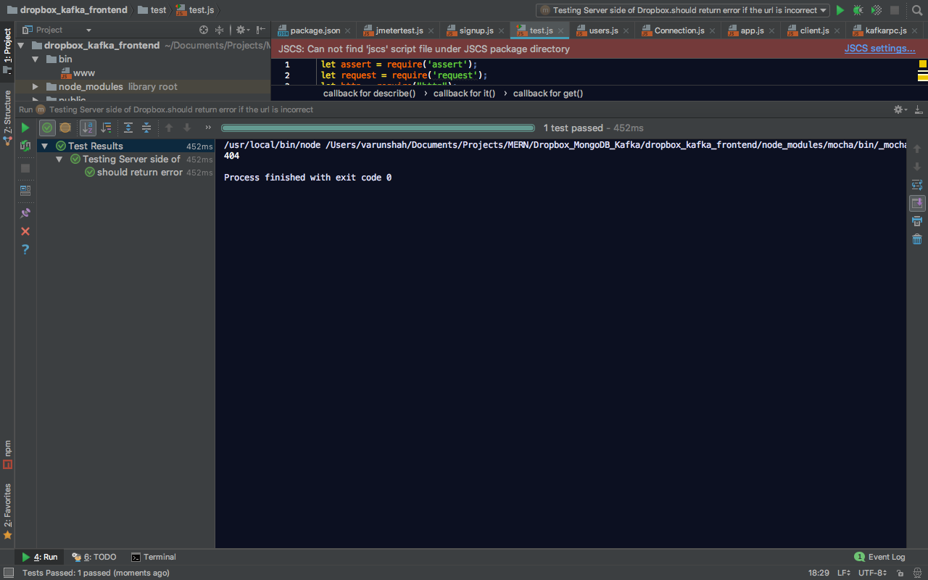

* + Kafka_Front_End Output

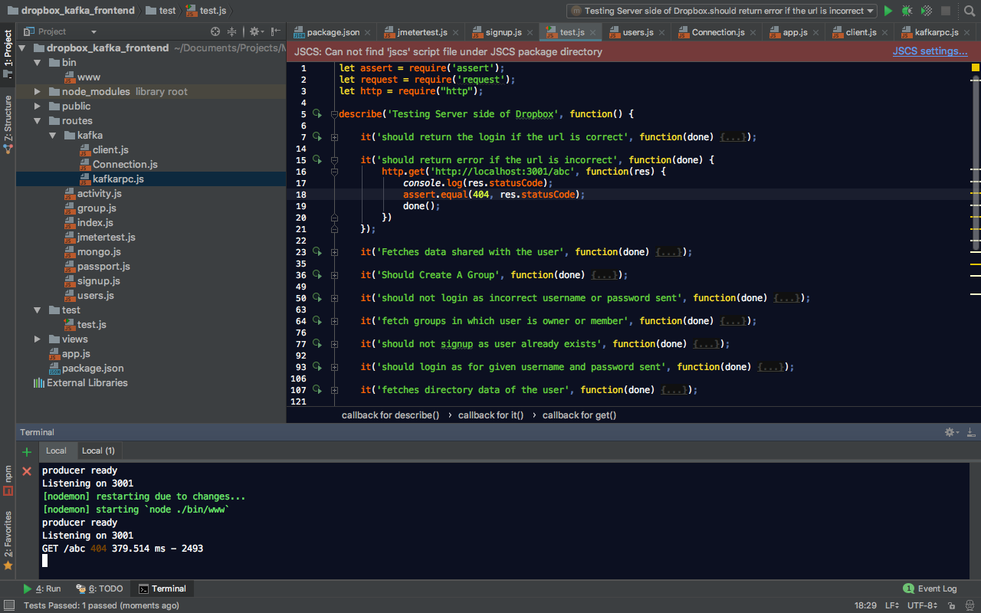

1. Test to create directory in users’s root directory of dropbox storage
   * Test Output

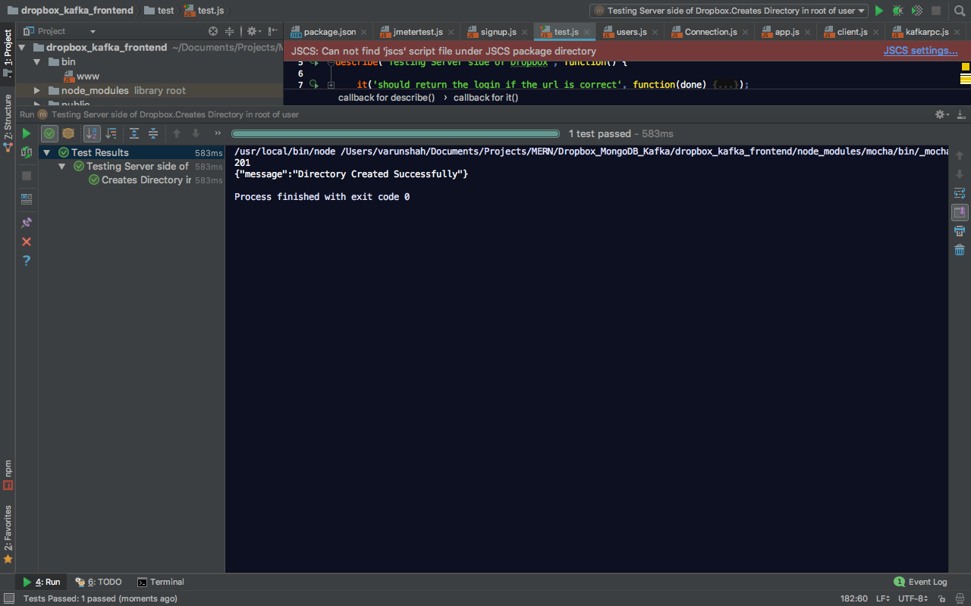

* + Kafka_Front_End Output

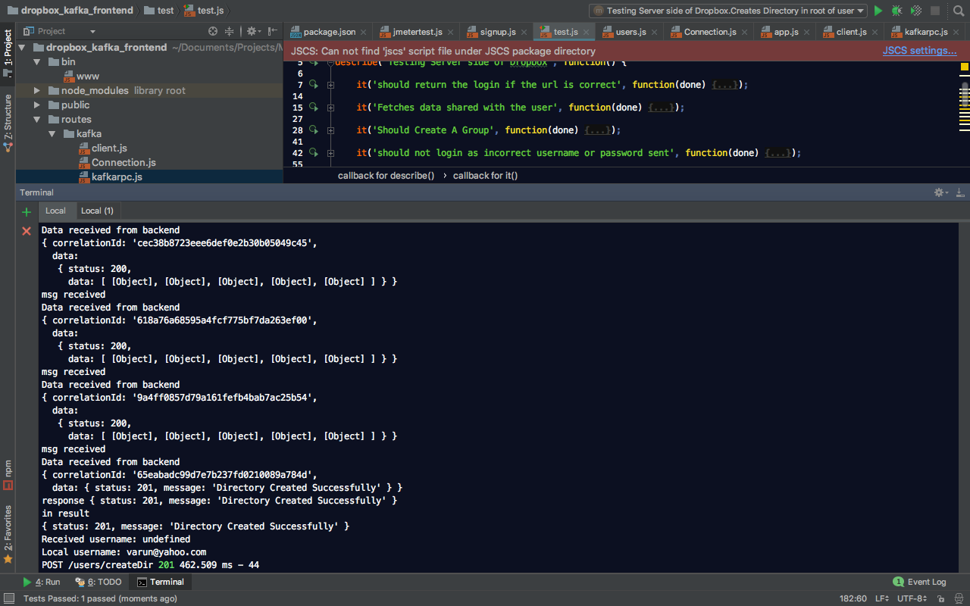

* + Kafka_Back_End Output

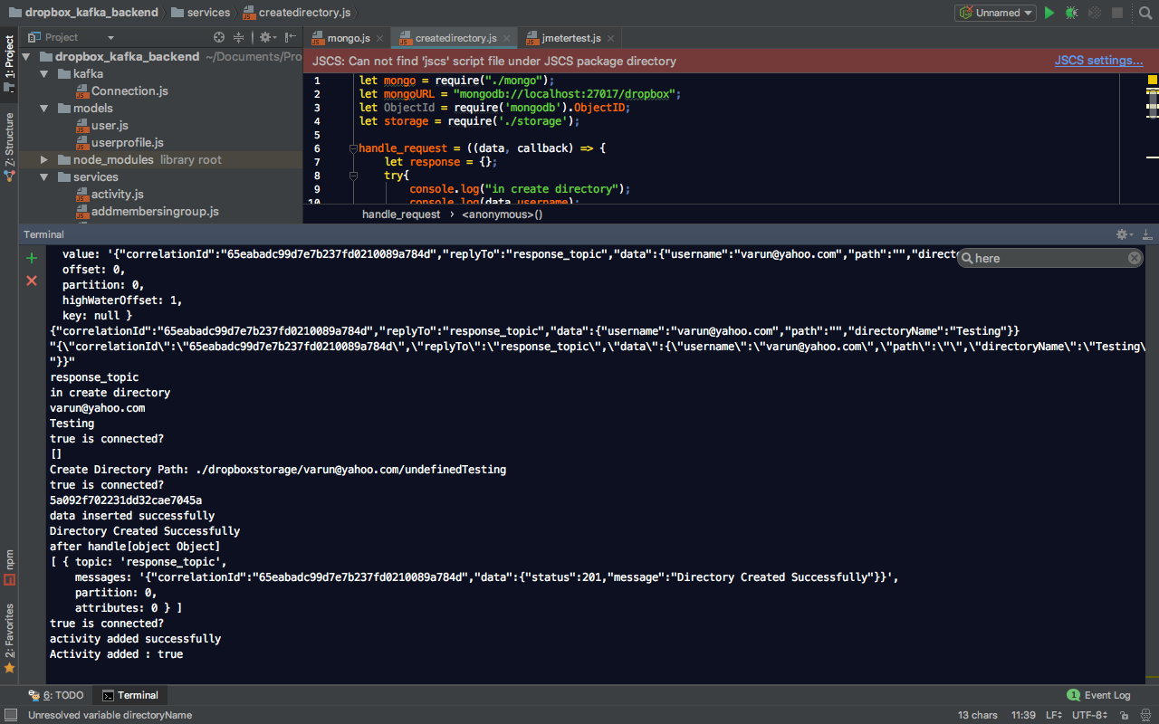

1. Fetches root directory data of the user and deletes first received data
   * Test Output

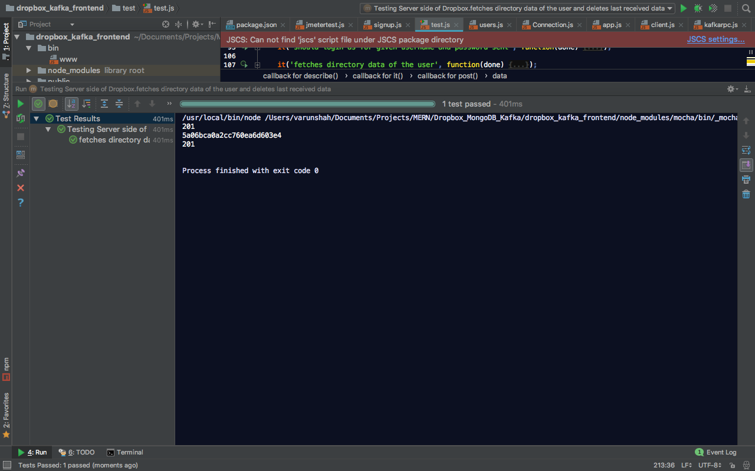

* + Kafka_Front_End Output

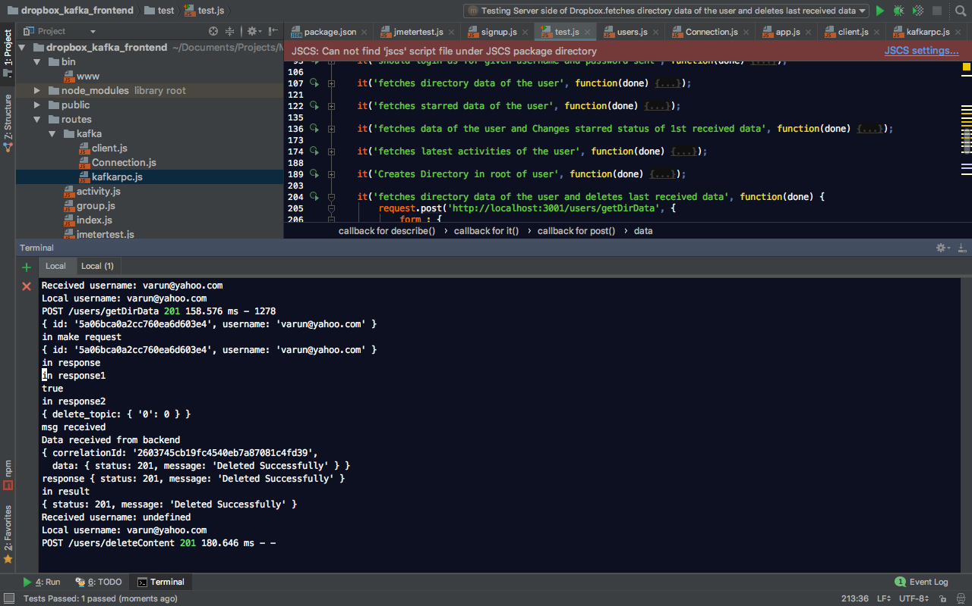

* + Kafka_Back_End Output

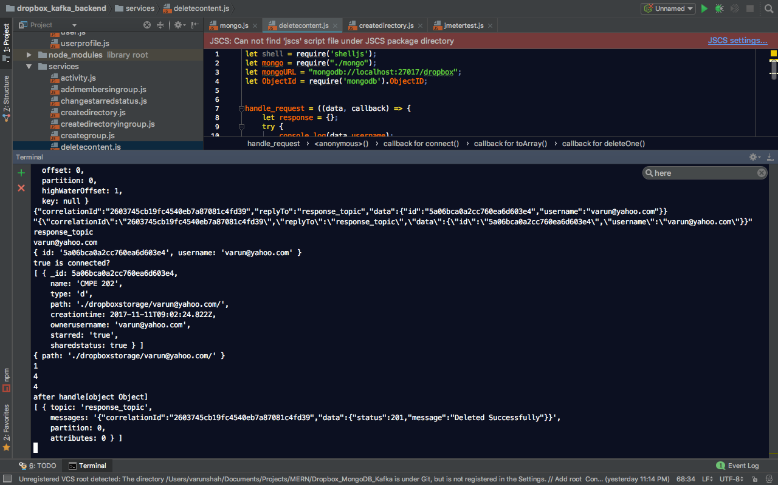

1. Test to verify that session does not contain username data prelogin
   * Test Output

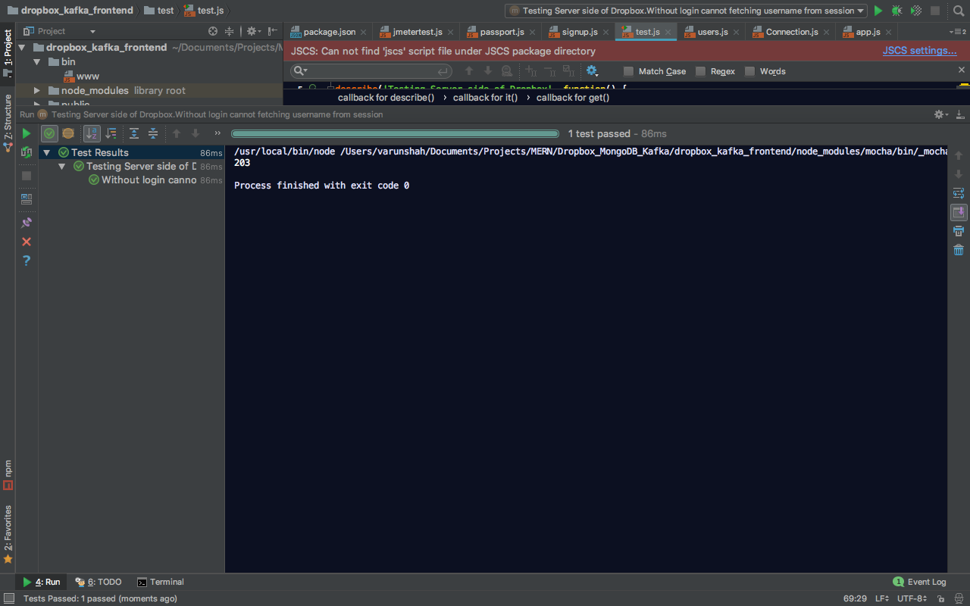

* + Kafka_Front_End Output

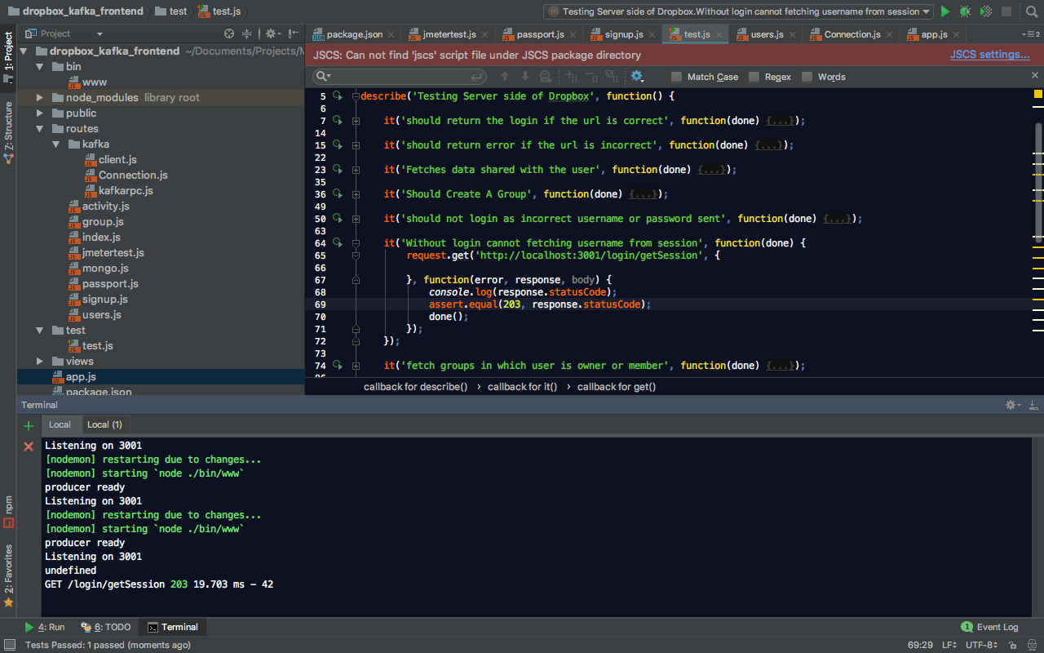

1. Test to User Profile Details
   * Test Output

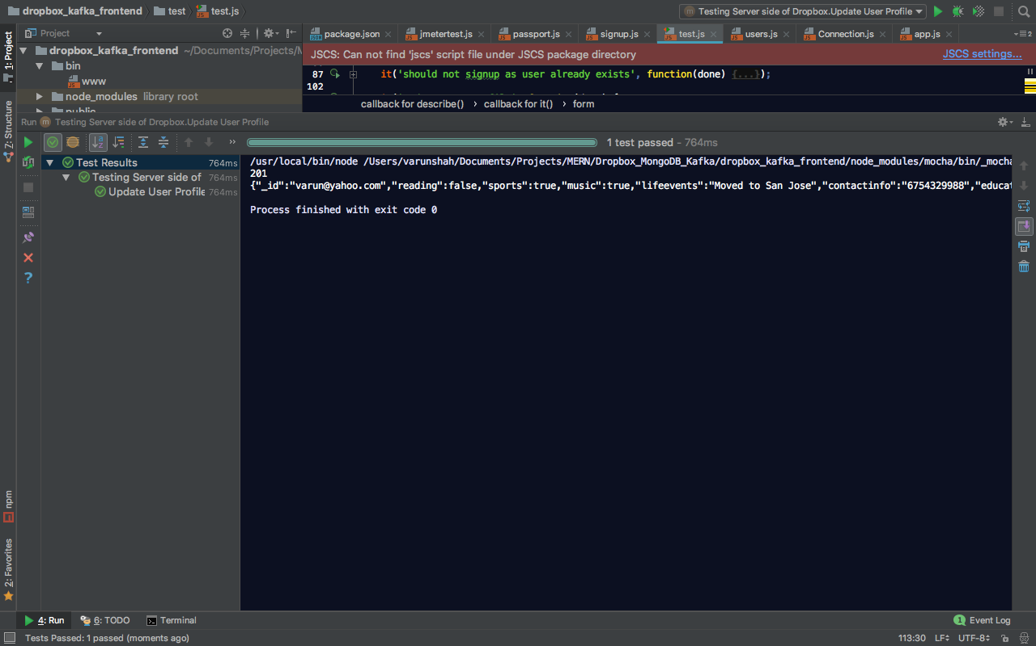

* + Kafka_Front_End Output

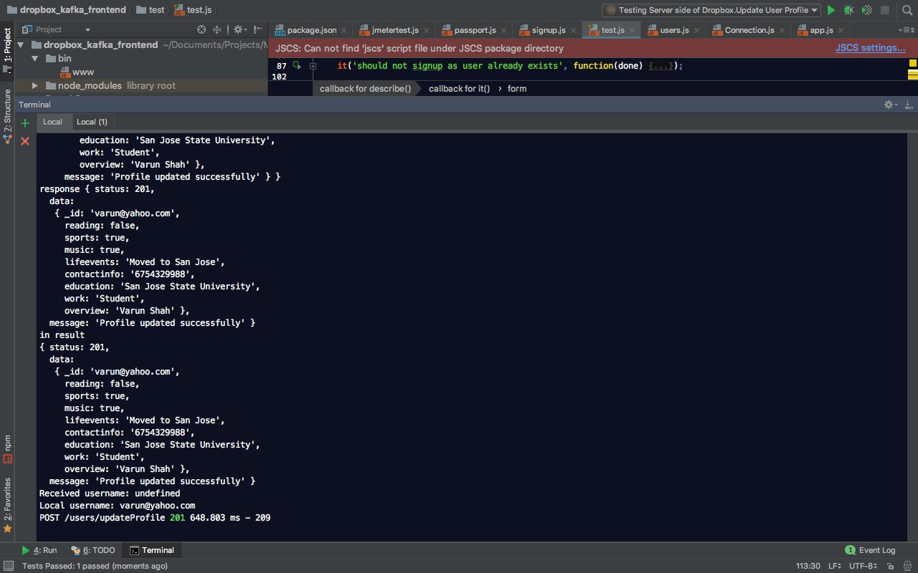

* + Kafka_Back_End Output

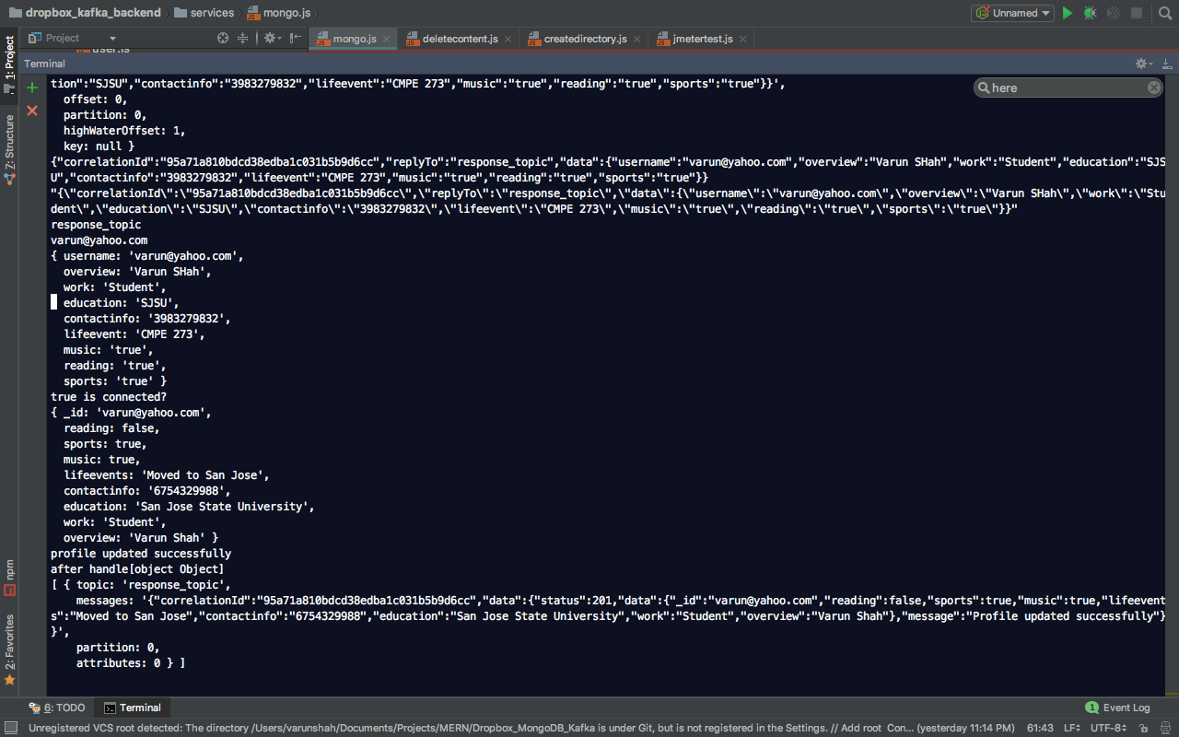

# Answers

1. Compare passport authentication process with the authentication process used in Lab1.

Passport authentication is a centralized authentication service/middleware for Node used solely to authenticate requests. Passport provides multiple strategies that can be implemented without creating unnecessary dependencies. The authenticate request is very simple. e.g. calling “passport.authenticate()”. After successful authentication, Passport establishes persistent login session which other traditional approaches failed to do. If the built-in options are not sufficient for handling an authentication request, Passport manages a custom callback, which allow the application to handle success or failure.

In current lab, authentication was implemented using Passport. The login form is submitted to the server via the POST method using authenticate () with the “**local**” strategy. In Lab 1, The authentication service used was the basic form authentication, where the username and password sent by the user to login were sent across the network in plain/text format, which is one of the insecure methods of authentication.

app.post('/login/doLogin', function(req, res) {  
 passport.authenticate('login', function(err, response) {  
 if(err) {  
 *console*.log(err);  
 res.status(401).send();  
 }  
 if(response.status===201) {  
 req.session.username = response.username;  
 *console*.log(req.session.username);  
 *console*.log("session initilized");  
 return res.status(response.status).send(req.session);  
 }  
 else if(response.status===301){  
 res.status(301).send({"message":response.message});  
 }  
 else {  
 res.status(401).send({"message":"Login Failed"});  
 }  
 })(req, res);  
});

passport.use('login', new LocalStrategy(function(username, password, done) {  
 try {  
 kafka.make_request('login_topic',{"service":"login","username":username,"password":password}, function(err,results){  
 *console*.log('in result');  
 *console*.log(results);  
 if(err){  
 done(err,{});  
 }  
 else  
 {  
 if(results.status === 201){  
 *console*.log("Received username: "+results.username);  
 *console*.log("Local username: "+ username);  
 done(null,{username:results.username,status:results.status});  
 }  
 else {  
 done(null,false);  
 }  
 }  
 });  
 }  
 catch (e){  
 done(e,{});  
 }  
}));

1. Compare performance with and without Kafka. Explain in detail the reason for difference in performance.

* 500 users concurrently calls (Without Kafka using MongoDB )

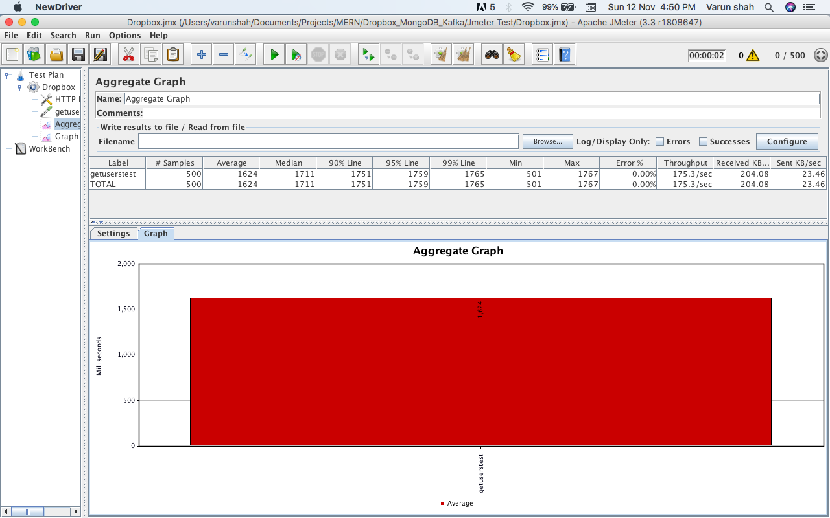

* 500 users concurrently calls (With Kafka using MongoDB)

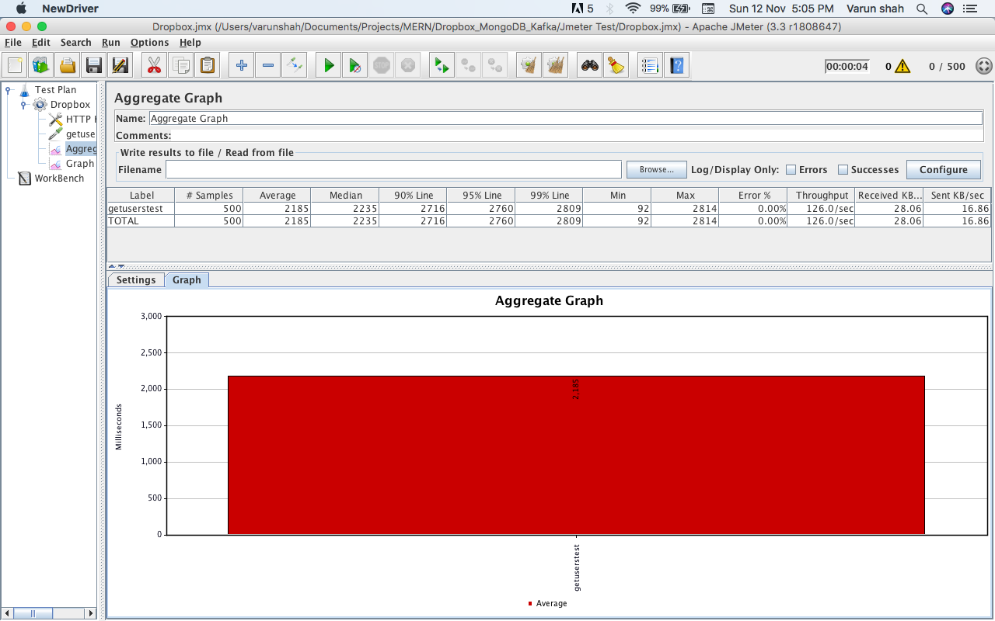

* Performance Comparison between with Kafka and without kafka

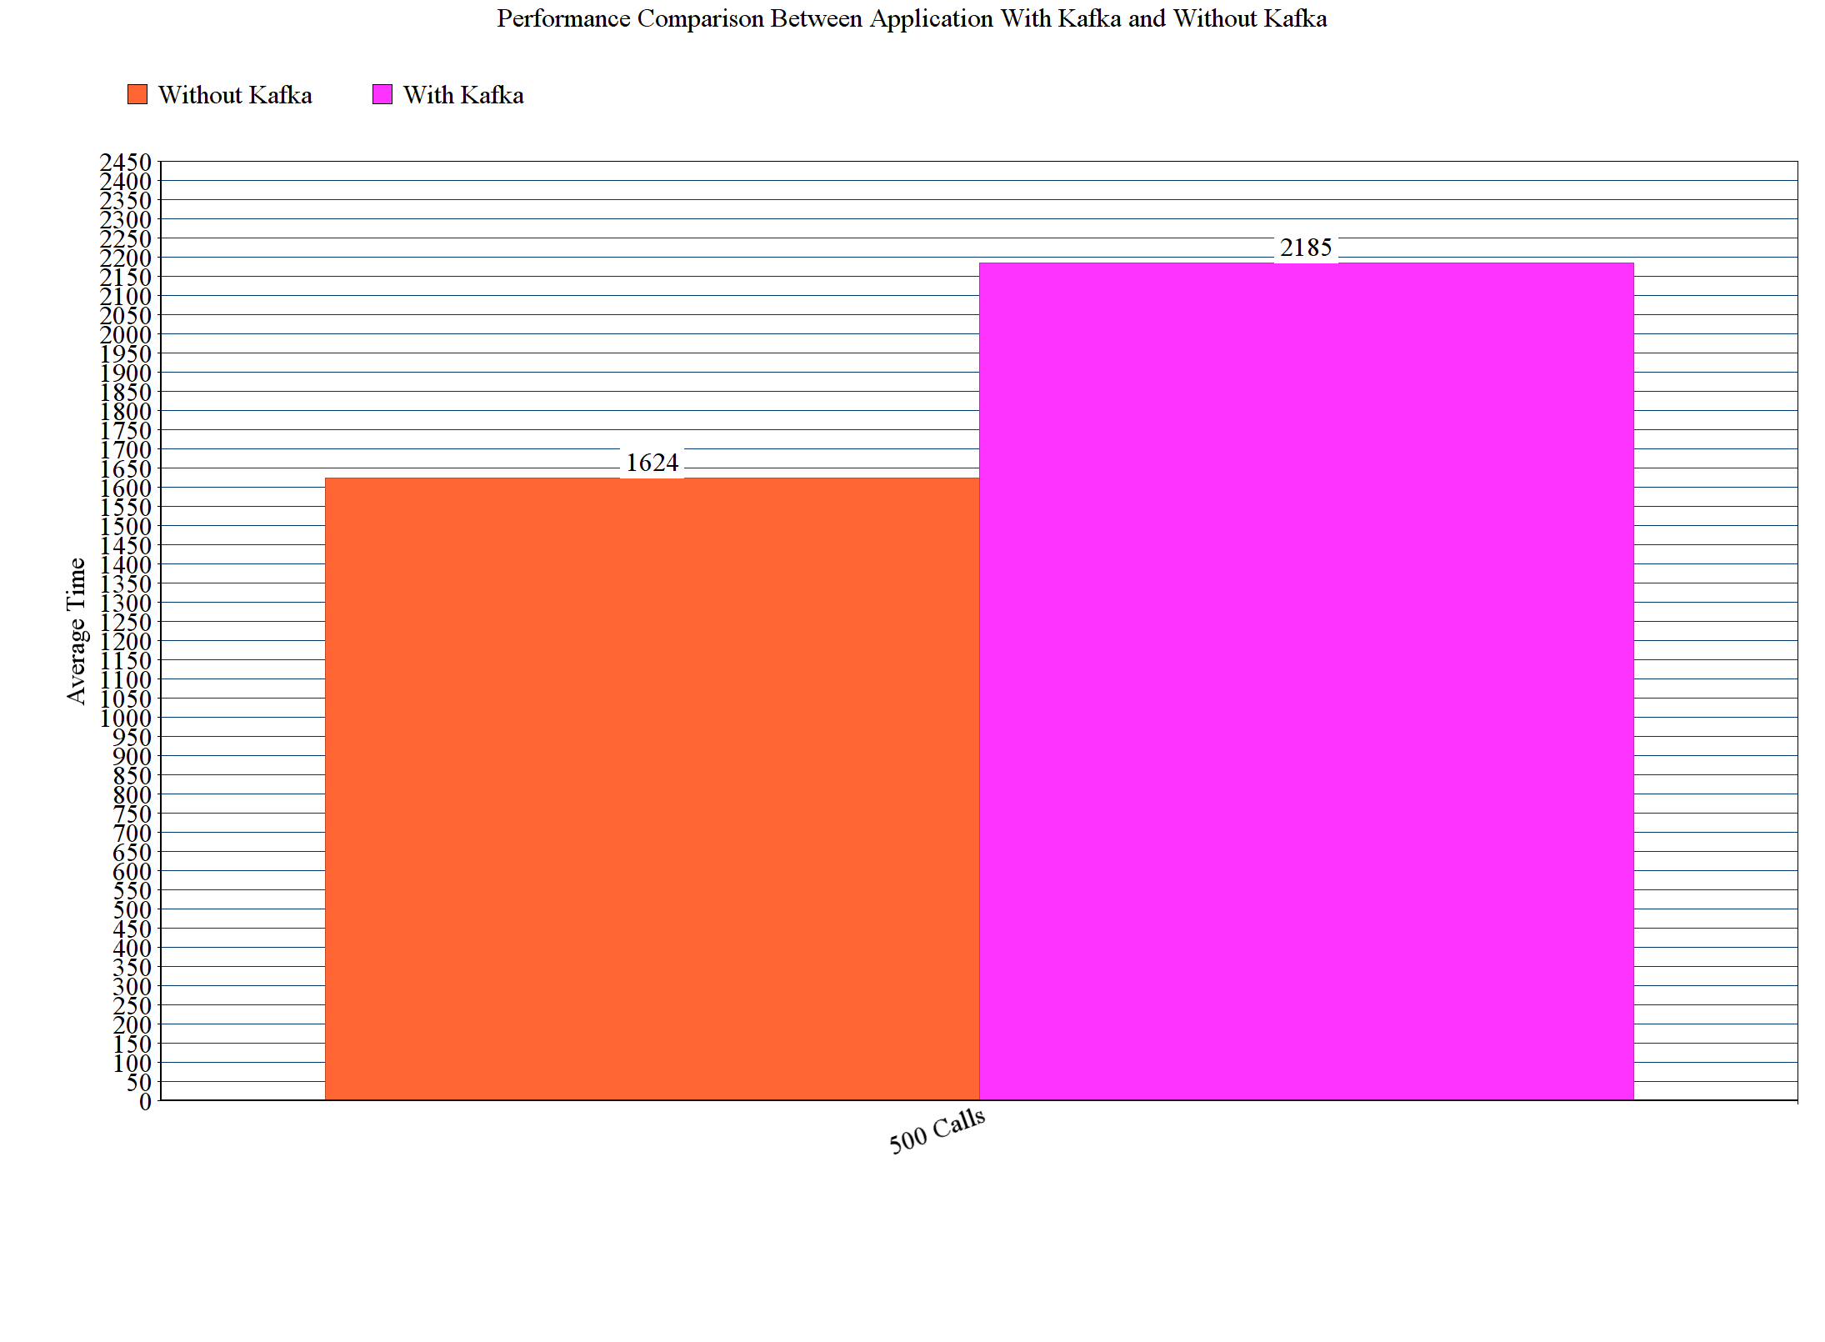

Comparison was based on following criteria’s:

* + 1. Database in both case was MongoDB
    2. 500 concurrent users send 1 call

While applying mentioned scenario in both with kafka and without kafka, it seems that average time while using kafka is higher than without kafka. Because, in this development scenario there are multiple topics, but with only one partition. When kafka is deployed on different servers with multiple partitions, it is most effective as it is highly efficient to send and receive messages to respective receivers.

1. If given an option to implement MySQL and MongoDB both in your application, specify which data of the applications will you store in MongoDB and MySQL respectively

SQL is well-known for its high performance, flexibility, data protection, availability, and management ease. MySQL follows proper data indexing which gives good performance, facilitate interaction and ensure robustness. However, if data is unstructured and complex, or when it is unlikely to pre-define schema, opting MongoDB is recommended.

Comparison of MySQL with MongoDB

|  |  |
| --- | --- |
| **MySQL** | **MongoDB** |
| Structured Data | Unstructured Data |
| Pre-define Schema (Static Schema) | Unstructured so. Pre-defining schema is not mandatory (Dynamic Schema) |
| RDBMS | Document Oriented |
| Scaling: Vertically | Scaling: Horizontally |
| Used for relatively small datasets | DB is set to grow Big. No Database Administrator |
| Pros: JOIN Support, Atomic Transaction support  Cons: Tough scaling, Stability | Pros: Storage engines, document validation  Cons: Not best option for Application having complex transactions |

Considering above comparison, drop box application should be divided in MySQL and MongoDB database following way:

**MySQL:**

* User Table
* User Profile Table (Username Foreign Key username(User)
* Activity Table (User Activity will be stored)

**MongoDB:**

* Dropbox Storage Collection (File system storage where whole directory hierarchy will be added)
* Groups Collection
* Group Storage Collection
* Storage Activities Collection (Storage activities like add, delete, starred, share, etc)